To: shildebrand@cititrends.com; jcollins@cititrends.com PRELIMINARY NOTIFICATION
lin@brandritesign.com; judyataaf@bellsouth.net Lafayette, IN
rosetta@brandritesign.com; regina@brandritesign.com;
bgraves@cititrends.com; rrhodes@cititrends.com;
gbaker@cititrends.com

Season: Fall 2011

Name of Shopping Center: Tippecanoe Plaza

FILE #: 4410

Premises Address: 2513 Maple Point Drive, Lafayette, IN 47905-5157
(confirmed as a deliverable address at USPS.com)

County: Tippecanoe

Latitude/Longitude: 40.387799 / -86.845226

Landlord Contact: Jamison Downs
Sand Capital VI LLC and Sand Capital VIA LLC
10689 N Pennsylvania St., Indianapolis, IN 46280
(Ph): 317.925.9011 (Email): jdowns@sandordev.com

Utilities:
Electric: Duke Energy
Water: unknown
Gas: Ventren

Former Occupant: TJ Maxx
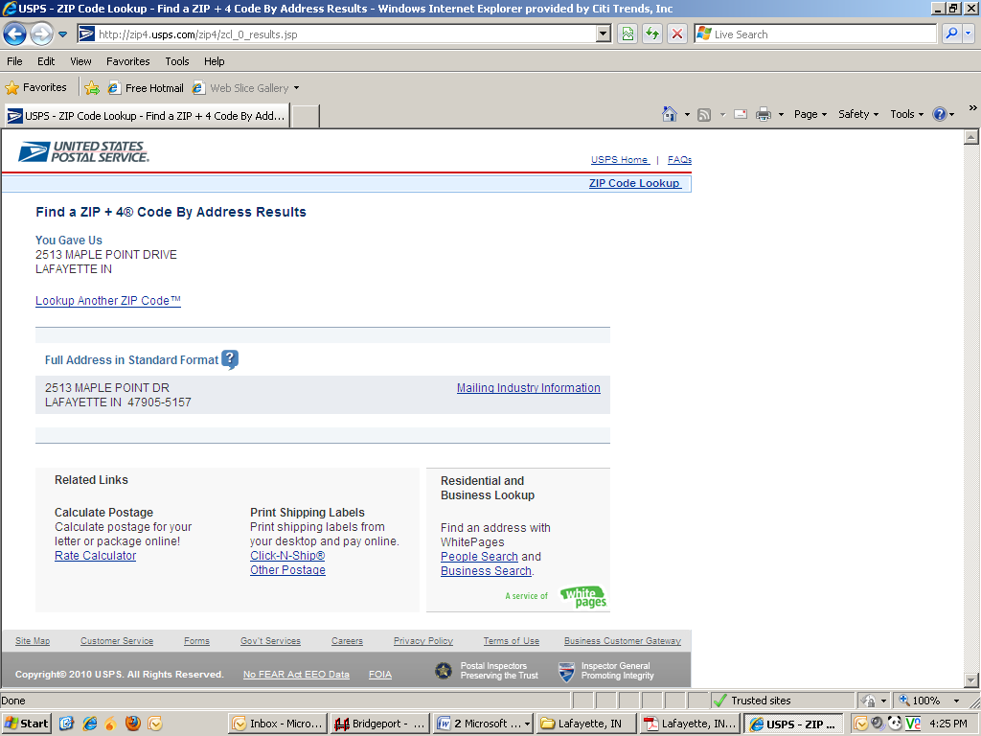

SIGNAGE: Subject to applicable local ordinances and shopping center sign criteria, Tenant shall have the right to install its standard signs on a raised parapet or tower as depicted in Exhibit C. In addition, Tenant shall be permitted to install, without cost to or charge by Landlord, (i) an undercanopy or blade sign, and (ii) sign panels in prominent positions on both sides of the existing pylon structure, in locations as depicted in Exhibit C-1, for so long as the lease remains in effect and Tenant is open and operating in the Shopping Center. Tenant also shall have the right to display professionally made advertising banners from time to time on the interior of the Premises.

