**To:** [jwithrow@cititrends.com](mailto:jwithrow@cititrends.com);[shildebrand@cititrends.com](mailto:shildebrand@cititrends.com); [mgabriel@cititrends.com](mailto:mgabriel@cititrends.com); [mreames@cititrends.com](mailto:mreames@cititrends.com); [jdunn@cititrends.com](mailto:jdunn@cititrends.com); [icouncil@cititrends.com](mailto:icouncil@cititrends.com);  sclifford@cititrends.com; [bgraves@cititrends.com](mailto:bgraves@cititrends.com); [acook@cititrends.com](mailto:acook@cititrends.com); [pabraham@cititrends.com](mailto:pabraham@cititrends.com); [abeisel@cititrends.com](mailto:abeisel@cititrends.com); [gwilder@cititrends.com](mailto:gwilder@cititrends.com); [ccheeseman@cititrends.com](mailto:ccheeseman@cititrends.com); [jhughley@cititrends.com](mailto:jhughley@cititrends.com); [dchisholm@cititrends.com](mailto:dchisholm@cititrends.com); [bharris@cititrends.com](mailto:bharris@cititrends.com); [vowens@cititrends.com](mailto:vowens@cititrends.com); [jcollins@cititrends.com](mailto:jcollins@cititrends.com); [mboyette@cititrends.com](mailto:mboyette@cititrends.com); [akoonce@cititrends.com](mailto:akoonce@cititrends.com); [dcook@cititrends.com](mailto:dcook@cititrends.com); [pwright@cititrends.com](mailto:pwright@cititrends.com); [bgreen@cititrends.com](mailto:bgreen@cititrends.com); [spoole@cititrends.com](mailto:spoole@cititrends.com); [adrinkman@cititrends.com](mailto:adrinkman@cititrends.com); [shorowitz@cititrends.com](mailto:shorowitz@cititrends.com); [mphillips@cititrends.com](mailto:mphillips@cititrends.com); [bfeher@cititrends.com](mailto:bfeher@cititrends.com); [rarnone@cititrends.com](mailto:rarnone@cititrends.com); [dalexander@cititrends.com](mailto:dalexander@cititrends.com); [jnapoli@cititrends.com](mailto:jnapoli@cititrends.com); [gdurkin@cititrends.com](mailto:gdurkin@cititrends.com); [scabeza@cititrends.com](mailto:scabeza@cititrends.com); [sholland@cititrends.com](mailto:sholland@cititrends.com);  [mbuchsbaum@cititrends.com](mailto:mbuchsbaum@cititrends.com); [kgroneck@cititrends.com](mailto:kgroneck@cititrends.com); [ekeyes@cititrends.com](mailto:ekeyes@cititrends.com); [vdavis@cititrends.com](mailto:vdavis@cititrends.com); [rrhodes@cititrends.com](mailto:rrhodes@cititrends.com); [gbaker@cititrends.com](mailto:gbaker@cititrends.com)

Fully executed Lease dated:            September 14, 2011

Date Received:                                      September 15, 2011

Season:      Spring 2012

Name of Shopping Center:       Great Southern Shopping Center 

STORE #: 528

Premises Address:                                          83 Great Southern Blvd., Columbus, OH 43207 -4001  
(*confirmed as a deliverable address at USPS.com*)

County:                                  Franklin

Latitude/Longitude:                                        39.882679 / -83.002994

Landlord Contact: Erica Lloyd, Property Manager

Spigel Properties

70 NE Loop 410, Suite 185, San Antonio, TX 78216

(Ph): 210.349.3636 x103 (Email): Erica@spigelproperties.com

Utilities:

Electric: unknown

Water: unknown

Gas: unknown

Former Occupant: unknown

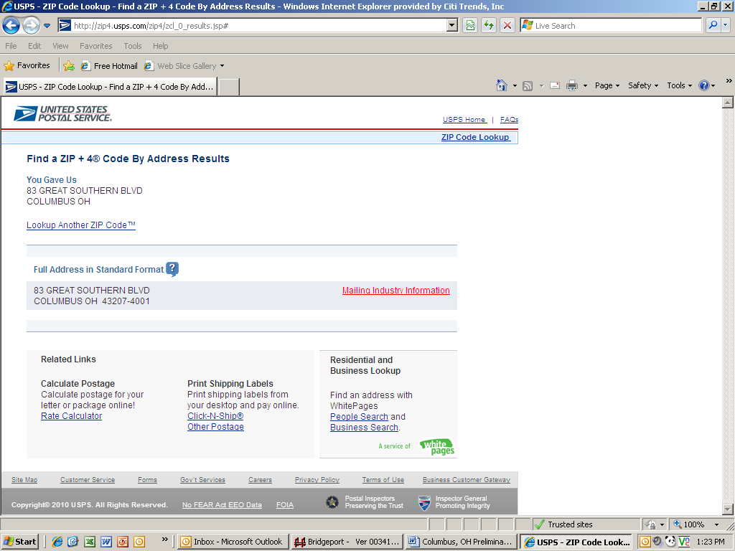







**1.3 Commencement Date:** -- The Commencement Date shall be the earlier of (a) Tenant opening for business, (provided that all of the delivery requirements (1)-(8), below (the “Delivery Requirements”), are satisfied), or (b) **one hundred eighty (180)** days from the date the last of the Delivery Requirements is satisfied (“**Delivery Date**”):

1. Possession of the Premises with Landlord’s Work complete in accordance with Exhibit B and Exhibit B-1 (Landlord-approved Tenant’s Plans). (Possession of the Premises by Tenant may occur prior to the Delivery Date, but in no event shall such possession relieve Landlord of its obligation to satisfy all of the Delivery Requirements set forth herein);
2. Tenant’s receipt from Landlord of an inspection report from RSM Maintenance (or other inspection company approved by Tenant’s Director of Construction) indicating that the roof is “water-tight” and has an expected remaining life of at least 5 years. The report must be dated no earlier than thirty (30) days prior to the Delivery Date. Repairs or replacement to achieve this requirement must be completed prior to the Delivery Date;
3. Landlord shall have provided utility services (gas, water and sewer) to the Premises at the capacities adequate for Tenant’s needs and the services are separately and individually metered or sub-metered. Tenant will contract directly for all utility services or transfer services to Tenant, but Landlord shall pay all tap fees and connection charges;
4. Landlord shall have provided a report dated no earlier than six (6) months prior to the Delivery Date from an environmental consultant satisfactory to Tenant that certifies that there are no Hazardous Materials (as defined in Section 11.1 of this Lease) in the Premises or that the Hazardous Materials are satisfactorily encapsulated and non-friable;
5. Landlord shall have repaired all parking field and delivery area lights and provided Tenant with a letter confirming that this work has been performed;
6. Receipt by Tenant of Landlord’s approval of Tenant’s Plans, which shall be delivered to Landlord within 60 days of lease execution, and Tenant obtaining construction permits (if necessary) for Tenant’s Work;

**3.2 Approval of Tenant’s Plans** -- In no event shall Landlord’s approval of Tenant’s Plans create or be regarded as grounds for any liability on Landlord’s part (a) to any contractor, sub-contractor, laborer, materialman, or vendor performing work on or furnishing materials for the Premises on Tenant’s account; (b) any governmental agency for any legal or code violations or use of improper materials or the like; or (c) to any third-party sustaining an injury due to poor workmanship, improper design or improper materials. It is agreed and understood that Landlord’s review of any plans or specifications of Tenant is for a very limited purpose and that Landlord undertakes absolutely no responsibility as to the safety or compliance with laws and codes of any improvements made by Tenant nor for the payment of persons working on or supplying materials for such improvements. No approval by Landlord of any of Tenant’s plans, specifications, building materials, drawings or the like constitutes a representation, warranty or opinion as to the compliance thereof with applicable building, health, environmental, or safety codes or other applicable state, federal or local laws, codes or regulations including the Americans with Disabilities Act , and the entire responsibility to see to it that Tenant’s plans, specifications, drawings and improvements so comply shall lie with Tenant.

**7.2 Security Equipment -** Tenant shall be allowed, at its sole cost and discretion, to install security equipment, including but not limited to, bars, gates, shutters or interior grills across, in front of, or on top of any glass area on the exterior walls of the Premises. In addition, Tenant shall also be allowed, at its sole cost and expense, to install 4’ high X 6”O.D. (but not to exceed the size permitted by code) concrete bollards in the Common Area in front of the Premises. The installation of security equipment shall be in compliance with the local building code for commercial buildings. At the expiration or earlier termination of the Lease, upon Landlord’s written request, Tenant shall remove any and all security equipment installed by Tenant at Tenant’s sole cost and expense.

**14.17 Signs, Awnings, and Canopies** - Landlord may erect and maintain such suitable signs as it, in its sole discretion, may deem appropriate to advertise the Shopping Center but not on the exterior of the Premises. Tenant shall install and maintain on the facade of the Premises one of Tenant’s standard signs at least 72” in height (but not to exceed the maximum amount permitted under applicable law). Tenant at its own expense will construct a raised marquee (mansard or parapet or tower) on the storefront to accommodate Tenant’s signage. No tenant shall have a sign or sign letters larger than Tenant’s unless such tenant’s premises contains more floor area than the Premises contains. Tenant shall also be permitted to install (a) an under-canopy or blade sign, at Tenant’s expense and/or (b) sign panels on both sides of all existing and future pylon and monument structures, as provided below. Tenant shall submit to Landlord detailed drawings of such sign for review and approval by Landlord which shall not be unreasonably withheld prior to erecting said sign on the Premises. Landlord hereby approves Tenant’s Sign Specifications attached hereto as Exhibit C. Tenant also shall have the right to display from time to time on the exterior of the Premises professionally-made advertising banners. Upon the expiration or earlier termination of this Lease, Tenant, at its sole cost and expense shall remove all such signage and repair any damage caused by the same.

During the Term of this Lease, Tenant shall be entitled to display its trade name in prominent positions on both sides of all future Shopping Center pylon and monument signs (each a “**Pylon**”). Landlord shall maintain and repair such Pylon, Pylon sign cabinets and all associated electrical and lighting components at its cost and expense, and may replace such sign from time to time provided that any new sign shall not be substantially smaller than the original dimensions of the Pylon and Tenant’s position on the new Pylon shall be substantially the same. Tenant shall be responsible for the fabrication and maintenance of Tenant’s sign panel on the Pylon. Tenant’s sign for the Pylon shall be prepared in accordance with all applicable legal requirements.

Changes to Tenant’s signs shall be subject to Landlord’s consent, not to be unreasonably withheld. If Landlord does not respond in writing within ten (10) business days after receipt of Tenant’s written request for consent, then such consent shall be deemed given

**15.5** **Construction Allowance --** Landlord shall pay to Tenant the sum of two hundred seventy-three thousand seven hundred fiftyand 00/100 Dollars ($336,000.00) as and for a construction allowance and contribution toward the cost to Tenant for performing Tenant’s Work in the Premises, within thirty (30) days after Tenant’s opening for business and Tenant providing Landlord with (a) lien waivers by each of Tenant’s contractors or subcontractors providing work or services in excess of $10,000.00; (b) a copy of the Certificate of Occupancy or its equivalent in the jurisdiction; (c) Tenant’s estoppel certificate stating that the Lease is in full force and effect; (d) Tenant’s form W-9; and (e) Tenant’s written request for payment of the construction allowance. In the event Landlord fails to make payment of such amount within thirty (30) days after receipt of items (a) through (e), in the preceding sentence, then in addition to all other remedies which Tenant may have, Tenant shall thereafter be entitled to offset the unpaid amount, plus interest thereon at eight percent (8%) per annum, against all Gross Annual Rent, Percentage Rent, and any other amounts due, until recovered in full.

**Exhibit B**

“As Is” Premises

*General*

A Tenant shall be permitted to use all existing improvements/fixtures in the Premises.

1. Landlord agrees to provide any asbestos reports required for governmental permits.
2. Landlord agrees to provide to Tenant Appendix B-Building Code Summary-2002 Edition-IBC (if required by local jurisdiction).

Landlord agrees to deliver the Premises with all structural and mechanical components of the Premises as is on the Delivery Date and Tenant may use all existing improvements remaining in the Premises

In the event, Landlord fails to deliver the Premises to Tenant on the Delivery Date in the condition set forth in this Exhibit B and otherwise as required under Section 1.3 of the Lease, then Tenant may complete such work as is necessary to meet such requirements and Tenant shall have the right to withhold the cost of such work from Rent (including Gross Annual Rent, Percentage Rent and all other charges due under the Lease).