To: jbroyles@cititrends.com; shildebrand@cititrends.com; mgabriel@cititrends.com; mreames@cititrends.com; jdunn@cititrends.com; icouncil@cititrends.com; eanderson@cititrends.com; sclifford@cititrends.com; bgraves@cititrends.com; acook@cititrends.com; pabraham@cititrends.com; abeisel@cititrends.com; gwilder@cititrends.com; ccheeseman@cititrends.com; jhughley@cititrends.com; dchisholm@cititrends.com; bharris@cititrends.com; vowens@cititrends.com; jcollins@cititrends.com; mboyette@cititrends.com; akoonce@cititrends.com; dmcgraw@cititrends.com; pwright@cititrends.com; bgreen@cititrends.com; spoole@cititrends.com; adrinkman@cititrends.com; shorowitz@cititrends.com; tstephens@cititrends.com; mphillips@cititrends.com; bfeher@cititrends.com; dmiller@cititrends.com; gpinka@cititrends.com; dalexander@cititrends.com; scarter@cititrends.com; jnapoli@cititrends.com; gdurkin@cititrends.com

Fully executed Lease dated: September 9, 2009
Date Received: September 15, 2009
Delivery of Premises: on or before: October 1, 2010

Season: Fall 2010

Name of Shopping Center: Old National Marketplace

Store #: t/b/d

Premises Address: 6425 Old National Hwy., College Park, GA 30349
(confirmed as a deliverable address at USPS.com) (subject to change)

County: Fulton

Landlord Contact: Jamie Pearson, Inland Atlantic Development Corp., 100 Colony Square
1175 Peachtree St. NE, Suite 840, Atlanta, GA 30361 770-355-0954
jpearson@inlandgroup.com

Utilities:
Electric: Unknown
Water: Unknown
Gas: Unknown

Former Occupant: None. NEW Construction

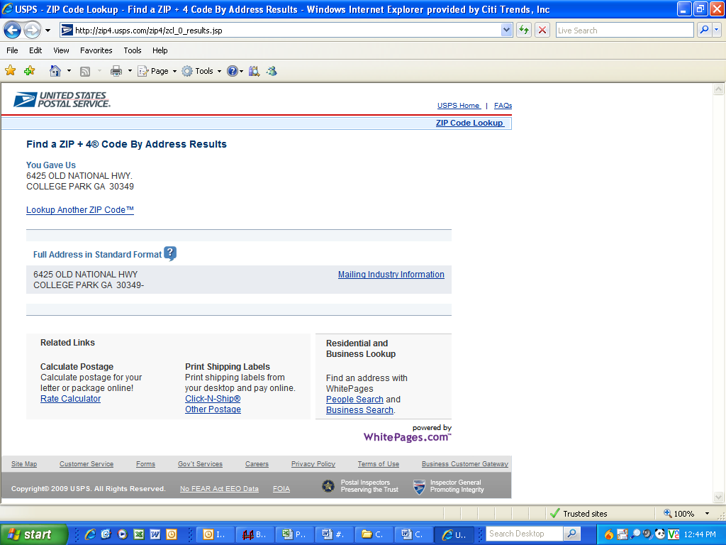
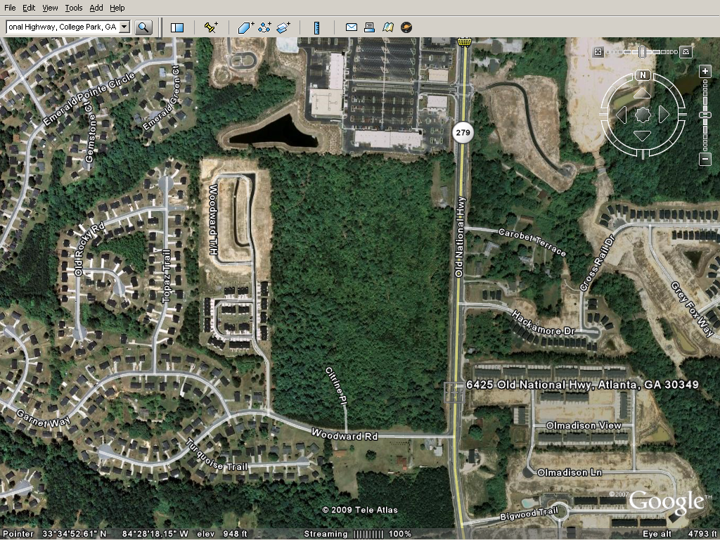
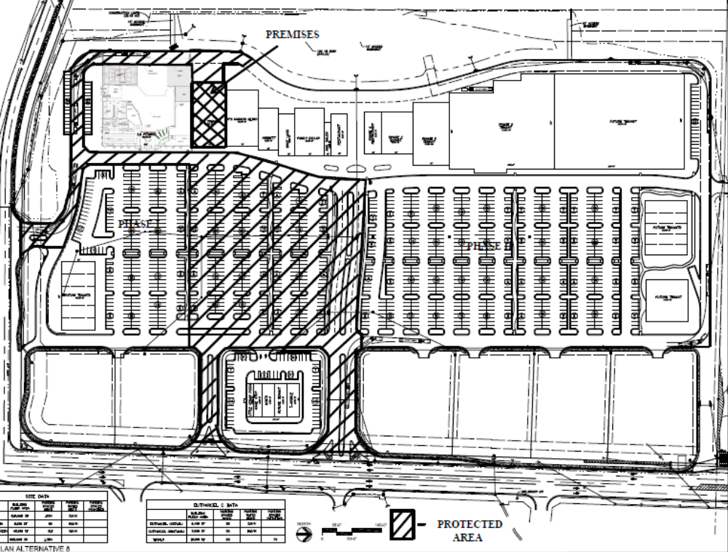

DESCRIPTION OF LANDLORD’S WORK

1) FLOORS – Floors in sales area and stockroom area shall be level, even and free of any type of existing floor covering (carpet, vinyl, ceramic, quarry, tile, etc.), free of any adhesive with all holes and cracks filled with fill stop. Sales area shall be broom clean, smooth and ready for new carpet installation.

Bathroom floor(s) shall be covered with vinyl composite tile and 4” base or ceramic tile and 4” base as required by code, and be free of any obstructions, bumps, etc. and be in broom clean condition.

2) WALLS – All walls in sales and storage areas shall be plumb straight, properly braced, finished with sheet rock (5/8”), shall be even, mudded, taped and sanded smooth, finished, and painted with two finished coats of Sherwin Williams (SW-7006 Extra White) paint. If any walls in the sales area are of masonry construction, the walls shall be furred, with a minimum clearance of ¾” between the masonry walls and drywall. Walls in spaces previously occupied shall be free of all fixturing.

Landlord will install partition wall between the sales area and the stockroom at a location specified in Tenant’s plans, using construction and materials as specified above. Demising walls to include a least six-inch (“6”) studs, sound bat insulation, one-half (“1/2”) inch plywood with wire mesh extended to the ceiling and five-eighths (“5/8”) inch drywall covering, one hour fire rated;

3) CEILINGS – All ceilings within the leased space shall be of a suspended 2’ x 4’ acoustical tile. Suspension systems shall be evenly spaced, on a single level at a minimum of 11’0” and a maximum of 14'0" above finished floor and free of any damage. Lay-in tiles shall be clean, flat and free of any defects. Ceiling tiles and suspension systems shall be of uniform patterns and white in color. Ceilings shall be free of any electrical outlets and lighting systems except those required by Tenant. All ceilings shall bear no less than one layer of R-19 fiberglass insulation.

4) STOREFRONTS – Frontages of leased spaces shall be no less than 40% glass from side to side and from inside ceiling level down to inside finished floor level. If sill walls exist under glass front they shall be no higher than 30” above inside floor level. All glass and framework shall be free of damage and signage at time of possession. Glass exposed to the exterior of the Premises shall be impact resistant.

Fascia shall contain sufficient flat area to support signage requirements of Tenant (see Exhibit D). Fascia shall be free of any previous signage, and free of any indication of previous signage. Should any type canopy be attached to, or part of, space leased by Tenant, then same shall be in good, clean condition and leak free. Any lighting contained in said canopy shall be in good working condition and maintained by Landlord for duration of lease.

Doors in storefronts shall be single acting double 3’0” x 6’8” opening out. Doors in storefronts shall be of glass and aluminum construction, in proper working condition, sealed weather tight upon release and have all locking systems in working order.

KEYS – Keys to all front and back doors shall be provided to Tenant on or prior to written and confirmed date of possession. Tenant will not consider itself to be in possession of a leased space until proper keys are provided by Landlord for that space.

5) REAR SERVICE DOOR - All steel, minimum 3’0” x 6’8” x 1 ¾”. Door jamb shall also be of steel construction and set in concrete within concrete block wall. Door shall be hinged into jamb with locked hinge pins. Door shall open and close without resistance, and be air and water tight upon closure. Door shall contain one (1) locking passage knob in freely working condition. Door shall be single action opening out and contain one (1) optical thru-door viewer on the width of the door at 5’4” above inside floor.

6) HVAC SYSTEM – Landlord shall furnish complete (in working order) heating and air conditioning system for entire space (sales areas, storage areas and bathroom areas) leased by Tenant. System shall include one (1) working thermostat (locations to be determined by Tenant) per unit. It is expected that all the heat and air conditioning systems comply with the following general rules or standards: (1) U.S. Premises – one (1) ton per 350 S.F. minimums.

7) LIGHTING – Landlord will install one (1) Lithonia 2 x 4 lay-in fixture (Part # 432A121204/4) with GE T-8 Cool White bulbs (or an equivalent 2 x 4, 4 tube lay-in fixture with electronic ballast and #741 bulbs approved by Tenant) for every 60 sq. ft. of sales area and one (1) fixture for every 100 sq. ft. of storage space. Each Lay-In fixture shall contain working ballast(s) and circuits sufficient for proper operation. Storage space light fixtures may be 4’ or 8’ strip type surface mounted.

8) ELECTRICAL – Landlord shall provide electrical service to the Premises through a 400 amp. individual meter can and per the itemized requirements of Tenant as set forth in Tenant’s electrical plan attached hereto as Exhibit B-1 to the Lease. Landlord shall provide electrical distribution to the interior of the Premises through a 400 amp. three phase, 120/208 volt power panel with a minimum of 30 breakers. Each breaker switch in all Electrical Panels shall be accurately labeled. The electrical panel must be located in an area, which will be used for a stockroom by Tenant.

Number, type and location of electrical outlets in addition to those outlets specified on layout, the sidewalls of the front of the sales area shall contain regular duplex outlets to code requirements. But in no case be less than one (1) for every twenty (20) feet of wall length or part thereof.

A separate circuit shall be provided to include working time clock for lighted sign on fascia.

9) BATHROOMS – One (1) partition toilet, room meeting ADA requirements, with sufficient lighting including water closet, lavatory, mirror over lavatory, and toilet paper holder. Fixtures shall be clean, leak free and in good working order. Should any local municipal code require two (2) or more bathrooms or handicap bathroom facilities, Landlord shall supply same. All drainage lines from bathroom fixtures to sewerage system shall contain no leaks (above or below ground) and shall be free flowing.

Landlord shall supply and install either six (6) gallon energy efficient hot water heater, properly installed in drip pan or “on demand” in line water heater, type and location to conform to local code requirements.

10) RAISED PARAPET - Minimum 30’ wide and 25’ high for signing

11) CODES – Construction by Landlord and Landlord’s subcontractors shall comply with all existing municipal, state and Federal codes. Any special requirements imposed by governing bodies shall be the responsibility of Landlord for the duration of the lease. It is ultimately the responsibility of Landlord to have all construction inspected by authorities under whose jurisdiction the leased space falls. Tenant shall not take occupancy of any space until all inspections have been conducted and written certification has been obtained. Where applicable, it is the responsibility of the Landlord to procure a Certificate of Occupancy (C.O.) from local inspections office and forward same (or copy) to Tenant fourteen (14) days prior to opening. Tenant to notify Landlord of opening date.

12) SYSTEMS TEST – Upon delivery of the Premises to Tenant, Tenant will, at Tenant’s expense, test and inspect the following Landlord supplied services and building systems:
- Plumbing.
- Electrical service and distribution.
- Lighting.
- HVAC.
- Fire alarm, automatic sprinkler, and other life safety systems.

Tenant will at the conclusion of the test, report to Landlord any service or system not working, not meeting Tenant’s minimum standards necessary to operate its business, or failing to meet or comply with current building codes in effect for the area where Premises are located.

Landlord may, at its discretion, either repair or replace deficient systems or services, or authorize Tenant to complete the repairs or replacement and allow Tenant to recover such costs from rents due Landlord.

14.17 Signs, Awnings, and Canopies - Landlord may erect and maintain such suitable signs as it, in its sole discretion, may deem appropriate to advertise the Shopping Center but not on the exterior of the Premises. Tenant shall erect and maintain on the facade of the Premises one of Tenant’s standard signs at least 60” in height (but not to exceed the maximum amount permitted under applicable law). Tenant's signage shall be subject to the Old National Highway Overlay District requirements and Tenant hereby acknowledges receipt of a copy of such requirements. Landlord at its own expense will construct a raised marquee (mansard or parapet or tower) on the storefront to accommodate Tenant’s signage. Tenant shall also be permitted to install (i) an undercanopy or blade sign, at Tenant’s expense and/or (ii) sign panels on both sides of all existing and future pylon and monument structures, as provided below. Tenant shall submit to Landlord detailed drawings of such sign for review and approval by Landlord which shall not be unreasonably withheld prior to erecting said sign on the Premises. Landlord hereby approves Tenant’s Sign Specifications attached hereto as Exhibit C. Tenant also shall have the right to display from time to time on the exterior of the Premises professionally-made advertising banners, subject to applicable laws and the Old National Highway Overlay District requirements.

Landlord represents that there will be two monument signs serving the Shopping Center excluding the monument signs exclusively serving the outparcels. During the term of this Lease, Tenant shall be entitled to display its trade name on both sides of one of the Shopping Center monument signs, excluding the monument signs exclusively serving the outparcels (the “Pylon”) in the position designated on Exhibit C-1 attached hereto. The Pylon Sign is located as shown on the Site Plan. Landlord shall maintain such Pylon at its cost and expense (provided such cost shall be included in CAM Cost), and may replace such sign from time to time provided that any new sign shall not be substantially smaller than the original dimensions of the Pylon and Tenant’s position on the new Pylon shall be substantially the same. Tenant shall be responsible for the fabrication and maintenance of Tenant’s sign panel on the Pylon, at its sole cost and expense. Tenant’s sign for the Pylon shall be prepared in accordance with all applicable legal requirements and with Landlord’s sign criteria and further subject to Landlord's approval as set forth above.

1.2 Premises -- Landlord hereby leases to Tenant and Tenant rents from Landlord the Premises in the Shopping Center described in Section 1.1 (a) and shown in Exhibit A annexed hereto and made a part hereof. The Premises shall extend to the exterior faces of exterior walls or to the building line where there is no wall, or the center line of those walls separating the Premises from other leased premises in the Shopping Center, together with the appurtenances specifically granted in this Lease, but reserving and excepting to Landlord the right to install, maintain, use, repair, and replace pipes, ductwork, conduits, utility lines, and wire through hung ceiling space, column space, and partitions, in or beneath the floor slab, or above or below the Premises or the parts of the Shopping Center, except that Landlord in having such right shall not unreasonably interfere with, or interrupt the business operation of Tenant within the Premises anytime during the Term. Additionally, no pipes, conduits, utility lines, or wires installed by Landlord shall be exposed in the sales area of the Premises. If Landlord does interfere with Tenant’s business operation to the extent that Tenant, in its reasonable business judgment, is required to close its business, then all Minimum Annual Rent and all other charges pursuant to this Lease shall abate during the period that Tenant is closed.

The parties acknowledge that the Premises consist of approximately the square footage set forth in the Reference Provisions of Section 1.1. Within sixty (60) days after the Delivery Date (the “Applicable Period”), either party shall have the opportunity to measure the dimensions of the Premises for a determination of its exact square footage and provide the other party with written notice of its findings. If either party shall contest the square footage of the Premises within the Applicable Period, then the other party shall have fifteen (15) days after receiving written notice of such contest to make its own measurement. The parties shall thereafter use their best efforts to agree on the appropriate square footage. If neither party contests the square footage of the Premises within the Applicable Period, then the parties waive any right to contest such square footage amount in the future. When an agreement between Landlord and Tenant is reached, all monetary calculations in this Lease which rely upon the area shall be recalculated and adjusted retroactive to the Rent Commencement Date (but in no event shall such recalculation result in Tenant paying Rent on any square footage above the square footage set forth in Section 1.1(a) above).

3.1 Condition of Premises -- Landlord agrees to construct the Shopping Center and the Premises shown in Exhibit A substantially in accordance with Exhibit B (“Landlord’s Work”). Landlord shall submit its plans and specifications for Landlord’s Work to Tenant for its approval, not to be unreasonably withheld, within forty-five (45) days after the satisfaction or waiver of the financing contingency set forth in Section 15.7 below. Tenant shall have fifteen (15) days after receipt of such plans and specifications to approve or disapprove the same. If Tenant does not respond within such fifteen (15) day period, Landlord may send a second notice which prominently states: “FAILURE TO RESPOND WITHIN FIVE (5) BUSINESS DAYS AFTER RECEIPT SHALL CONSTITUTE DEEMED APPROVAL OF LANDLORD’S PLANS”. If Tenant fails to disapprove Landlord’s plans with specificity within five (5) business days after receipt of such second notice, then Landlord’s Plans shall be deemed approved. If Tenant disapproves Landlord’s plans with specificity within the time period provided, then Landlord shall revise and resubmit its plans to Tenant within ten (10) days thereafter, and the parties shall continue in like manner until such plans and specifications have been approved. All of Landlord’s Work shall be performed in a good and workmanlike manner employing appropriate materials so as to comply with all governmental requirements and the specifications set forth in Exhibit B. All other work on the Premises shall be completed by Tenant at Tenant’s expense (“Tenant’s Work”). Tenant’s Work shall include, but not be limited to, all work necessary and/or desired by Tenant to open for business in the Premises for its intended purposes, except those items of work specifically set forth as Landlord’s Work. Any modifications to Tenant’s Plans attached hereto as Exhibit B-1 and any of Tenant’s Work which is not shown on Tenant’s Plans shall be subject to Landlord’s approval in accordance with and to the extent required by Section 7.1 below, shall be performed in a good and workmanlike manner, and shall comply with all governmental requirements.

In the event Tenant is permitted access to or possession of the Premises during any period during which Landlord is performing Landlord’s Work, Tenant shall not unreasonably interfere with Landlord’s completion of Landlord’s Work and any such interference shall be deemed to be a “Tenant Delay” resulting in an equitable extension of the Notice Delivery Date. Tenant may act as its own general contractor and shall have the right to choose its subcontractors.

3.2 Acceptance by Tenant – Acceptance of possession by Tenant of the Premises shall constitute acceptance of the Premises by Tenant, except for punch list items to Landlord’s Work, if any, any patent defects discovered within one (1) year after the Commencement Date, and any latent defects. This Section 3.2 shall not negate or limit any representations or warranties made by Landlord under this Lease nor constitute any agreement by Tenant that such representations and warranties have been satisfied.



