To: jwithrow@cititrends.com; shildebrand@cititrends.com; mgabriel@cititrends.com; mreames@cititrends.com; jdunn@cititrends.com; icouncil@cititrends.com; sclifford@cititrends.com; bgraves@cititrends.com; acook@cititrends.com; pabraham@cititrends.com; abeisel@cititrends.com; gwilder@cititrends.com; ccheeseman@cititrends.com; jhughley@cititrends.com; dchisholm@cititrends.com; bharris@cititrends.com; vowens@cititrends.com; jcollins@cititrends.com; mboyette@cititrends.com; akoonce@cititrends.com; dcook@cititrends.com; pwright@cititrends.com; bgreen@cititrends.com; spoole@cititrends.com; adrinkman@cititrends.com; shorowitz@cititrends.com; mphillips@cititrends.com; bfeher@cititrends.com; rarnone@cititrends.com; dalexander@cititrends.com; jnapoli@cititrends.com; gdurkin@cititrends.com; scabeza@cititrends.com; sholland@cititrends.com; mbuchsbaum@cititrends.com; kgroneck@cititrends.com; ekeyes@cititrends.com; vdavis@cititrends.com; rrhodes@cititrends.com; gbaker@cititrends.com

Fully executed Lease dated: September 1, 2011
Date Received: September 1, 2011
Season: Fall 2011

Name of Shopping Center: The Shoppes at Broad Street

STORE #: 544

Premises Address: 1867 E Broad St., Suite D-4, Statesville, NC 28625-4307
(confirmed as a deliverable address at USPS.com)

County: Iredell

Latitude/Longitude 35.791504/-80.852994

Landlord Contact: Daniel Kelly, Property Manager
Sentinel Real Estate Corporation
8936 NorthPointe Executive Park, Huntersville, NC 28078
Phone: 704.655.8230 Fax: 704.655.8246 Email: dkelly_nprc@bellsouth.net

Robert Austin, Vice President
Sentinel Real Estate Corporation
1251 Avenue of the Americas, New York, NY 10020
Phone: 212.408.2951 Fax: 212.603.4965 Email: austinr@sentinelcorp.com

Utilities:
Electric: City of Statesville Meter # 1867-D4
Water: City of Statesville Meter # unknown
Gas: PSNC Energy Meter # unknown

Former Occupant: Ace Hardware

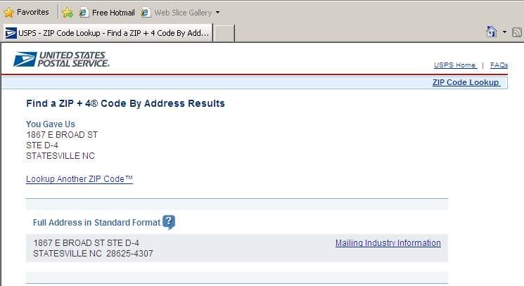

1.3 Commencement Date: -- The Commencement Date shall be the earlier of (a) Tenant opening for business, (provided that all of the delivery requirements (1)-(2), below (the “Delivery Requirements”), are satisfied), or (b) one hundred fifty (150) days from the date the last of the Delivery Requirements is satisfied (“Delivery Date”)

- Possession of the Premises, which shall occur within two (2) days after the full execution and delivery of this Lease.

Notwithstanding anything herein to the contrary, within 14 days after the Delivery Date (the “HVAC Completion Date”), Landlord shall install, in new condition, two (2) – 6-ton rooftop heating, ventilating and air conditioning units (“RTUs”) (including flashing, curbing, and connecting to existing ductwork and utilities), provide Tenant with the make, model and serial numbers for both RTUs and a copy of any warranties associated with the RTUs (the “HVAC Requirement”).

3.2 Acceptance by Tenant – Acceptance of possession by Tenant of the Premises shall constitute acceptance of the Premises by Tenant, except for punch list items to Landlord’s Work, if any, and any latent defects. This Section 3.2 shall not negate or limit any representations or warranties made by Landlord under this Lease nor constitute any agreement by Tenant that such representations and warranties have been satisfied.

7.2 Security Equipment -- Tenant shall be allowed, at its sole cost and discretion, to install interior roll-up security gates and alarmed security systems. The installation of security equipment shall be in compliance with the local building code for commercial buildings. At the expiration or earlier termination of the Lease, upon Landlord’s written request, Tenant shall remove any and all security equipment installed by Tenant at Tenant’s sole cost and expense.

14.17 Signs, Awnings, and Canopies - Landlord may erect and maintain such suitable signs as it, in its sole discretion, may deem appropriate to advertise the Shopping Center but not on the exterior of the Premises. Tenant shall erect and maintain on the facade of the Premises one of Tenant’s standard signs at least 72” in height (but not to exceed the maximum amount permitted under applicable law). Tenant shall also be permitted to install (a) an under-canopy or blade sign, at Tenant’s expense and/or (b) sign panels on both sides of all existing and future pylon and monument structures, as provided below. Tenant shall submit to Landlord detailed drawings of such sign, for review and approval by Landlord which shall not be unreasonably withheld, prior to erecting said sign on the Premises. Tenant also shall have the right to display from time to time on the exterior of the Premises professionally-made advertising banners, subject to all local sign laws and ordinances.

Tenant shall be entitled to display its trade name on both sides of all existing Shopping Center pylon and monument signs as shown on Exhibit C-1 attached hereto and in prominent positions on both sides of all future Shopping Center pylon and monument signs (each a “Pylon”), provided that Tenant is open for business in the Premises. Landlord shall maintain and repair such Pylon, Pylon sign cabinets and all associated electrical and lighting components at its cost and expense (subject to inclusion of such expenses in CAM Costs), and may replace such sign from time to time provided that any new sign shall not be substantially smaller than the original dimensions of the Pylon and Tenant’s position on the new Pylon shall be substantially the same. Tenant shall be responsible for the fabrication and maintenance of Tenant’s sign panel on the Pylon. Tenant’s sign for the Pylon shall be prepared in accordance with all applicable legal requirements.

Landlord hereby approves Tenant’s Sign Specifications attached hereto as Exhibit C and Tenant’s Pylon panel attached hereto as Exhibit C-1. Changes to Tenant’s signs shall be subject to Landlord’s consent, not to be unreasonably withheld.

Except as aforesaid, Tenant shall not display any signage, advertisement, notice or other lettering outside the Premises and any displayed in violation of the provisions of this Section may be removed by Landlord at Tenant’s sole cost.
15.4 Construction Allowance -- Landlord shall pay to Tenant the sum of Two Hundred Fifty Thousand and 00/100 Dollars ($250,000.00) as and for a construction allowance and contribution toward the cost to Tenant for performing Tenant’s Work in the Premises, within thirty (30) days after Landlords receipt from Tenant of the following: (a) lien waivers by each of Tenant’s contractors or subcontractors providing work or services in excess of $10,000.00, (b) a copy of the occupancy certificate or equivalent document confirming completion of Tenant’s Work in compliance with all applicable legal requrements, (c) an estoppel certificate certifying that the Lease is in full force and effect, (d) a completed IRS Form W-9 signed by Tenant, and (e) Tenant’s written request for payment of such allowance. In the event Landlord fails to make timely payment of such amount, then Tenant shall thereafter be entitled to offset the unpaid amount, plus interest thereon at eight percent (8%) per annum, against all Minimum Annual Rent, Percentage Rent, and any other amounts due, until recovered in full.

Exhibit B
“As Is” Premises

General

A. Tenant shall be permitted to use all existing improvements/fixtures in the Premises.

- Landlord agrees to provide any asbestos reports required for governmental permits.

Landlord’s Work:

Landlord shall have no obligation, except as expressly set forth in this Lease, to improve or alter the Premises for the benefit of Tenant.

