To: jwithrow@cititrends.com; shildebrand@cititrends.com; mgabriel@cititrends.com; mreames@cititrends.com; jdunn@cititrends.com; icouncil@cititrends.com; sclifford@cititrends.com; bgraves@cititrends.com; acook@cititrends.com; pabraham@cititrends.com; abeisel@cititrends.com; gwilder@cititrends.com; ccheeseman@cititrends.com; jhughley@cititrends.com; dchisholm@cititrends.com; bharris@cititrends.com; vowens@cititrends.com; jcollins@cititrends.com; mboyette@cititrends.com; akoonce@cititrends.com; dcook@cititrends.com; pwright@cititrends.com; bgreen@cititrends.com; spoole@cititrends.com; adrinkman@cititrends.com; shorowitz@cititrends.com; mphillips@cititrends.com; bfeher@cititrends.com; rarnone@cititrends.com; dalexander@cititrends.com; jnapoli@cititrends.com; gdurkin@cititrends.com; scabeza@cititrends.com; sholland@cititrends.com; mbuchsbaum@cititrends.com; kgroneck@cititrends.com; apulsney@cititrends.com; vdavis@cititrends.com; rrhodes@cititrends.com; gbaker@cititrends.com

Fully executed Lease dated: July 18, 2011
Date Received: July 20, 2011
Season: Fall 2011

Name of Shopping Center: Lake Air Mall

STORE #: 0534

Premises Address: 5301 Bosque Blvd., Waco, TX 76710
(subject to change)

County: McLennan

Latitude/Longitude: 31.533820/ -97.194432

Landlord Contact: John Hardaway, VP of Finance
HPI Real Estate Services
3600 N Capital of Texas Highway, Building B – Suite 250, Austin, TX 78746
Main Phone: 512.835.4455 Direct Phone: 512.538.0093
Email: hardaway@HPITX.com

Utilities:
Electric: City of Waco/Oncor
Water: City of Waco
Gas: N/A

Former Occupant: N/A

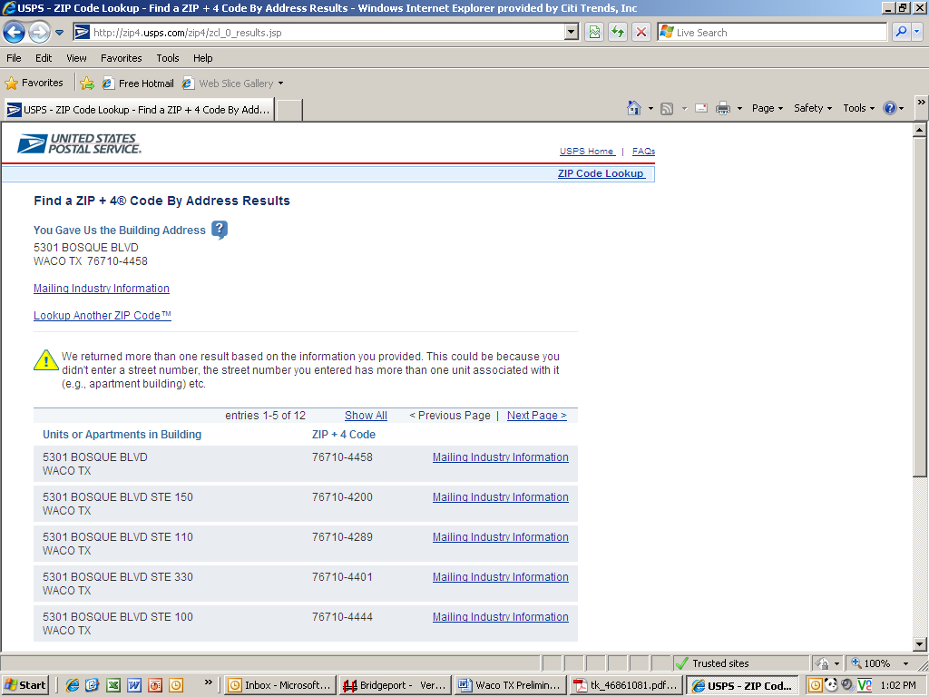
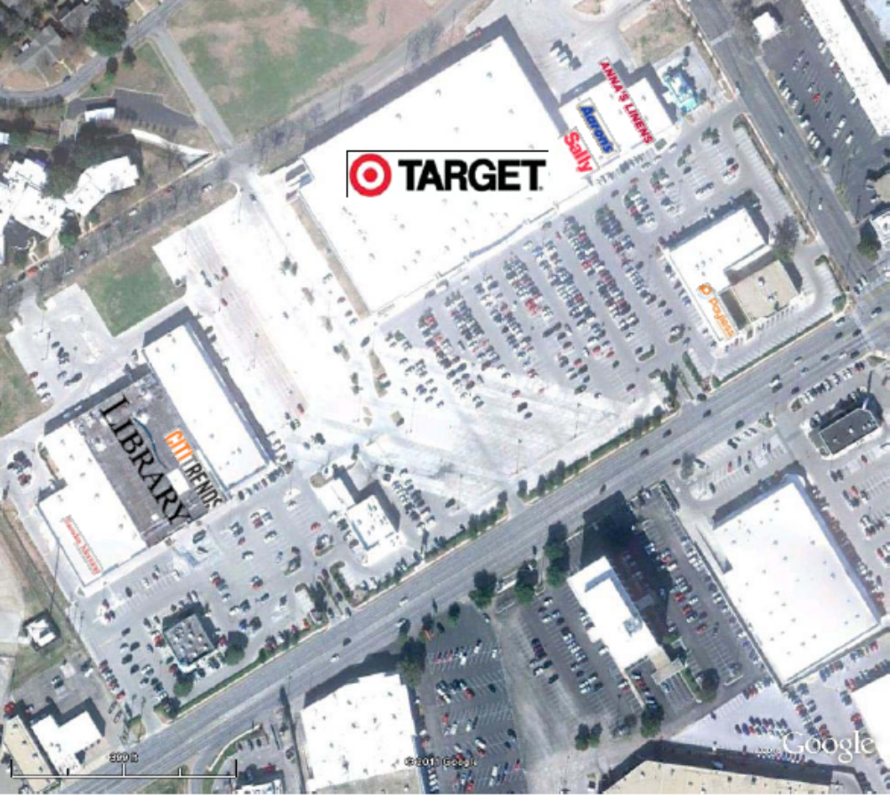
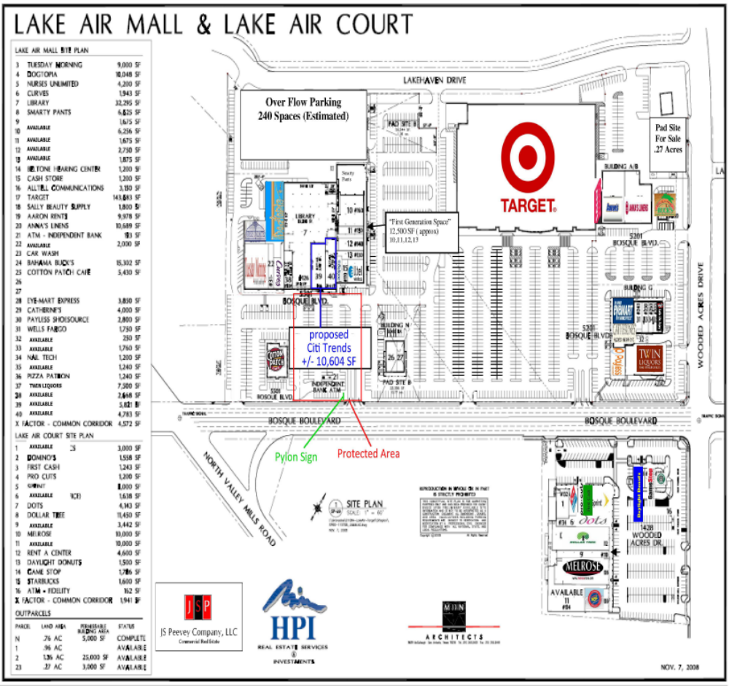
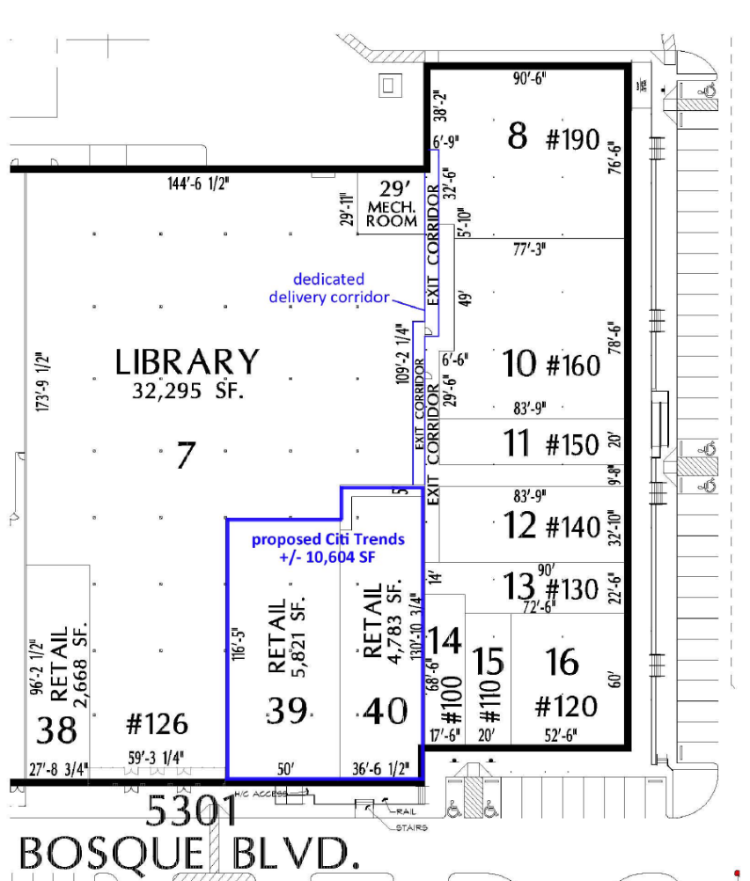

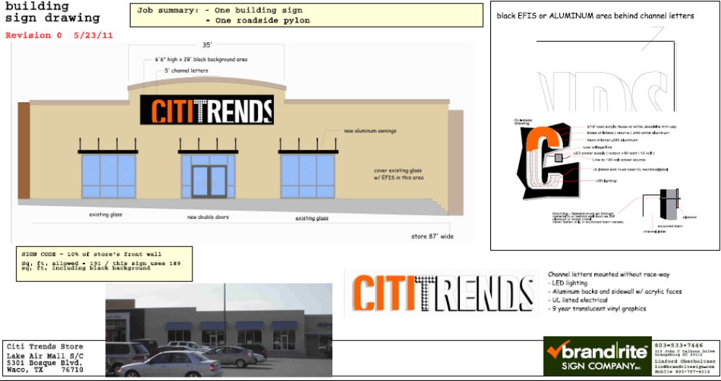
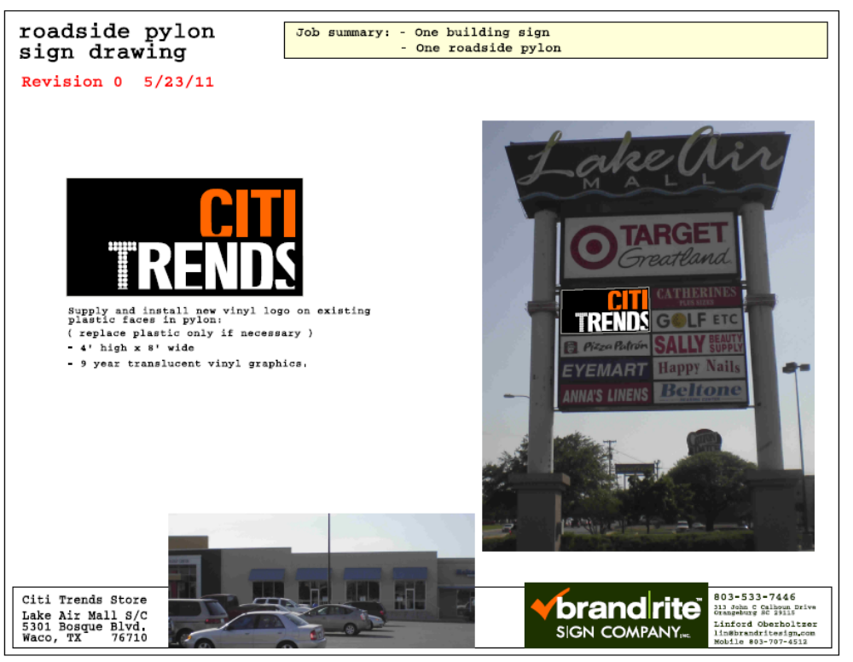

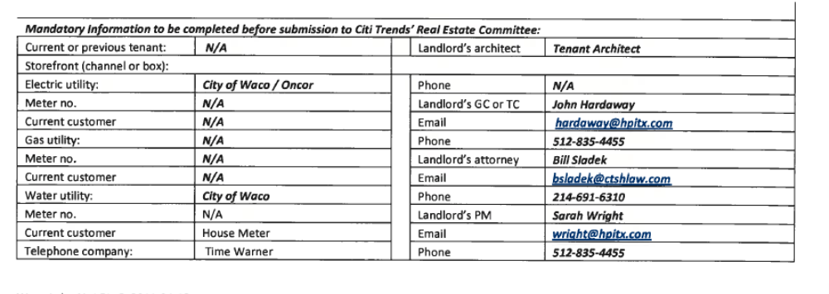
1.2 Premises – The parties acknowledge that the Premises consist of approximately the square footage set forth in the Reference Provisions of Section 1.1. Within sixty (60) days after the Delivery Date (the "Applicable Period"), either party shall have the opportunity to measure the dimensions of the Premises for a determination of its exact square footage and provide the other party with written notice of its findings. If either party shall contest the square footage of the Premises within the Applicable Period, then the other party shall have fifteen (15) days after receiving written notice of such contest to make its own measurement. The parties shall thereafter use commercially reasonable efforts to agree on the appropriate square footage. If neither party contests the square footage of the Premises within the Applicable Period, then the parties waive any right to contest such square footage amount in the future. When an agreement between Landlord and Tenant is reached, all monetary calculations in this Lease which rely upon the area shall be recalculated and adjusted retroactive to the Rent Commencement Date (but in no event shall such recalculation result in Tenant paying Rent on any square footage above the square footage set forth in Section 1.1(a) above).

1.3 Commencement Date – The Commencement Date shall be the earlier of (a) Tenant opening for business, (provided that all of the delivery requirements (1)-(8), below (the “Delivery Requirements”), are satisfied), or (b) one hundred eighty (180) days from the date the last of the Delivery Requirements is satisfied (“Delivery Date”):

- Possession of the Premises with Landlord's Work substantially complete in accordance with Exhibit B;

- Tenant's receipt from Landlord of an inspection report from RSM Maintenance (or other inspection company approved by Tenant's Director of Construction) indicating that the roof is "water-tight" and has an expected remaining life of at least 5 years. The report must be dated no earlier than thirty (30) days prior to the Delivery Date. Repairs or replacement to achieve this requirement must be completed prior to the Delivery Date;

- Landlord shall have provided utility services (electricity, gas (if available), water and sewer) to the Premises at the capacities adequate for Tenant's needs and the services are separately and individually metered or sub-metered. Tenant will contract directly for all utility services or transfer services to Tenant, but Landlord shall pay all tap fees and connection charges (This requirement will be deemed satisfied on the date of possession if Landlord completes this work by July 29, 2011);

- Landlord shall have provided a report dated no earlier than six (6) months prior to the Delivery Date from a reputable environmental consultant that certifies that there are no Hazardous Materials (as defined in Section 11.1 of this Lease) in the Premises or that the Hazardous Materials are satisfactorily encapsulated and non-friable;

- Landlord shall have repaired all parking field and delivery area lights and provided Tenant with a letter confirming that this work has been performed;

- Receipt by Tenant of Landlord's approval of Tenant's Plans (which plans Tenant shall prepare and deliver for Landlord review with due diligence and which Landlord shall review with due diligence), and Tenant obtaining construction permits (if necessary) for Tenant's Work. (Tenant agrees to pursue such permits with due diligence and in good faith, and to advise Landlord immediately upon encountering any delays with the City of Waco).

3.2 Acceptance by Tenant – Acceptance of possession by Tenant of the Premises shall constitute acceptance of the Premises by Tenant, except for punch list items to Landlord’s Work, if any, any patent defects discovered within one (1) year after the Commencement Date, and any latent defects. This Section 3.2 shall not negate or limit any representations or warranties expressly made by Landlord under this Lease nor constitute any agreement by Tenant that such representations and warranties have been satisfied.

7.2 Security Equipment – Subject to the prior written consent of Landlord, which consent may be given or withheld in the sole discretion of Landlord, Tenant shall be allowed, at its sole cost and discretion, to install security equipment, including but not limited to, bars, gates, shutters or interior grills across, in front of, or on top of any glass area on the exterior walls of the Premises. The installation of security equipment shall be in compliance with all applicable laws, codes and ordinances. At the expiration or earlier termination of the Lease, upon Landlord's written request, Tenant shall remove any and all security equipment installed by Tenant, such removal to be at Tenant's sole cost and expense, and Tenant shall repair all damage caused by such removal and otherwise restore the applicable portions of the Premises to their condition existing immediately prior to the installation of such security equipment.

14.17 Signs, Awnings, and Canopies – Landlord may erect and maintain such signs as it, in its sole discretion, may deem appropriate to advertise the Shopping Center but not on the exterior of the Premises. Subject to compliance with all applicable local ordinances and shopping center sign criteria attached as Exhibit C-2 (unless otherwise approved pursuant to this Section14.17), Tenant shall have the right to (a) erect and maintain on the facade of the Premises one of Tenant's standard signs at least 72" in height (but not to exceed the maximum amount permitted under applicable law), (b) construct a raised marquee (mansard or parapet or tower) on the storefront to accommodate Tenant's signage, (c) install (i) an under-canopy or blade sign, at Tenant's expense and/or (ii) one (1) sign panel on both sides of all existing and future multi-tenant pylon and monument structures, as provided below, and (d) display from time to time on the exterior of the Premises professionally-made advertising banners. Subject to the rights of all tenants under leases in existence as of the date of final execution of this Lease, no tenant shall have a sign or sign letters larger than Tenant's unless such tenant's premises contains more floor area than the Premises contains. Tenant shall submit to Landlord detailed drawings of such sign for review and approval by Landlord, which shall not be unreasonably withheld, prior to erecting said sign on the Premises. Landlord hereby approves Tenant's Sign Specifications attached hereto as Exhibit C.

During the Term of this Lease, Tenant shall be entitled to display its trade name on both sides of all existing Shopping Center multi-tenant pylon and monument signs as shown on Exhibit C-1 attached hereto and in a prominent position on both sides of a future Shopping Center multi-tenant pylon and monument sign (each a "Pylon"). Landlord shall maintain and repair such Pylon, Pylon sign cabinets and all associated electrical and lighting components at its cost and expense, (such cost and expense to be included as CAM Cost) and may replace such sign from time to time provided that any new sign shall not be substantially smaller than the original dimensions of the Pylon and Tenant's position on the new Pylon shall be substantially the same. Tenant shall be responsible for the fabrication and maintenance of Tenant's sign panel on the Pylon. Tenant's sign for the Pylon shall be prepared in accordance with all applicable legal requirements.

Changes to Tenant's signs shall be subject to Landlord's consent, not to be unreasonably withheld. If Landlord does not respond in writing within ten (10) business days after receipt of Tenant's written request for consent, then such consent shall be deemed given.

15.3 Construction Allowance – Landlord shall pay to Tenant the total sum of Three Hundred Thousand and 00/100 Dollars ($300,000.00) (“Construction Allowance”) as and for a construction allowance and contribution toward the cost to Tenant for performing Tenant's Work in the Premises. Such Construction Allowance shall be payable in two parts. Landlord shall pay to Tenant the sum of Two Hundred Fifty Thousand and 00/100 Dollars ($250,000.00) within thirty (30) days after Tenant has provided Landlord with each of the following: (a) executed final lien waivers and releases from each of Tenant's contractors or subcontractors providing work or services in excess of $10,000.00 in connection with Tenant’s Work; (b) a final certificate of occupancy, or the applicable equivalent, issued by the City of Waco, Texas, for the Premises; (c) an estoppel certificate, executed by Tenant, in the form attached hereto as Exhibit F; (d) a completed W-9 form; (f) a written request for reimbursement of the $250,000.00 portion of the Construction Allowance, which written request shall include a certification by Tenant that all conditions to the funding of such portion of the Construction Allowance have been satisfied by Tenant and that Tenant’s Work has been completed in accordance with Tenant’s Plans. In the event Landlord fails to make timely payment of such amount, then in addition to all other remedies which Tenant may have, Tenant shall thereafter be entitled to offset the unpaid amount, plus interest thereon at ten percent (10%) per annum, against all Minimum Annual Rent, CAM Costs, Real Estate Taxes, Insurance Costs, Percentage Rent, and any other amounts due, until recovered in full.

Notwithstanding anything to the contrary in this Lease, Tenant shall offset the remaining Fifty Thousand and 00/100 Dollars ($50,000.00) of the Construction Allowance against all Minimum Annual Rent, CAM Costs, Real Estate Taxes, Insurance Costs, Percentage Rent, and any other amounts due until recovered in full.

In the event this Lease is terminated for any reason prior to the full payment of the Construction Allowance to Tenant, Landlord shall pay to Tenant the unrecovered portion of the Construction Allowance, unless such termination is due to an Event of default by Tenant, in which case Landlord shall not be required to reimburse any outstanding unrecovered portion (but the unreimbursed portion shall be offset against any damages claimed by Landlord).

Exhibit B
"As Is" Premises

Tenant shall be permitted to use all existing improvements/fixtures in the Premises.

Landlord agrees to deliver the Premises with all structural and mechanical components of the Premises in compliance with local, state or federal code requirements on the Delivery Date and with a smooth, level, broom clean, concrete floor. Except as provided in the immediately preceding sentence, and Section 1.3, Tenant acknowledges and agrees that the Premises shall be delivered by Landlord to Tenant "as is", without any work required to be performed therein. This paragraph is not intended to alter Landlord’s obligations under Section 6.1 of the Lease.

In the event, Landlord fails to deliver the Premises to Tenant on the Delivery Date in the condition set forth in this Exhibit B and otherwise as required under Section 1.3 of the Lease, then Tenant may complete such work as is necessary to meet such requirements and Tenant shall have the right to offset the cost of such work against Rent (including Minimum Annual Rent, Percentage Rent, CAM Costs, Real Estate Taxes, Insurance Costs and all other charges due under the Lease).

