To: jwithrow@cititrends.com; shildebrand@cititrends.com; mgabriel@cititrends.com; mreames@cititrends.com; jdunn@cititrends.com; icouncil@cititrends.com; sclifford@cititrends.com; bgraves@cititrends.com; acook@cititrends.com; pabraham@cititrends.com; abeisel@cititrends.com; gwilder@cititrends.com; ccheeseman@cititrends.com; jhughley@cititrends.com; dchisholm@cititrends.com; bharris@cititrends.com; vowens@cititrends.com; jcollins@cititrends.com; mboyette@cititrends.com; akoonce@cititrends.com; dcook@cititrends.com; pwright@cititrends.com; bgreen@cititrends.com; spoole@cititrends.com; adrinkman@cititrends.com; shorowitz@cititrends.com; mphillips@cititrends.com; bfeher@cititrends.com; rarnone@cititrends.com; dalexander@cititrends.com; jnapoli@cititrends.com; gdurkin@cititrends.com; scabeza@cititrends.com; sholland@cititrends.com; mbuchsbaum@cititrends.com; kgroneck@cititrends.com; apulsney@cititrends.com; vdavis@cititrends.com; rrhodes@cititrends.com; gbaker@cititrends.com

Fully executed Lease dated: June 7, 2011
Date Received: June 10, 2011

Season: Fall 2011

Name of Shopping Center: Memphis Fulton S/C

STORE #: 530

Premises Address: 4253 Fulton Rd., Cleveland, OH 44144-1866
(confirmed as a deliverable address at USPS.com)

County: Cuyahoga

Landlord Contact: Joe Del Balso
Paran Management
2720 Van Aken Blvd., Suite 200, Cleveland, OH 44120
(Ph): 216.921.5663 (Email): JDelBalso@paranmgt.com
Utilities:
Electric: Illuminating Company 674045763 (HVAC) 834745654 (Electric)
Water: Division of Water
Gas: East Ohio Gas 54619024

Former Occupant: Ladies Super Fitness

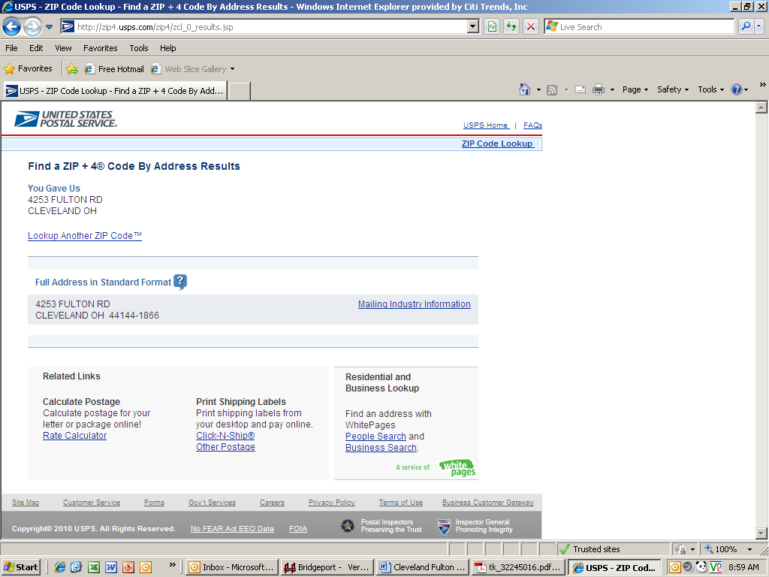
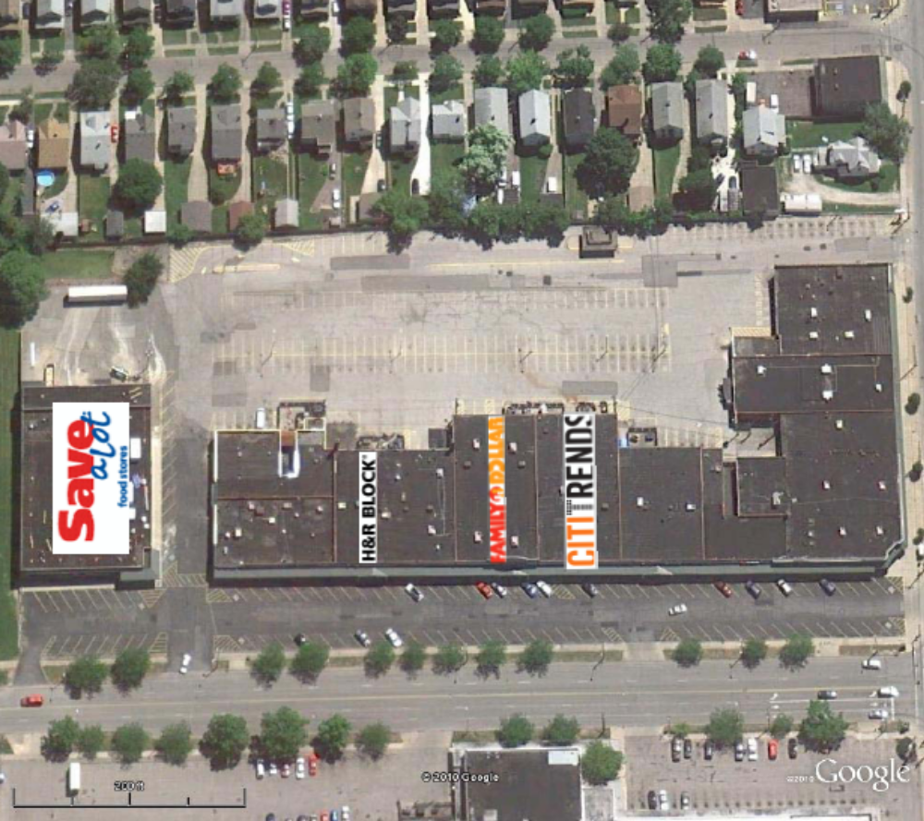

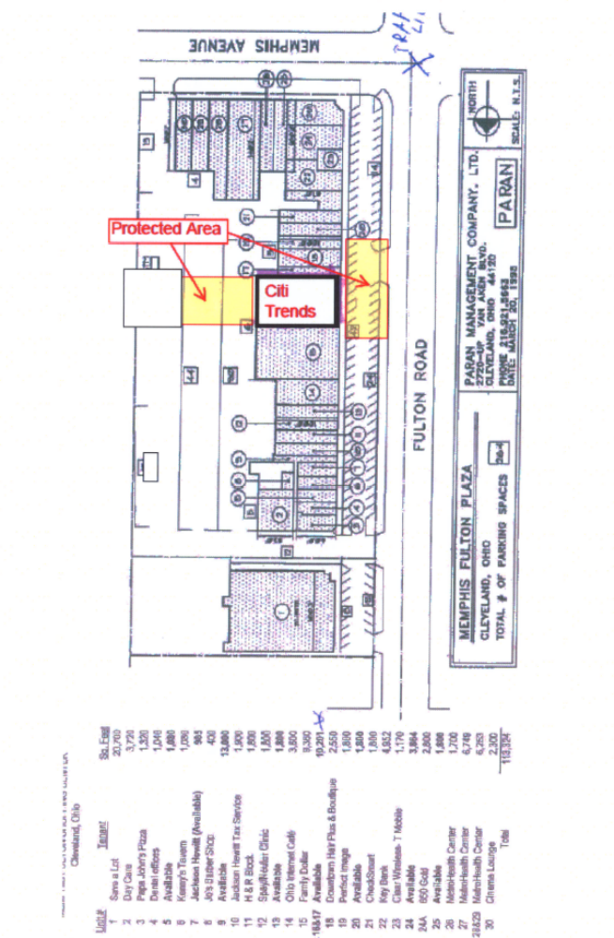
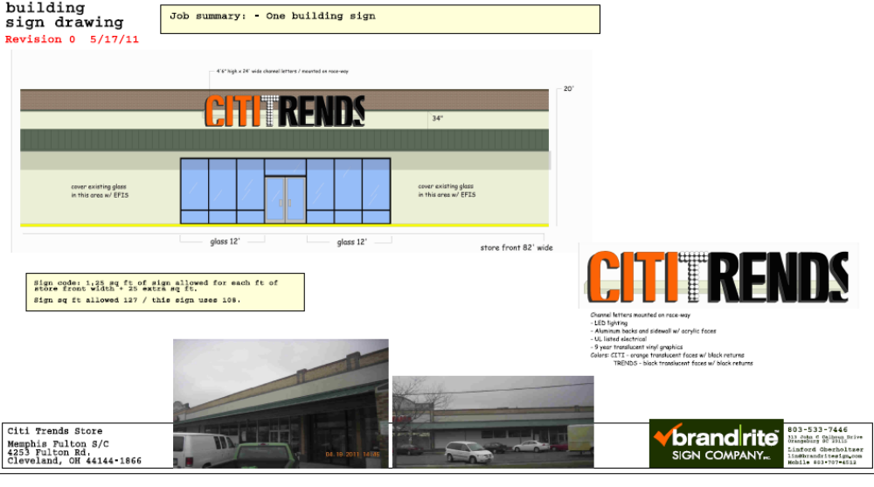

Exhibit C-1

Sign Criteria

All signs must be approved by appropriate local authorities and by Landlord before manufacture and installation. Tenant will be fully-responsible for compliance with sign requirements.
Tenant at its sole cost and expense shall be required to install its sign as designated by Landlord.

1. Tenant's sign shall be constructed and installed in accordance with the following:

- Style and Construction: Landlord shall notify Tenant in writing of design approval or of modifications necessary to obtain approval.

B. Tenant must notify Landlord prior to having done any work that would require access to the roof.

C. The wording of the sign shall be limited to the Tenant's advertised name as set forth in the lease. Use of a corporate shield, crest, logo or insignia will be permitted but will be subject to Landlord's prior written approval.

- Designs.

A. The overall length of the sign shall be neither larger than 75%, nor smaller than 50%, of the store’s frontage.

- Storefront sign shall be consistent with other storefront signs within the shopping center.

- Sign letters shall be mounted on exterior raceway, said raceway to match, as closely as possible, the color of the fascia.

- Tenant's sign contractor shall secure the necessary permits prior to connecting sign to wiring
provided at store front. All electrical work relating to signage shall be UL approved.

E. No exposed conduit or junction boxes on the face of the building will be permitted.

3. Prohibitions. Without the prior written consent of the Landlord, the following are prohibited types of signs or sign components:

A. Moving, free standing, rotating, roof-top, back illuminated signs, or signs employing noise-making devices and components, moving or flashing lights, exposed raceways, transformers, painted and/or non-illuminated letters, luminous vacuum-form-type plastic letters, unedged or uncapped plastic letters or letters with no returns and/or exposed fastenings.

B. Banners; sandwich boards; cloth, wood, paper or cardboard signs; letters, symbols, decals or painted signs or identification of any nature, around, on, or under exterior surfaces, (excluding interior and exterior surfaces of all doors and/or windows) of the Premises. No handwritten paper signs are permitted.

4. Rear Door. Tenant shall have identification on at least one rear door.

5. Miscellaneous.

- Tenant is responsible for damages to the building as result of fire caused by sign-related
secondary wiring or neon within a sign.

- Upon lease expiration, Tenant shall be responsible for the removal of its sign and for the repair of any holes or other damage caused to building or canopy by its sign.

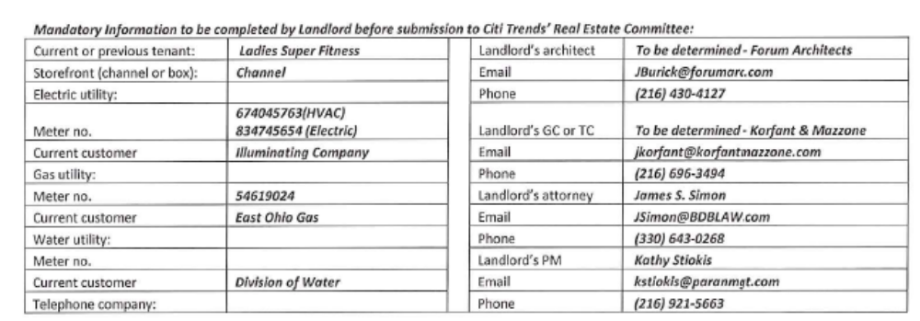

1.2 Premises – The parties acknowledge that the Premises consist of approximately the square footage set forth in the Reference Provisions of Section 1.1. Within sixty (60) days after the Delivery Date (the “Applicable Period”), either party shall have the opportunity to measure the dimensions of the Premises for a determination of its exact square footage and provide the other party with written notice of its findings. If either party shall contest the square footage of the Premises within the Applicable Period, then the other party shall have fifteen (15) days after receiving written notice of such contest to make its own measurement. The parties shall thereafter use their best efforts to agree on the appropriate square footage. If neither party contests the square footage of the Premises within the Applicable Period, then the parties waive any right to contest such square footage amount in the future. When an agreement between Landlord and Tenant is reached, all monetary calculations in this Lease which rely upon the area shall be recalculated and adjusted retroactive to the Rent Commencement Date (but in no event shall such recalculation result in Tenant paying Rent on any square footage above the square footage set forth in Section 1.1(a) above).

1.3 Commencement Date – The Commencement Date shall be the earlier of (a) Tenant opening for business, (provided that all of the delivery requirements (1)-(10), below (the “Delivery Requirements”), are satisfied), or (b) one hundred eighty (180) days from the date the last of the Delivery Requirements is satisfied (“Delivery Date”):

- Receipt by Tenant of Delivery Notice (defined below) and delivery by Landlord of possession of the Premises with Landlord’s Work complete in accordance with Exhibit B and Exhibit B-1 (Landlord-approved Tenant’s Plans) and the Tenant-approved plans;

- Tenant’s receipt from Landlord of an inspection report from RSM Maintenance (or other inspection company approved by Landlord and Tenant’s Director of Construction) indicating that the roof is “water-tight” and has an expected remaining life of at least 5 years. The report must be dated no earlier than thirty (30) days prior to the Delivery Date. Repairs or replacement to achieve this requirement must be substantially completed prior to the Delivery Date;

- Tenant’s receipt from Landlord of inspection report from RSM Maintenance (or an independent HVAC inspection company approved by Tenant) indicating that the HVAC system is composed of a minimum of 29 tons, that the units are less than 7 years old and are in good working condition. The report must be dated within thirty (30) days of the Delivery Date. Repairs or replacement to achieve this requirement must be substantially completed prior to the Delivery Date;

- Landlord shall have provided utility services (electricity, gas, water and sewer) to the Premises at the capacities adequate for Tenant’s needs and the services are separately and individually metered or sub-metered. Tenant will contract directly for all utility services or transfer services to Tenant, but Landlord shall pay all tap fees and connection charges;

- Landlord shall have provided a report dated no earlier than six (6) months prior to the Delivery Date from an environmental consultant reasonably satisfactory to Tenant that certifies that there are no Hazardous Materials (as defined in Section 11.1 of this Lease) in the Premises or that the Hazardous Materials are satisfactorily encapsulated and non-friable;

- Landlord shall have repaired all parking field and delivery area lights and provided Tenant with a letter confirming that this work has been performed;

- Receipt by Tenant of Landlord’s approval of Tenant’s Plans which Tenant shall submit to Landlord within 30 days following execution of the Lease by Landlord and Tenant, and;

- Tenant obtaining construction permits (if necessary) for Tenant’s Work which Tenant agrees to submit within five (5) days following Landlord’s approval of Tenant’s plans.

3.2 Acceptance by Tenant – Acceptance of possession by Tenant of the Premises shall constitute acceptance of the Premises by Tenant, except for punch list items to Landlord’s Work, if any, any patent defects discovered within one (1) year after the Commencement Date, and any latent defects. This Section 3.2 shall not negate or limit any representations or warranties made by Landlord under this Lease nor constitute any agreement by Tenant that such representations and warranties have been satisfied.

7.2 Security Equipment – Tenant shall be allowed, at its sole cost and discretion, to install security equipment, including but not limited to, bars, gates, shutters or interior grills across, in front of, or on top of any glass area on the exterior walls of the Premises. The installation of security equipment shall be in compliance with the local building code for commercial buildings. At the expiration or earlier termination of the Lease, upon Landlord’s written request, Tenant shall remove any and all security equipment installed by Tenant at Tenant’s sole cost and expense.

14.17 Signs, Awnings, and Canopies – Landlord may erect and maintain such suitable signs as it, in its sole discretion, may deem appropriate to advertise the Shopping Center but not on the exterior of the Premises. Subject to Landlord approval, local ordinances and the Shopping Center Sign Criteria attached as Exhibit C-2, Tenant shall erect and maintain on the facade of the Premises one of Tenant’s standard signs with a letter height of approximately 24” (but not to exceed the maximum amount permitted under applicable law). Tenant shall also be permitted to install (a) an under-canopy or blade sign, at Tenant’s expense and/or (b) sign panels on both sides of a future pylon or monument structure, as provided below and to the extent permitted under applicable law. Tenant shall submit to Landlord detailed drawings of such sign for review and approval by Landlord which shall not be unreasonably withheld prior to erecting said sign on the Premises. Landlord hereby approves Tenant’s Sign Specifications attached hereto as Exhibit C. Tenant also shall have the right to display from time to time on the exterior of the Premises professionally-made advertising banners to the extent permitted under applicable law.

During the Term of this Lease, Tenant shall be entitled to display its trade name on both sides of a future Shopping Center pylon or monument (each a “Pylon”). Landlord shall maintain and repair such Pylon, Pylon sign cabinets and all associated electrical and lighting components at its cost and expense, and may replace such sign from time to time. Notwithstanding the foregoing, Tenant shall be permitted to install, without cost to or charge by Landlord, a sign panel on both sides of all future pylon and monument structures so long as such future pylon or monument sign is constructed for purpose of displaying multiple tenant names. Tenant shall be responsible for the fabrication and maintenance of Tenant’s sign panel on the Pylon. Tenant’s sign for the Pylon shall be prepared in accordance with all applicable legal requirements and approved by Landlord, such approval not to be unreasonably withheld.

Changes to Tenant’s signs shall be subject to Landlord’s consent, not to be unreasonably withheld. If Landlord does not respond in writing within ten (10) business days after receipt of Tenant’s written request for consent, then such consent shall be deemed given.

15.5 Construction Allowance – Landlord shall pay to Tenant the sum of Two Hundred Fifty-Nine Thousand Five Hundred and 00/100 Dollars ($259,500.00) (the “Construction Allowance”) as and for a contribution toward the cost to Tenant for performing Tenant’s Work in the Premises, within thirty (30) days after (a) Tenant’s opening for business and (b) Tenant providing Landlord with (1) lien waivers by each of Tenant’s contractors or subcontractors providing work or services in excess of $10,000.00; (2) Final certificate of Occupancy or the equivalent, for the Premises, (3) Estoppel certificate that the lease is in full force and effect and (4) completed W-9 form. Landlord shall pay the Construction Allowance to Tenant as a Rent credit, to be credited against Tenant’s Minimum Annual Rent in sixty (60) equal monthly installments of Four Thousand Three Hundred and 00/100 Dollars ($4,325.00) each. In the event this Lease is terminated during the Initial Term, other than in the event of Tenant’s default or exercise of its rights under Section 15.4, Landlord shall pay Tenant a fee computed by multiplying $259,500 by a fraction, the numerator of which is the number of months remaining in the Initial Term and the denominator of which is 60.

Exhibit B

Landlord shall deliver the Premises with a structurally sound floor and subfloor. However, Landlord shall not be responsible for the condition of any existing floor covering, including tile and or carpeting.

