To: jwithrow@cititrends.com; shildebrand@cititrends.com; mgabriel@cititrends.com; mreames@cititrends.com; jdunn@cititrends.com; icouncil@cititrends.com; sclifford@cititrends.com; bgraves@cititrends.com; acook@cititrends.com; pabraham@cititrends.com; abeisel@cititrends.com; gwilder@cititrends.com; ccheeseman@cititrends.com; jhughley@cititrends.com; dchisholm@cititrends.com; bharris@cititrends.com; vowens@cititrends.com; jcollins@cititrends.com; mboyette@cititrends.com; akoonce@cititrends.com; dcook@cititrends.com; pwright@cititrends.com; bgreen@cititrends.com; spoole@cititrends.com; adrinkman@cititrends.com; shorowitz@cititrends.com; mphillips@cititrends.com; bfeher@cititrends.com; rarnone@cititrends.com; dalexander@cititrends.com; jnapoli@cititrends.com; gdurkin@cititrends.com; scabeza@cititrends.com; sholland@cititrends.com; mbuchsbaum@cititrends.com; kgroneck@cititrends.com; apulsney@cititrends.com; vdavis@cititrends.com; rrhodes@cititrends.com; gbaker@cititrends.com

Fully executed Lease dated: May 18, 2011
Date Received: May 24, 2011

Season: BTS 2011

Name of Shopping Center: Nacogdoches Mall

STORE #: 0527

Premises Address: 1122 N University Dr., Nacogdoches, TX 75961
(subject to change)

County: Nacogdoches

Landlord Contact: Jeff Hurst
ORDA Corporation
15400 Knoll Trail, Suite 350, Dallas, TX 75248
(Ph): 972.960.2003 (Fax): 972.960.0627 (Email): ordacorp_jeff@yahoo.com

Utilities:
Electric: TXU Meter #: 93 871 925
Water: Nacogdoches Public Works Meter#: 010671454
Gas: n/a

Former Occupant: Sebastians
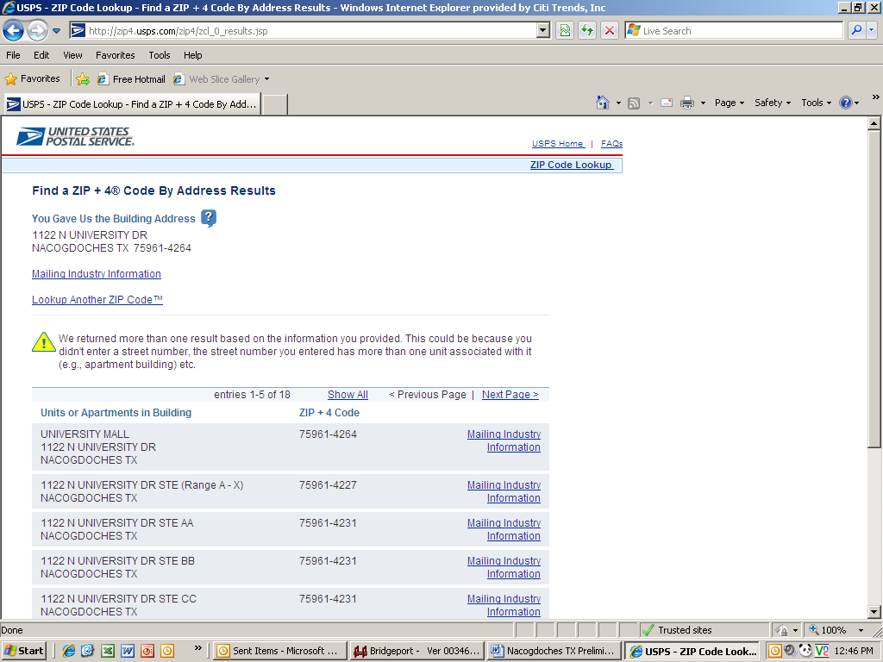
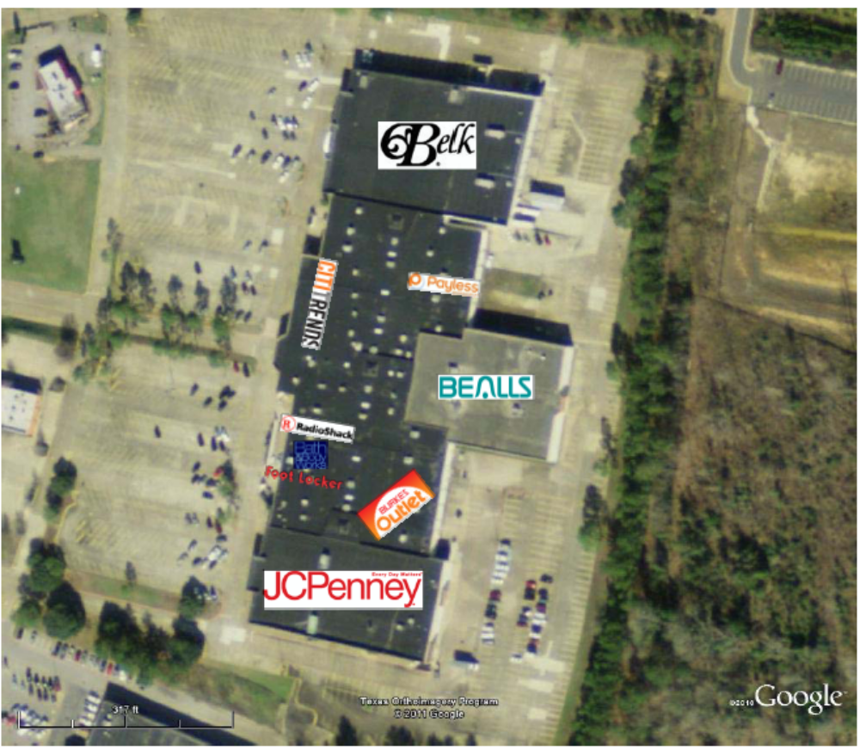

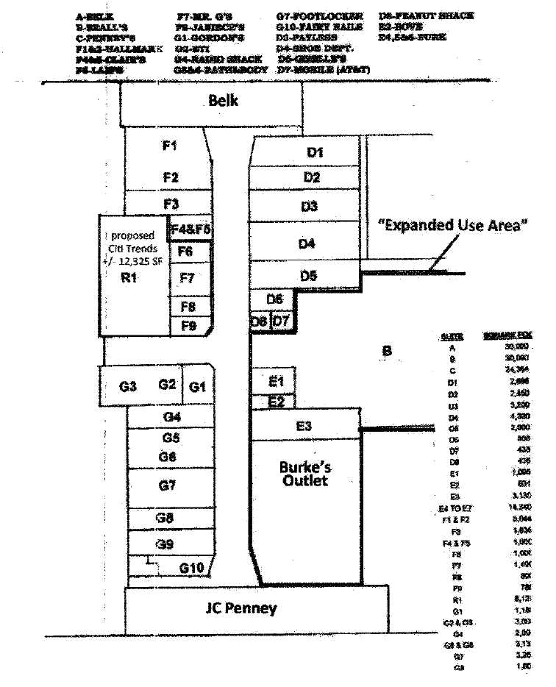

Protected Area

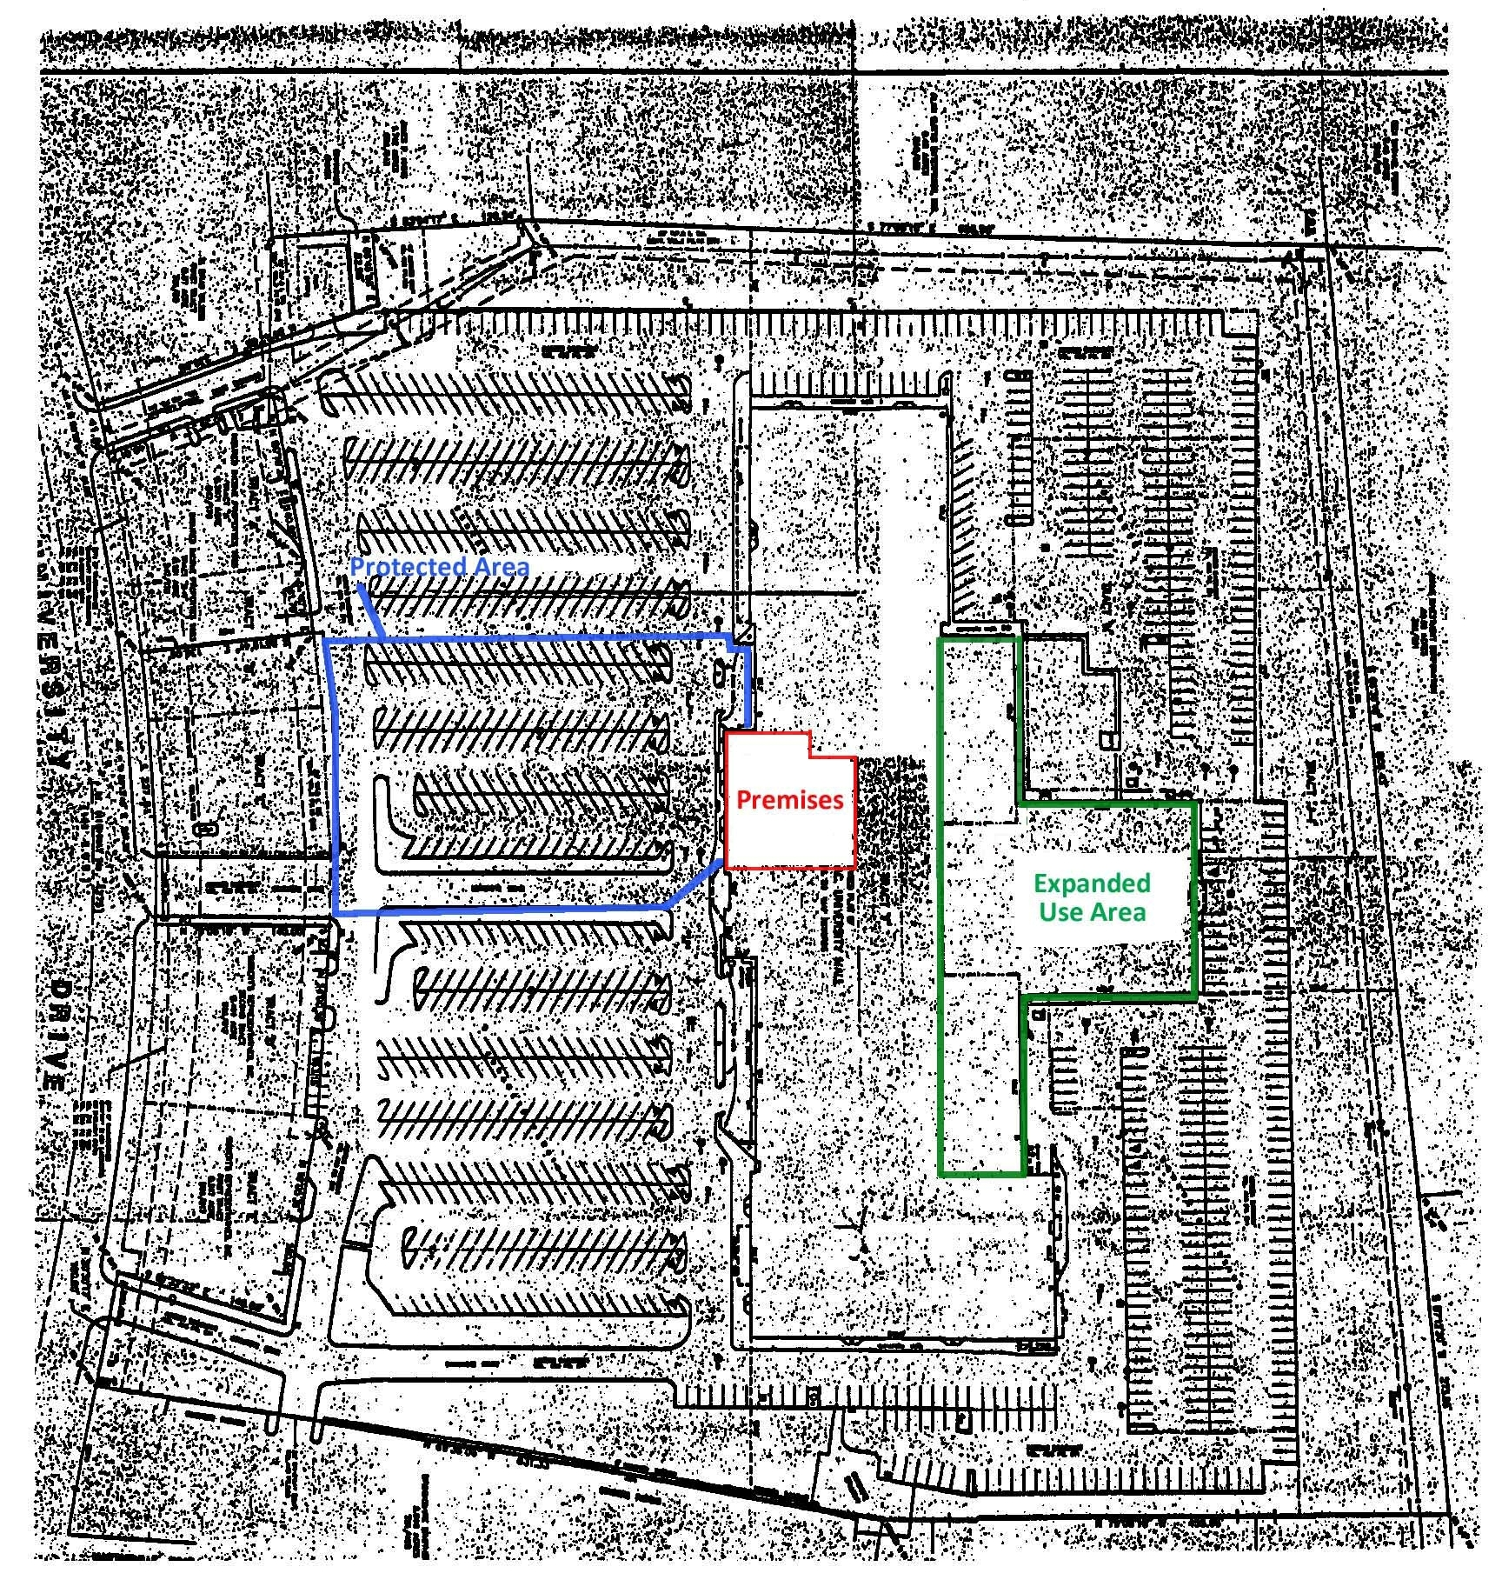
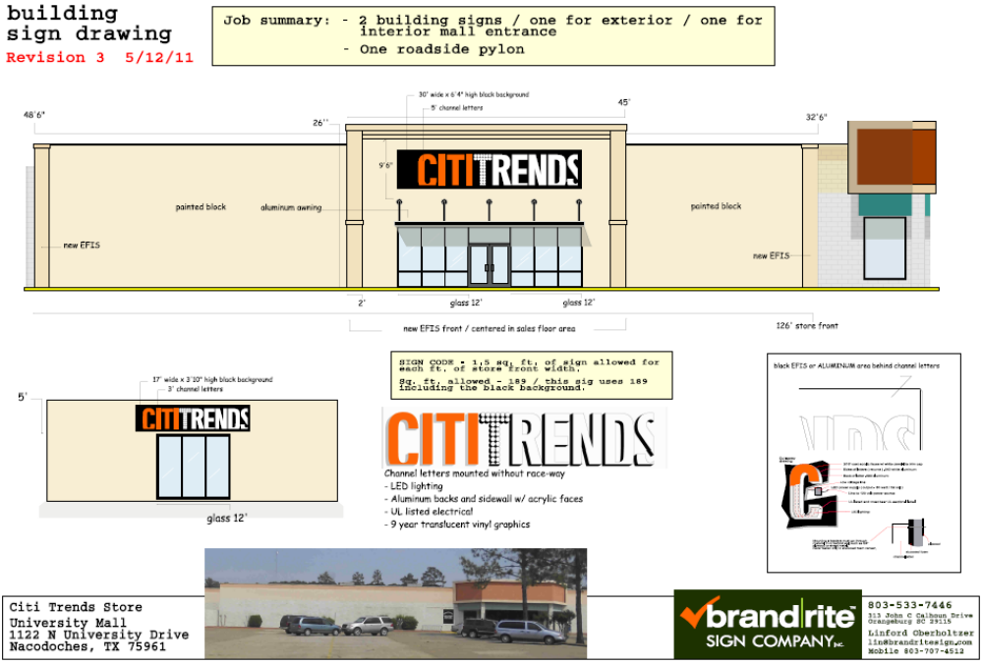
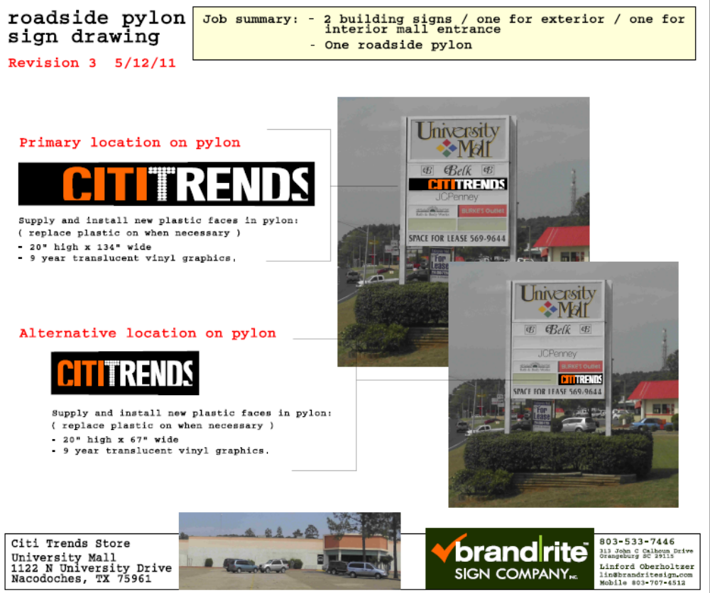

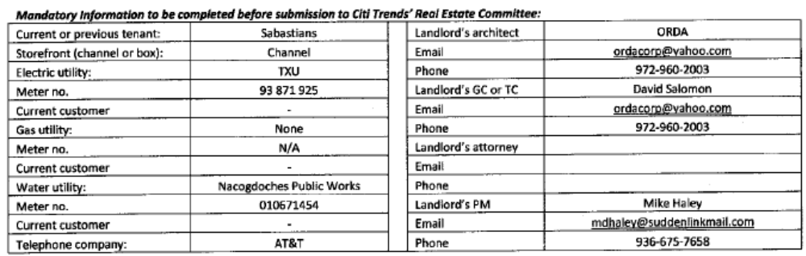

1.2 Premises – The parties acknowledge that the Premises consist of approximately the square footage set forth in the Reference Provisions of Section 1.1. Within sixty (60) days after the Delivery Date (the “Applicable Period”), either party shall have the opportunity to measure the dimensions of the Premises for a determination of its exact square footage and provide the other party with written notice of its findings. If either party shall contest the square footage of the Premises within the Applicable Period, then the other party shall have fifteen (15) days after receiving written notice of such contest to make its own measurement. The parties shall thereafter use their best efforts to agree on the appropriate square footage. If neither party contests the square footage of the Premises within the Applicable Period, then the parties waive any right to contest such square footage amount in the future. When an agreement between Landlord and Tenant is reached, all monetary calculations in this Lease which rely upon the area shall be recalculated and adjusted retroactive to the Rent Commencement Date (but in no event shall such recalculation result in Tenant paying Rent on any square footage above the square footage set forth in Section 1.1(a) above).

1.3 Commencement Date – The Commencement Date shall be one hundred twenty (120) days from the date the last of the Delivery Requirements is satisfied (“Delivery Date”):

- Landlord shall have provided Tenant with written notice of delivery of possession of the Premises; and Landlord shall have delivered sole and exclusive possession of the Premises with Landlord’s Work complete in accordance with Exhibit B and Exhibit B-1 (Landlord-approved Tenant’s Plans) and the Tenant-approved plans;

- Tenant’s receipt from Landlord of an inspection report from RSM Maintenance (or other inspection company approved by Tenant’s Director of Construction) indicating that the roof is “water-tight” and has an expected remaining life of at least 5 years. The report must be dated no earlier than thirty (30) days prior to the Delivery Date. Repairs or replacement to achieve this requirement must be completed prior to the Delivery Date;

- Landlord shall have provided utility services (electricity, gas, water and sewer) to the Premises at the capacities adequate for Tenant’s needs and the services are separately and individually metered or sub-metered. Tenant will contract directly for all utility services or transfer services to Tenant, but Landlord shall pay all tap fees and connection charges;

- Landlord shall have provided a report dated no earlier than six (6) months prior to the Delivery Date from an environmental consultant satisfactory to Tenant that certifies that there are no Hazardous Materials (as defined in Section 11.1 of this Lease) in the Premises or that the Hazardous Materials are satisfactorily encapsulated and non-friable; and
- Landlord shall have repaired all parking field and delivery area lights and provided Tenant with a letter confirming that this work has been performed.

3.2 Acceptance by Tenant – Acceptance of possession by Tenant of the Premises shall constitute acceptance of the Premises by Tenant, except for punch list items to Landlord’s Work, if any, any patent defects discovered within one (1) year after the Commencement Date, and any latent defects. This Section 3.2 shall not negate or limit any representations or warranties made by Landlord under this Lease nor constitute any agreement by Tenant that such representations and warranties have been satisfied.

7.2 Security Equipment – Tenant shall be allowed, at its sole cost and discretion, to install security equipment, including but not limited to, bars, gates, shutters or interior grills across, in front of, or on top of any glass area on the exterior walls of the Premises. In addition, Tenant shall also be allowed, at its sole cost and expense, to install concrete bollards in the Common Area in front of the Premises. The installation of security equipment shall be in compliance with the local building code for commercial buildings. At the expiration or earlier termination of the Lease, upon Landlord’s written request, Tenant shall remove any and all security equipment installed by Tenant at Tenant’s sole cost and expense.

14.17 Signs, Awnings, and Canopies – Landlord may erect and maintain such suitable signs as it, in its sole discretion, may deem appropriate to advertise the Shopping Center but not on the exterior of the Premises. Tenant shall erect and maintain on the facade of the Premises one of Tenant’s standard signs at least 72” in height (but not to exceed the maximum amount permitted under applicable law). Landlord at its own expense will construct a raised marquee (mansard or parapet or tower) on the storefront to accommodate Tenant’s signage. No tenant shall have a sign or sign letters larger than Tenant’s unless such tenant’s premises contains more floor area than the Premises contains. Tenant shall also be permitted to install (a) an under-canopy or blade sign, at Tenant’s expense and/or (b) sign panels on both sides of all existing and future pylon and monument structures, as provided below. Tenant shall submit to Landlord detailed drawings of such sign for review and approval by Landlord which shall not be unreasonably withheld prior to erecting said sign on the Premises. Landlord hereby approves Tenant’s Sign Specifications attached hereto as Exhibit C. Tenant also shall have the right to display from time to time on the exterior of the Premises professionally-made advertising banners in good condition without visible signs of wear and tear.

During the Term of this Lease, Tenant shall be entitled to display its trade name on both sides of all existing Shopping Center pylon and monument signs as shown on Exhibit C-1 attached hereto and in prominent positions on both sides of all future Shopping Center pylon and monument signs (each a “Pylon”). However, if Landlord leases the space in the Shopping Center formerly occupied by Beall’s (designated in Exhibit A as “B”) to a tenant occupying at least 30,000 square feet (excluding a flea market or office), then Tenant’s panel on the Pylon shall be replaced by such tenant’s trade name and Tenant shall have the right to display its trade name in the position shown on Exhibit C-1 as “Alternate Position”. Landlord shall maintain and repair such Pylon, Pylon sign cabinets and all associated electrical and lighting components at its cost and expense, and may replace such sign from time to time provided that any new sign shall not be substantially smaller than the original dimensions of the Pylon and Tenant’s position on the new Pylon shall be substantially the same. Tenant shall be responsible for the fabrication and maintenance of Tenant’s sign panel on the Pylon. Tenant’s sign for the Pylon shall be prepared in accordance with all applicable legal requirements.

Changes to Tenant’s signs shall be subject to Landlord’s consent, not to be unreasonably withheld. If Landlord does not respond in writing within ten (10) business days after receipt of Tenant’s written request for consent, then such consent shall be deemed given

15.5 Construction Allowance – Landlord shall pay to Tenant the sum of Thirty-One Thousand and 00/100 Dollars ($31,000.00) as and for a construction allowance and contribution toward the cost to Tenant for performing Tenant’s Work in the Premises (“Construction Allowance”), within thirty (30) days after Tenant has provided Landlord (a) lien waivers by each of Tenant’s contractors or subcontractors providing work or services in excess of $10,000.00; (b) a final certificate of occupancy or jurisdictional equivalent, if any, for the Premises; (c) estoppel certificate that the Lease is in full force and effect; (d) completed W-9 form; and (e) written request for reimbursement of the Construction Allowance. In the event Landlord fails to make timely payment of such amount, then in addition to all other remedies which Tenant may have, Tenant shall thereafter be entitled to offset the unpaid amount, plus interest thereon at ten percent (10%) per annum, against all Minimum Annual Rent, Percentage Rent, and any other amounts due, until recovered in full.

Exhibit B

Description of Landlord’s Work
(“Citi Lights” vanilla box)

Landlord shall deliver the Premises in broom–sweep condition. In addition, Landlord shall deliver the Premises free of all hazardous materials, including all asbestos-containing materials (“ACM”).

FLOORS
Floors in the sales area and storage area shall be level, on an even grade and free of; (a) any type of existing floor covering (carpet, vinyl, ceramic, quarry, tile, etc.), (b) floor drains, and, (c) adhesive. All holes, cracks or imperfections in the floor surface shall be filled with Sikafloor 104 Epoxy Patching Mortar. Sales area shall be ready for new carpet installation.
Bathroom floor covering shall be (subject to local building code) either Mannington Essentials vinyl composite tile (12”x12”) 122 Glacier and VPI 4” vinyl cove base or London Fog 05 Dal Tile ceramic tile (12”x12”) with matching Brino (TN98) bullnose (4”x12”) ceramic tile and all work shall be free of any obstructions, bumps, etc., and be in broom-sweep clean condition. Ceramic tile installations shall utilize Laticrete SpectraLOCK Pro Grout (Color #38 River Rock).

WALLS & FINISHES
All walls in the sales and storage areas shall be plumb straight, properly braced, minimum 20 gauge 3 5/8” metal studs at a maximum spacing of 16” on center finished with 5/8” gypsum sheetrock and be on an even plane, mudded, taped and sanded smooth with a Level 4 finish. All partitions shall receive one (1) coat of Sherwin Williams primer and painted with two (2) finish coats of Sherwin Williams Paint as follows;

- Front wall SW 6258 Tricorn Black
- Back wall, SW 6902 Decisive Yellow
- Side walls, SW 7016 Mindful Grey to 8’-0” AFF
- Side walls, SW 6902 Decisive Yellow 8’-0” AFF to 13’-6” AFF
- Stockroom and Restrooms shall be painted SW7006 Extra White, Egg Shell from finished floor to 13’-6” AFF.

If any walls in the sales area are of masonry construction, such walls shall be furred with 7/8” 20 gauge DWC metal hat furring with 5/8” gypsum sheetrock. Walls in previously occupied spaces shall be free of all fixtures.

If any walls in the stockroom area are of masonry construction, such walls shall be furred with 7/8” 20 gauge DWC metal hat furring with 5/8” gypsum sheetrock. Walls in previously occupied spaces shall be free of all fixtures.

All walls in the restroom areas shall be plumb straight, properly braced, minimum 20 gauge 3 5/8” metal studs at a maximum spacing of 16” on center, finished with 5/8” gypsum sheetrock, on an even plane, mudded, taped and sanded smooth with a Level 4 finish. If any walls in the restroom area are of masonry construction, such walls shall be furred with 7/8” 20 gauge DWC metal hat furring with 5/8” gypsum sheetrock on an even plane, mudded, taped and sanded smooth with a Level 4 finish. Restroom walls in spaces previously occupied shall be free of all fixtures.

Landlord shall install a rated partition between the sales area and the storage area at a location specified in Tenant’s plans and finished using construction and materials as specified above. Such partition wall shall include a 3-0” x 6’-8” solid core wood door on a knockdown metal frame with locking lever type hardware in the location specified in Tenant’s Plans.

Demising walls shall be a minimum of 20 gauge 6” metal studs at 16” on center with ⁵/₈” gypsum board on both sides (U.L. U465) with R-19 fiberglass sound batt insulation and 18 gauge 1 1/2” x 1 1/2” welded wire mesh to 6” above the finished ceiling. Demising walls in the Premises shall be finished using construction and materials as specified above. 1/2” CDX plywood and 1/2” gypsum sheetrock drywall covering from finished floor to 13’-6” AFF must be applied on tenant side of demising partition. Demising walls shall be mudded, taped and sanded smooth Level 4 finish.

CEILINGS
Two level 2’-0” x 4’-0” suspended grid with lay-in acoustical tile. Suspension systems shall be evenly spaced and centered in the sales area of the Premises. Acoustical ceiling tiles shall be clean, flat and free of any defects. Ceiling tiles and suspension systems shall be of uniform patterns and white in color. All lay-in light fixtures shall be fastened to the ceiling grid and independently supported at each corner or as required by the local building code. Ceilings shall be free of electrical outlets and lighting systems except those shown on Tenant’s plans. Ceilings shall bear no less than one layer of R-19 fiberglass insulation.

Upper Grid Assembly at 13’-6” AFF shall be USG Grid (2’-0”x4’-0”) Donn DX/DXL with a minimum of 12 gauge steel wire spaced at a maximum of 4’-0” on center fastened to the structure above or as required by the local building code. Grid shall be continuous from the storefront to the partition wall and from demising wall to demising wall. Grid and acoustical ceiling tile shall be black in color. (No acoustical ceiling tiles shall be installed when underside of roof deck is below 16’-0” AFF. Underside of roof deck structure, HVAC components, electrical components, ceiling grid components and miscellaneous construction materials shall be painted Benjamin Moore Black (INT. RM/EXT. RM) in store where above referenced acoustical tiles are installed. )

Lower Grid Assembly at 11’-6” AFF shall be USG Grid (2’-0”x4’-0”) Donn DX/DXL with a minimum of 12 gauge steel wire spaced at a maximum of 4’-0” on center fastened to the structure above or as required by the local building code. Grid shall be white in color. Acoustical ceiling tile (USG Radar ClimaPlus) shall be white in color and shall employ a finished USG finished edge trim Compasso (2 ¼” x 9/16”) white.

Storage Room Assembly at 11’-6” AFF shall be USG Grid (2’-0”x4’-0”) Donn DX/DXL with a minimum of 12 gauge steel wire spaced at a maximum of 4’-0” on center fastened to the structure above or as required by the local building code. Grid shall be white in color. Acoustical ceiling tile (USG Radar ClimaPlus) shall be white in color

STOREFRONTS
Frontage of the Premises shall be no less than 40% glass from side to side. The height of such glass shall span from 10’-0” AFF to interior finished floor level. If sill walls exist under the storefront glass they shall be no higher than 30” above the interior finished floor level. All glass and framework shall be clean and free of damage and signage at the time of possession. Glass exposed to the exterior of the Premises shall be impact resistant.

Storefront system and entry doors shall be centered on the Tenant’s space (Premises). A pair of 3’-0”x7’-0” storefront doors shall be centered on the storefront system. A continuous uninterrupted 12’-0” wide storefront system comprised of three (3) equal 4’-0” sections shall be installed adjacent to each side of the storefront doors. Complete storefront system shall be black in color and extend from the interior finished floor to 10’-0” AFF. Doors in the storefront system shall be of glass and aluminum construction, in good working condition, sealed weather-tight upon release and have all locking systems in working order.

Fascia shall contain sufficient flat area to support signage requirements of Tenant. Fascia shall be free of any previous signage, free of any indication of previous signage and be newly painted. Should any type of canopy be attached to, or part of, the exterior of the Premises, then the same shall be in good, clean condition and leak free. Any lighting contained in such canopy shall be in good working condition and maintained by Landlord throughout the Lease Term.

REAR SERVICE DOOR
Landlord shall install a solid steel door, minimum of 3’-0” x 6’-8” x 1 ¾”. Door jamb and head shall also be of steel construction grout filled and set in concrete within a concrete block wall. Door shall open and close without resistance, and be air and water tight upon closure. Door shall have locking lever type hardware in good working condition. Door and hardware shall be single action, opening out, and contain one (1) optical thru-door viewer centered on the width of the door at 5’-4” above interior finished floor.

HVAC SYSTEM
Complete heating and air conditioning system in good working order and condition for the entire Premises (sales area, storage area and bathroom area). The system shall be comprised of one (1) ton per 350 square feet of floor area and shall include one (1) working thermostat (locations to be determined by Tenant) per unit. Diffusers, ducts and other components of the HVAC system located within, at or above the Upper Grid assembly shall be painted black. All units must have been in service for 10 years or less.

LIGHTING
One (1) Lithonia 2’ x 4’ lay-in fixture (GT8 2’x4’ 4-lamp acrylic lens) general purpose troffer with GE T-8 (32W) Cool White bulbs (Electronic ballast and #741 bulbs approved by Tenant) for every 60 square feet of sales area in the upper black grid and Twilite OD Series in the lower white grid over the merchandise area. Provide one (1) general purpose fixture for every 100 square feet of storage area. Provide Philips Bodine fluorescent emergency ballast as required by building code for emergency lighting. Each lay-In fixture shall contain working ballast(s) and circuits sufficient for proper operation. Sales floor lighting shall be controlled by an astronomical time-clock mounted adjacent to the electrical panels with a bypass timer at the cash wrap.

Upper Grid Assembly acrylic lens frames shall be painted Benjamin Moore black (INT. RM/EXT. RM).

Lower Grid Assembly acrylic lens frames shall be white.

Perimeter wall washers shall be installed on a continuous black track light system located 4’-6” perpendicular to the perimeter partitions at 8’-0” O.C. as shown on Tenant’s plans. Wall washers shall be ET-PL-24-2X408X (black) from Elite Lighting.

Segmented track shall be installed at the cash wrap, look-out and dressing rooms, as shown on Tenant’s plans. Black ET292 light heads by Elite Lighting shall be installed on track. A total of thirty-five (35) head units and lamps shall be provided (50W PAR20).

2-light vanity fixture shall be installed above the lavatory in the restroom. #1087MN-132 by Capital Lighting. 2-100W-M. Matte Nickel finish.

(10) Ten eight Elite clear cube pendants Cat. # 918-CLEAR 2.75" x 2.75" x 67" Overall Height with 120V 35W maximum JCD G8 bi-pin bulb shall be installed above Cash Wrap.

ELECTRICAL
Landlord shall provide electrical service to the Premises through a 400-amp/3phase, 120/208 volt individual meter can and per the itemized requirements set forth in Tenant’s prototype electrical plan. Landlord shall provide electrical distribution to the Premises through a 400-amp/3phase, 120/208 volt power panel with a minimum of 30 breakers. Each breaker switch in the electrical panel shall be accurately labeled. The electrical panel shall be located in the storage area in the Premises.

One (1) convenience duplex receptacle shall be provided at each interior column or at a minimum one (1) receptacle per twenty (20’-0”) linear feet along the perimeter partitions on the sale floor. Additionally, the sidewalls that are a part of the storefront shall contain standard duplex outlets in accordance with local building code. A separate circuit and an astronomical time-clock shall be provided for lighting of the storefront signage.

FIRE ALARM & FIRE SPRINKLER
Landlord shall provide a code compliant fire alarm and fire sprinkler system per the local building codes.

BATHROOMS
A minimum of one (1) single men’s and one (1) single women’s toilet room meeting ADA requirements, with sufficient lighting, including water closet, lavatory, mirror over lavatory, toilet paper holder and one (1) TFV50 60 CFM bathroom exhaust fan by Craftmade International shall be provided. Fixtures shall be clean, leak free and in good working order. Landlord shall supply the number and type of bathroom facilities and fixtures required by local building code. All drainage lines from the bathroom fixtures to the sewerage system shall contain no leaks (above or below ground) and shall be free flowing.

Landlord shall supply and install, in a drip pan made for such purpose, a 6-gallon energy efficient water heater, or an “on demand” in line water heater, type and location in accordance with local building code.

RAISED PARAPET
Minimum 30’-0” wide and 25’-0” high for signage as shown in Exhibit C.

SECURITY
Landlord shall install security equipment, including, but not limited to, bars, gates, shutters or interior grills across, in front of, or on top of any glass area on the exterior walls of the Premises. In addition, Landlord shall also install 4’-0” high, 6” diameter concrete filled steel bollards, at 4’-0” O.C. intervals, in the Common Area immediately in front of the Premises.

KEYS
Keys to all exterior doors shall be provided to Tenant on or prior to the date of possession (as set forth in writing and confirmed by Tenant). Tenant will not be in possession of the Premises until working keys are provided by Landlord for the Premises.

CODES
Construction by Landlord and Landlord’s subcontractors shall comply with all existing municipal, state and Federal codes. Any special requirements imposed by governing bodies shall be the responsibility of Landlord during the Lease Term. Landlord shall have all construction inspected by authorities within whose jurisdiction the Premises is located. Tenant shall not be required to accept possession of the Premises until Landlord’s Work (for which a permit was issued) has been inspected and a written certification of acceptance by the appropriate authority has been given. Where applicable, Landlord shall procure a Certificate of Occupancy (C.O.) (or its equivalent) from the local building department and forward the same (or copy) to Tenant fourteen (14) days prior to Tenant’s opening date. Tenant shall notify Landlord of the opening date.

SYSTEMS TEST
Prior to Delivery of the Premises, Tenant will, at Tenant’s expense, test and inspect the following services and building systems:

- Plumbing.
- Electrical service and distribution.
- Lighting.
- HVAC.
- Fire alarm, automatic sprinkler, and other life safety systems.

Tenant will at the conclusion of the test, report to Landlord any service or system not working; insufficient; or, failing to meet or comply with building codes currently in effect in the area where the Premises is located. Landlord may, at its discretion, either repair or replace deficient systems or services, or authorize Tenant to complete the repairs or replacement and allow Tenant to recover such costs from Rents due. If Landlord repairs o replaces such deficient systems or services, the work will commence promptly upon execution of the Lease, and be pursued diligently and efficiently so as not to delay the opening date.

In the event, Landlord fails to deliver the Premises to Tenant on the Delivery Date in the condition set forth in this Exhibit B and otherwise as required under Section 1.3 of the Lease, then Tenant may complete such work as is necessary to meet such requirements, and Tenant shall have the right to withhold the cost of such work from Rent (including Minimum Annual Rent, Percentage Rent, CAM Costs, Real Estate Taxes, Insurance Costs and all other charges due under the Lease).

