To: jwithrow@cititrends.com; shildebrand@cititrends.com; mgabriel@cititrends.com; mreames@cititrends.com; jdunn@cititrends.com; icouncil@cititrends.com; sclifford@cititrends.com; bgraves@cititrends.com; acook@cititrends.com; pabraham@cititrends.com; abeisel@cititrends.com; gwilder@cititrends.com; ccheeseman@cititrends.com; jhughley@cititrends.com; dchisholm@cititrends.com; bharris@cititrends.com; vowens@cititrends.com; jcollins@cititrends.com; mboyette@cititrends.com; akoonce@cititrends.com; dcook@cititrends.com; pwright@cititrends.com; bgreen@cititrends.com; spoole@cititrends.com; adrinkman@cititrends.com; shorowitz@cititrends.com; mphillips@cititrends.com; bfeher@cititrends.com; rarnone@cititrends.com; dalexander@cititrends.com; scarter@cititrends.com; jnapoli@cititrends.com; gdurkin@cititrends.com; scabeza@cititrends.com; sholland@cititrends.com; mbuchsbaum@cititrends.com; kgroneck@cititrends.com; apulsney@cititrends.com; vdavis@cititrends.com;

Fully executed Lease dated: February 24, 2011
Date Received: March 21, 2011
Season: Fall 2011

Name of Shopping Center: Country Fair

STORE #: 0504

Premises Address: 4345 Tuscarawas St West, Canton, OH 44708-5461
(confirmed as a deliverable address at USPS.com)

County: Stark

Landlord Contact: Steven Eisenberg
Arnold J Eisenberg & Associates
24500 Chagrin Blvd, Suite 120
Beachwood, OH 44122
Ph: 216.831.6773 Email: seisenberg@aol.com

Utilities:
Electric: unknown
Water: unknown
Gas: unknown

Former Occupant: unknown
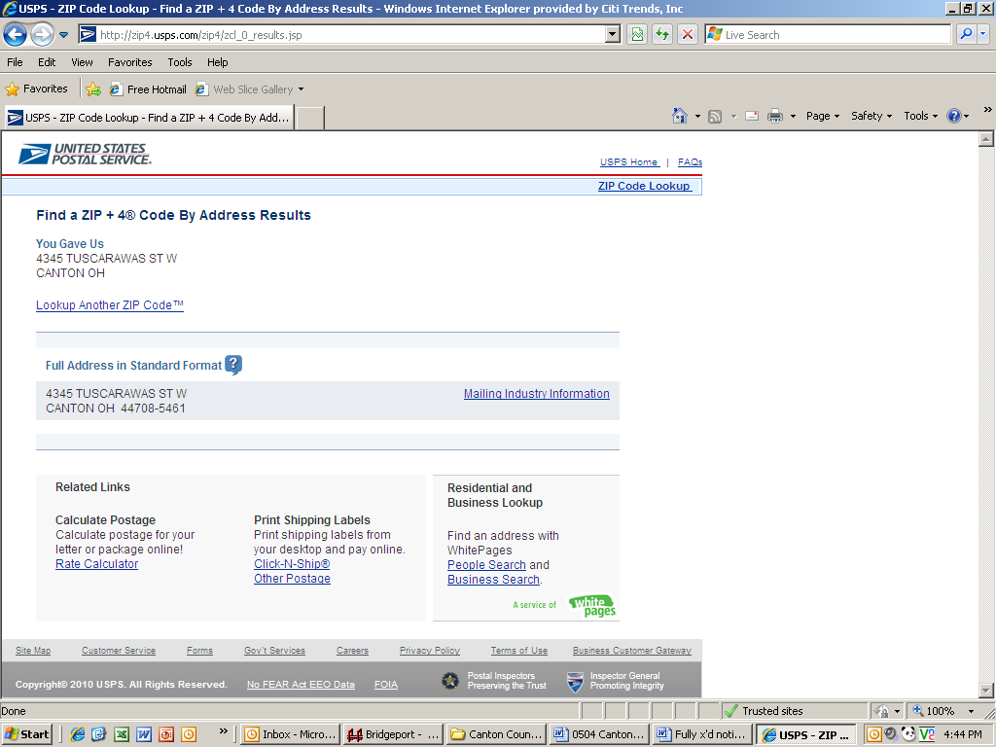
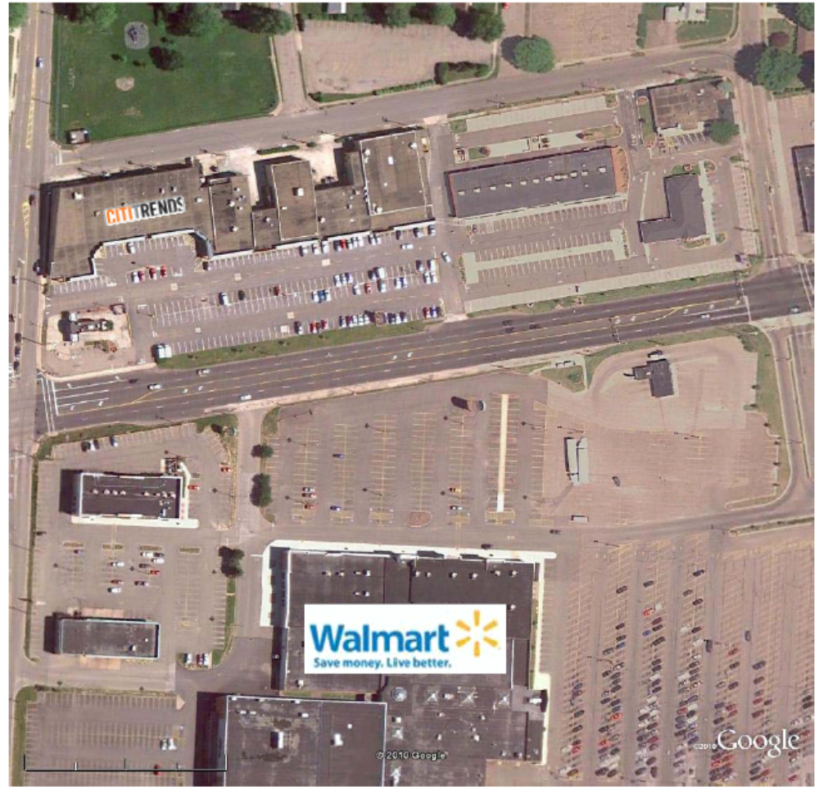

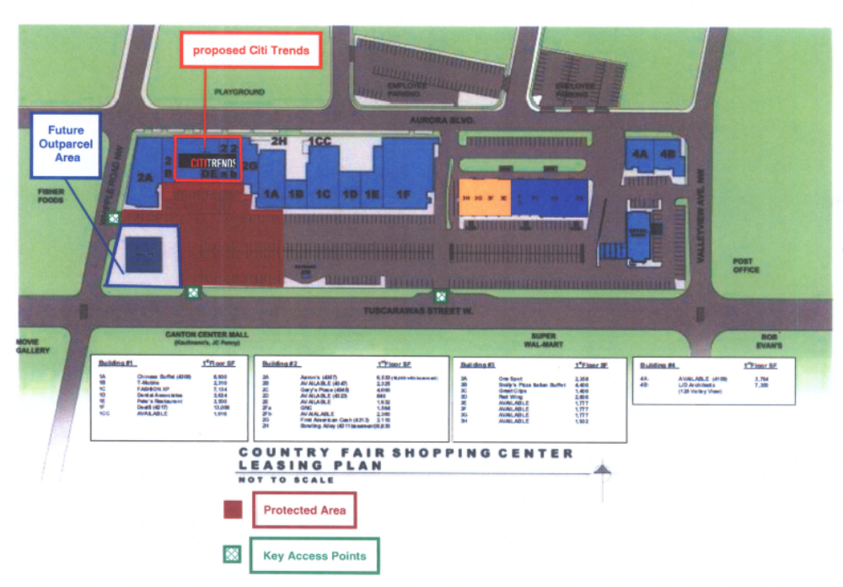

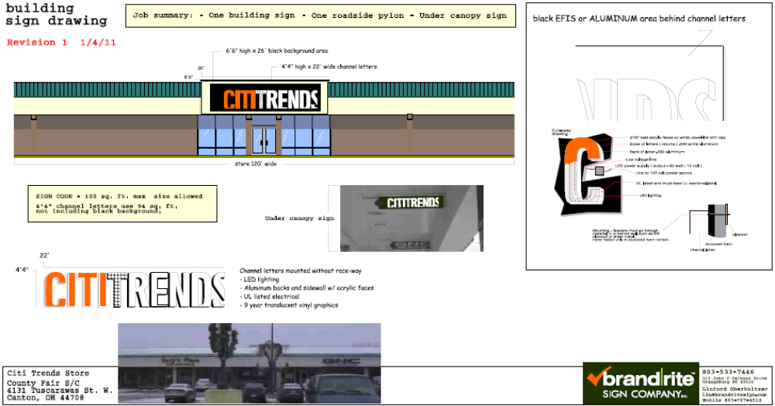

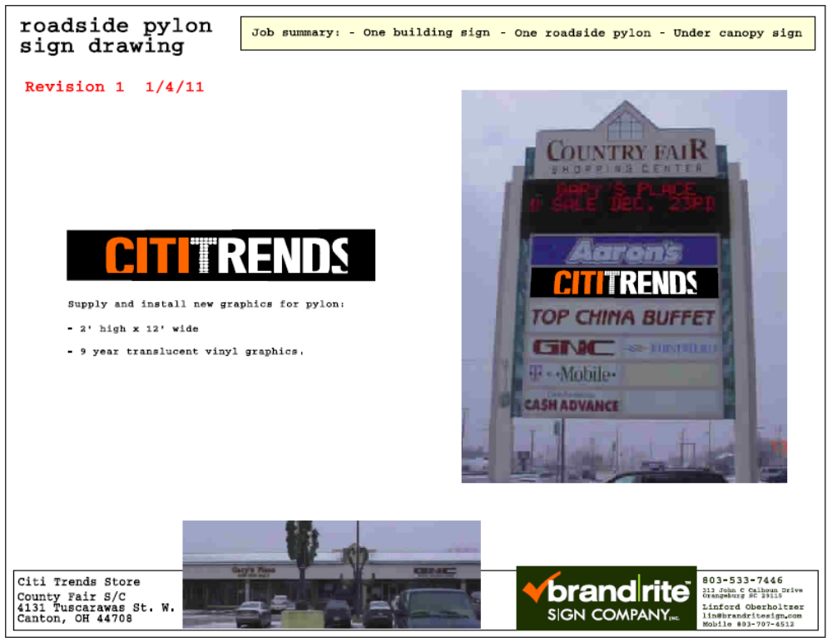

1.2 Premises – The parties acknowledge that the Premises consist of approximately the square footage set forth in the Reference Provisions of Section 1.1. Within sixty (60) days after the Delivery Date (the “Applicable Period”), either party shall have the opportunity to measure the dimensions of the Premises for a determination of its exact square footage and provide the other party with written notice of its findings. If either party shall contest the square footage of the Premises within the Applicable Period, then the other party shall have fifteen (15) days after receiving written notice of such contest to make its own measurement. The parties shall thereafter use their best efforts to agree on the appropriate square footage. If neither party contests the square footage of the Premises within the Applicable Period, then the parties waive any right to contest such square footage amount in the future. When an agreement between Landlord and Tenant is reached, all monetary calculations in this Lease which rely upon the area shall be recalculated and adjusted retroactive to the Rent Commencement Date (but in no event shall such recalculation result in Tenant paying Rent on any square footage above the square footage set forth in Section 1.1(a) above).

1.3 Commencement Date – The Commencement Date shall be one hundred eighty (180) days from the date the last of the delivery requirements (items (1)-(8), below) is satisfied (“Delivery Date”):

- Receipt by Tenant of written notice of possession of the Premises and possession of the Premises in accordance with this Lease;

- Tenant’s receipt from Landlord of an inspection report from RSM Maintenance (or other inspection company approved by Tenant’s Director of Construction) indicating that the roof is “water-tight” and has an expected remaining life of at least 5 years. The report must be dated no earlier than thirty (30) days prior to the Delivery Date. Repairs or replacement to achieve this requirement must be completed prior to the Delivery Date;

- Landlord shall have provided utility services (electricity, gas, water and sewer) at the capacities adequate for Tenant’s needs and the services are separately and individually metered or sub-metered; provided, however, Tenant acknowledges that upon the Delivery Date the Premises will consist of multiple tenant spaces which were served by separate utilities (and utility meters), and that Tenant, as part of Tenant’s Work, shall be responsible for combining such utilities. Tenant will contract directly for all utility services or transfer services to Tenant;

- Landlord shall have provided copies of the most recent environmental reports in respect of the Shopping Center certifying that there are no Hazardous Materials (as defined in Section 11.1 of this Lease) in the Shopping Center in violation of law;

- Landlord shall have repaired all parking field and delivery area lights and provided Tenant with a letter confirming that this work has been performed.;

- Receipt by Tenant of Landlord’s approval of Tenant’s Plans, and Tenant obtaining construction permits (if necessary) for Tenant’s Work.

3.2 Acceptance by Tenant – Acceptance of possession by Tenant of the Premises shall constitute acceptance of the Premises by Tenant except as expressly set forth in this Lease. This Section 3.2 shall not negate or limit Landlord’s maintenance obligations under Section 6.1.

7.2 Security Equipment – Tenant shall be allowed, at its sole cost and discretion, to install security equipment, including but not limited to, bars, gates, shutters or interior grills across, in front of, or on top of any glass area on the exterior walls of the Premises. In addition, Tenant shall also be allowed, at its sole cost and expense, to install concrete bollards in the Common Area in front of the Premises, which shall be pursuant to plans and specifications approved in advance by Landlord (which approval shall not be unreasonably withheld). The installation of security equipment and bollards shall be in compliance with all applicable laws, rules, and regulations the local building code for commercial buildings. At the expiration or earlier termination of the Lease, upon Landlord’s written request, Tenant shall remove any and all security equipment installed by Tenant at Tenant’s sole cost and expense and shall repair any damage to the Premises caused thereby.

14.17 Signs, Awnings, and Canopies – Landlord may erect and maintain such suitable signs as it, in its sole discretion, may deem appropriate to advertise the Shopping Center but not on the exterior of the Premises. Subject to receipt of all required governmental approvals, Tenant shall erect and maintain on the facade of the Premises one of Tenant’s standard signs at least 72” in height (but not to exceed the maximum amount permitted under applicable law). Tenant may, at its own expense, construct a raised marquee (mansard or parapet or tower) on the storefront to accommodate Tenant’s signage as shown on Exhibit C. Tenant shall also be permitted to install (i) an under-canopy or blade sign, at Tenant’s expense and/or (ii) sign panels on both sides of all existing pylon and monument structures, as provided below. Tenant shall submit to Landlord detailed drawings of all signs for review and approval by Landlord which shall not be unreasonably withheld prior to erecting said signs. Landlord hereby approves Tenant’s Sign Specifications attached hereto as Exhibit C. Subject to receipt of all required governmental approvals, Tenant also shall have the right to display from time to time on the exterior of the Premises professionally-made advertising banners in accordance with applicable code.

During the Term of this Lease, Tenant, without cost to or charge by Landlord, shall be entitled to display its trade name on both sides of all existing Shopping Center pylon signs in the position designated on Exhibit C-1 attached hereto and on both sides of all future Shopping Center pylon signs (each a “Pylon”). Landlord shall maintain and repair such Pylon and Pylon sign cabinets at its cost and expense, and may replace such sign from time to time provided that any new sign shall not be substantially smaller than the original dimensions of the Pylon and Tenant’s position on the new Pylon shall be substantially the same. Tenant shall be responsible for the fabrication and maintenance of Tenant’s sign panel on the Pylon. Tenant’s sign for the Pylon shall be prepared in accordance with all applicable legal requirements and with Landlord’s sign criteria. Notwithstanding anything to the contrary contained herein, it shall be a condition to Tenant’s right to maintain sign panels on any Pylon that Tenant shall be open and operating for business in the Shopping Center. Tenant shall not be permitted to maintain a panel on the existing monument sign in front of Building 3 depicted on Exhibit A.

15.5 Construction Allowance – Landlord shall credit to Tenant’s account the sum of three hundred thousand and 00/100 Dollars ($300,000.00) as and for a construction allowance and contribution toward the cost to Tenant for performing Tenant’s Work in the Premises, within thirty (30) days after Landlord’s receipt from Tenant of all of the following: (i) a copy of the Certificate of Occupancy (or its equivalent); (ii) lien waivers by each of Tenant’s contractors or subcontractors providing work or services in excess of $10,000.00; ii) Tenant’s certification that this Lease is in full force and effect; (iv)Tenant’s completed Internal Revenue Service Form W-9; and, (v) written request for payment of such allowance. Tenant shall thereafter be entitled to offset the unpaid amount, against Minimum Annual Rent until recovered in full.

Exhibit B
“As Is” Premises
General

A. Landlord agrees to notify Tenant, in writing, at least 40 days prior to the Delivery Date.

- Tenant shall be permitted to use all improvements/fixtures in the Premises existing in the Premises on the Delivery Date.

Except as provided below and pursuant to Section 1.3 of the Lease, Landlord will provide the Premises in its “AS IS” condition, without any further work by Landlord.

In the event, Landlord fails to deliver the Premises to Tenant on the Delivery Date in the condition set forth in this Exhibit B and otherwise as required under Section 1.3 of the Lease, then Tenant may complete such work as is necessary to meet such requirements and Tenant shall have the right to withhold the cost of such work from Rent (including Minimum Annual Rent, Percentage Rent, CAM Costs, Real Estate Taxes, Insurance Costs and all other charges due under the Lease).

