To: jwithrow@cititrends.com; shildebrand@cititrends.com; mgabriel@cititrends.com; mreames@cititrends.com; jdunn@cititrends.com; icouncil@cititrends.com; sclifford@cititrends.com; bgraves@cititrends.com; acook@cititrends.com; pabraham@cititrends.com; abeisel@cititrends.com; gwilder@cititrends.com; ccheeseman@cititrends.com; jhughley@cititrends.com; dchisholm@cititrends.com; bharris@cititrends.com; vowens@cititrends.com; jcollins@cititrends.com; mboyette@cititrends.com; akoonce@cititrends.com; dmcgraw@cititrends.com; pwright@cititrends.com; bgreen@cititrends.com; spoole@cititrends.com; adrinkman@cititrends.com; shorowitz@cititrends.com; tstephens@cititrends.com; mphillips@cititrends.com; bfeher@cititrends.com; dmiller@cititrends.com; gpinka@cititrends.com; dalexander@cititrends.com; scarter@cititrends.com; jnapoli@cititrends.com; gdurkin@cititrends.com; scabeza@cititrends.com; sholland@cititrends.com;
Fully executed Lease dated: September 16, 2010
Date Received: October 1, 2010
Delivery of Premises on or before: December 1, 2010

Season: Spring 2011

Name of Shopping Center: Azalea Plaza

Store #: 0120 exp

Premises Address: No change (2101 Bemiss Rd, Valdosta, GA 31602)
(confirmed as a deliverable address at USPS.com)

County: Lowndes

Landlord Contact: Tom Palmer Maple Drive Partners LP 3151 Maple Dr. NE Atlanta, GA 30305
(404) 262-2225 triallaw@comcast.net

Suzette U. Sarju, CFO
(678) 764-7717
(770) 234-6242 (e-fax)
ssarju@summitatlanta.net

Utilities: No change (expansion of existing space)

Former Occupant: Tuesday Morning
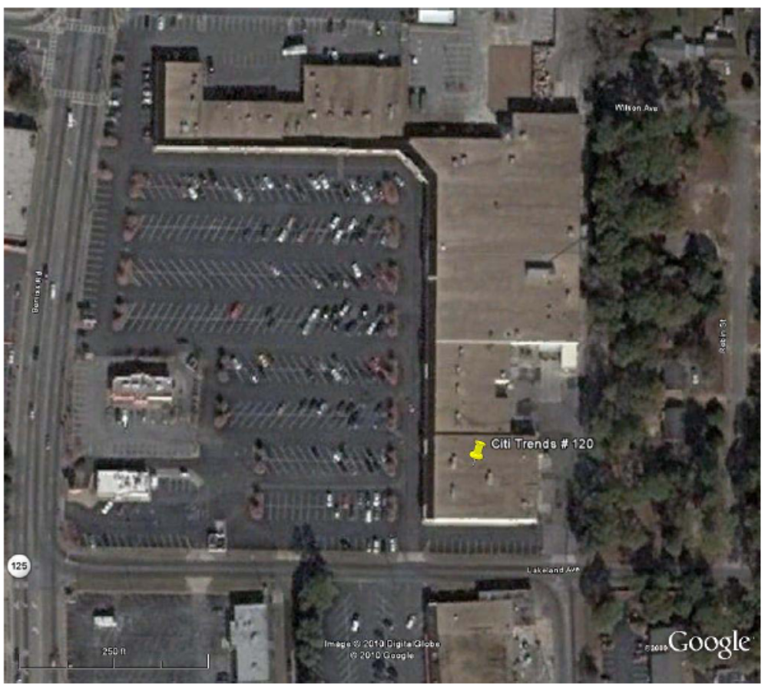

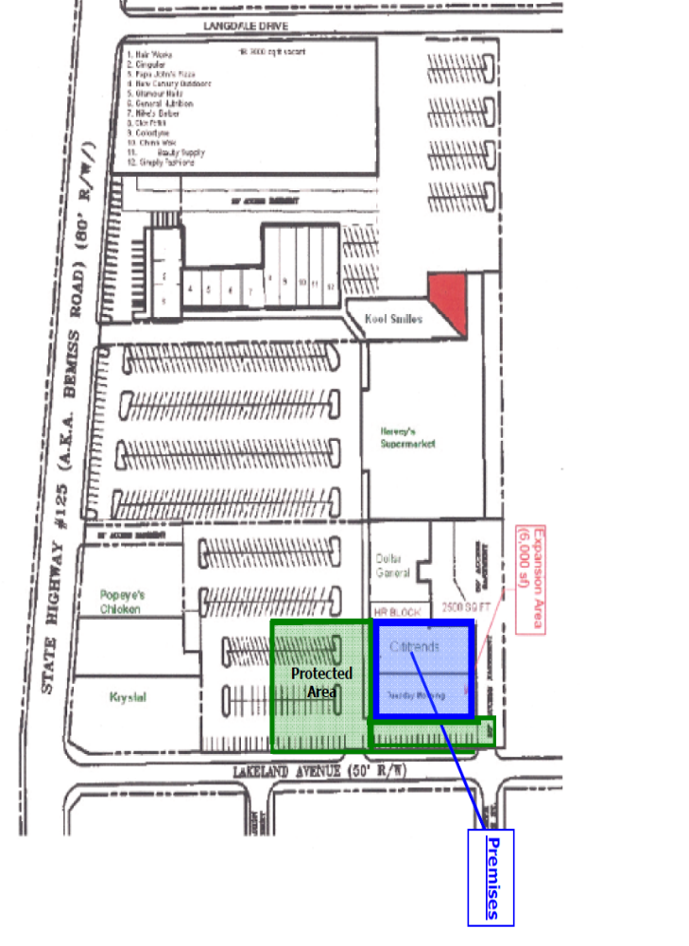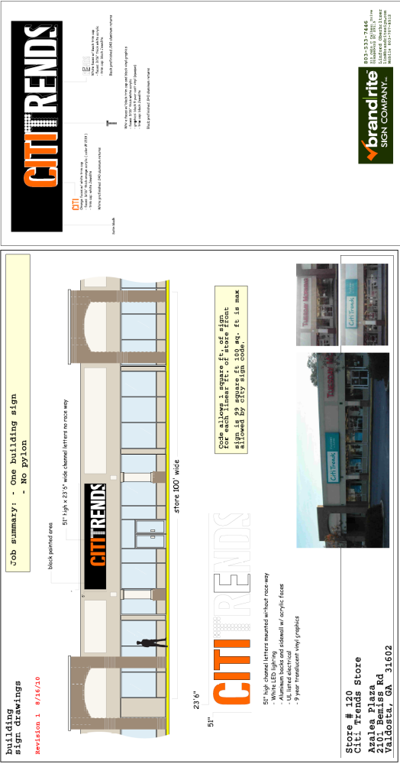

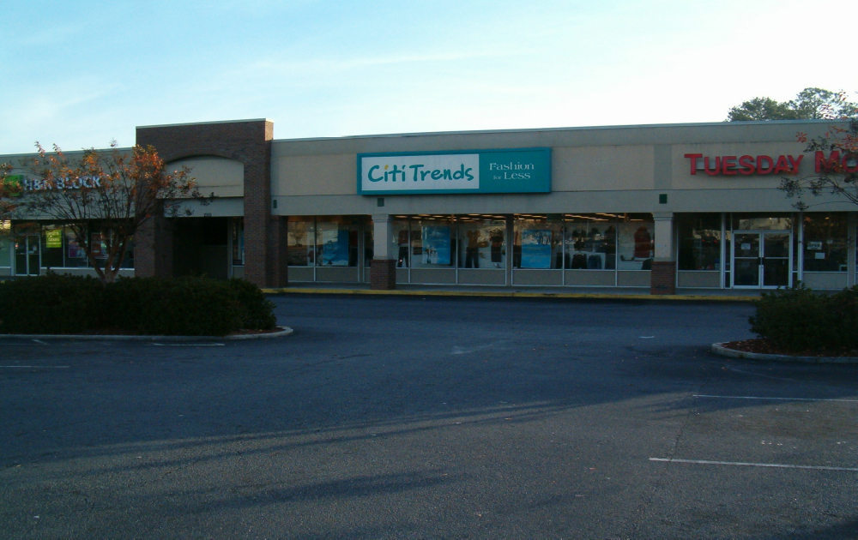

1.2 Premises -- The parties acknowledge that the Premises consist of approximately the square footage set forth in the Reference Provisions of Section 1.1. Within sixty (60) days after the Delivery Date (the “Applicable Period”), either party shall have the opportunity to measure the dimensions of the Premises for a determination of its exact square footage and provide the other party with written notice of its findings. If either party shall contest the square footage of the Premises within the Applicable Period, then the other party shall have fifteen (15) days after receiving written notice of such contest to make its own measurement. The parties shall thereafter use their best efforts to agree on the appropriate square footage. If neither party contests the square footage of the Premises within the Applicable Period, then the parties waive any right to contest such square footage amount in the future. When an agreement between Landlord and Tenant is reached, all monetary calculations in this Lease which rely upon the area shall be recalculated and adjusted retroactive to the Rent Commencement Date (but in no event shall such recalculation result in Tenant paying Rent on any square footage above the square footage set forth in Section 1.1(a) above).

1.3 Commencement Date: -- The Commencement Date shall be the earlier of (i) the date that Tenant opens for business with the public in the Expansion Area, or (ii) one hundred eighty (180) days from the Delivery Date. The “Delivery Date” shall be the date that conditions 1-5 below are all met.

- Tenant’s receipt from Landlord of an inspection report from First Service Networks or Lowndes Roofing indicating that the roof on the Expansion Area is “water-tight” and has an expected remaining life of at least 5 years. The report must be dated no earlier than thirty (30) days prior to the Delivery Date. Repairs or replacement to achieve this requirement must be completed prior to the Delivery Date;

- Receipt by Tenant of Landlord’s approval of Tenant’s Plans, and Tenant obtaining construction permits (if necessary) for Tenant’s Work;

3.1 Condition of Premises – Tenant acknowledges that neither Landlord nor any of Landlord’s employees, agents, representatives, contractors or brokers has made, and Landlord does not hereby make, any representations or warranties regarding the physical condition of the Premises (except as set forth in Exhibit B) or the Shopping Center, or the suitability thereof for Tenant’s use or the conduct of Tenant’s business therein, or the occupancy or operation within the Shopping Center by any other person or entity. Any such warranties which may exist are hereby expressly released and waived. Accordingly, except as set forth in Exhibit B, Tenant hereby agrees to accept the Premises in their “AS IS” condition. Except as expressly provided in this Lease, Landlord shall have no obligation to improve or alter the Premises for the benefit of Tenant and all other work on the Premises shall be completed by Tenant at Tenant’s expense (“Tenant’s Work”). Tenant’s Work shall include, but not be limited to, all work necessary and/or desired by Tenant to for Tenant to open for business in the Premises for its intended purposes, except those items of work specifically set forth as Landlord’s Work. Any modifications to Tenant’s Plans attached hereto as Exhibit B-1 and any of Tenant’s Work which is not shown on Tenant’s Plans shall be subject to Landlord’s approval in accordance with and to the extent required by Section 7.1 below, shall be performed in a good and workmanlike manner, and shall comply with all governmental requirements.

3.2 Acceptance by Tenant – Acceptance of possession by Tenant of the Premises shall constitute acceptance of the Premises by Tenant, except for punch list items to Landlord’s Work, if any. This Section 3.2 shall not negate or limit any representations or warranties made by Landlord under this Lease nor constitute any agreement by Tenant that such representations and warranties have been satisfied.

7.2 Security Equipment. Tenant shall be allowed, at its sole cost and discretion, to install security equipment, including but not limited to, bars, gates, shutters or interior grills across, in front of, or on top of any glass area on the exterior walls of the Premises. In addition, Tenant shall also be allowed, upon Landlord’s written approval, not to be unreasonably withheld, conditioned, or delayed, at its sole cost and expense, to install concrete bollards in the Common Area in front of the Premises. The installation of security equipment shall be in compliance with the local building code for commercial buildings. At the expiration or earlier termination of the Lease, upon Landlord’s written request, Tenant shall remove any and all security equipment installed by Tenant at Tenant’s sole cost and expense.

14.17 Signs, Awnings, and Canopies - Landlord may erect and maintain such suitable signs as it, in its sole discretion, may deem appropriate to advertise the Shopping Center but not on the exterior of the Premises. Tenant shall erect and maintain on the facade of the Premises one of Tenant’s standard signs at least 60” in height (but not to exceed the maximum amount permitted under applicable law). No tenant shall have a sign or sign letters larger than Tenant’s unless such tenant’s premises contains more floor area than the Premises contains. Tenant shall also be permitted to install an undercanopy or blade sign, at Tenant’s expense. Tenant shall submit to Landlord detailed drawings of such sign for review and approval by Landlord which shall not be unreasonably withheld prior to erecting said sign on the Premises. Landlord hereby approves Tenant’s Sign Specifications attached hereto as Exhibit C. Tenant also shall have the right to display from time to time on the exterior of the Premises professionally-made advertising banners.

Exhibit B

“AS IS” PREMISES

General

A. Landlord agrees to notify Tenant, in writing, at least 30 days prior to the Delivery Date.

- Tenant shall be permitted to use all existing improvements/fixtures in the Premises.

- Landlord agrees to provide any asbestos reports required for governmental permits.

- Landlord agrees to provide to Tenant Appendix B-Building Code Summary-2002 Edition-IBC (if required by local jurisdiction).

Except as provided below, Landlord will provide the Leased Premises in its “AS IS” condition, without any further work by Landlord, except that all structural and mechanical components of the Premises will be in good working order and the Premises shall meet all legal requirements, including, without limitation, the requirements of any local, state, or federal code:

Tenant’s receipt from Landlord of an inspection report from First Service Networks or Lowndes Roofing (or other inspection company approved by Tenant’s Director of Construction) indicating that the roof is “water-tight” and has an expected remaining life of at least 5 years. The report must be dated no earlier than 30 days prior to the Delivery date. Repairs or replacement to achieve this requirement must be completed prior to the Delivery Date.

In the event, Landlord fails to deliver the Premises to Tenant on the Delivery Date in the condition set forth in this Exhibit B, then Tenant may complete such work as is necessary to meet the “As-Is” condition herein and Tenant shall have the right to withhold the cost of such work from Rent (including Minimum Annual Rent, All other charges and all other charges due under the Lease).

