To: jwithrow@cititrends.com; shildebrand@cititrends.com; mgabriel@cititrends.com; mreames@cititrends.com; jdunn@cititrends.com; icouncil@cititrends.com; sclifford@cititrends.com; bgraves@cititrends.com; acook@cititrends.com; pabraham@cititrends.com; abeisel@cititrends.com; gwilder@cititrends.com; ccheeseman@cititrends.com; jhughley@cititrends.com; dchisholm@cititrends.com; bharris@cititrends.com; vowens@cititrends.com; jcollins@cititrends.com; mboyette@cititrends.com; akoonce@cititrends.com; dmcgraw@cititrends.com; pwright@cititrends.com; bgreen@cititrends.com; spoole@cititrends.com; adrinkman@cititrends.com; shorowitz@cititrends.com; tstephens@cititrends.com; mphillips@cititrends.com; bfeher@cititrends.com; dmiller@cititrends.com; kgroneck@cititrends.com; dalexander@cititrends.com; scarter@cititrends.com; jnapoli@cititrends.com; gdurkin@cititrends.com; scabeza@cititrends.com; sholland@cititrends.com; rkay@cititrends.com;

Fully executed Lease dated: December 15, 2010
Date Received: December 20, 2010
Delivery of Premises: on or before: November 1, 2010
Season: Spring 2011
Name of Shopping Center: Morse Shores
Store #: 0452
Premises Address: 4901 Palm Beach Blvd, Suite 10A
Ft. Myers, FL 33905 (confirmed as a deliverable address at USPS.com)
Subject to change - subdividing space
County: Lee
Landlord Contact: Charles A. Carver, Senior Vice President 800-206-0238
David Killian, Property Manager david.killian@centroprop.com
800-206-0238, Ext 2983 727-744-3933
Mike Wood, VP Construction 407-903-2907 mike.wood@centroprop.com
Siobhan Pecora 407-903-2919 siobhan.pecora@centroprop.com
9101 International Drive, Suite 1600, Orlando, FL 32819
(Office) 407-264-9950 (Fax) 407-264-2905
Utilities:
Electric: Unknown
Water: Unknown
Gas: Unknown
Former Tenant: Publix (Subdividing space)
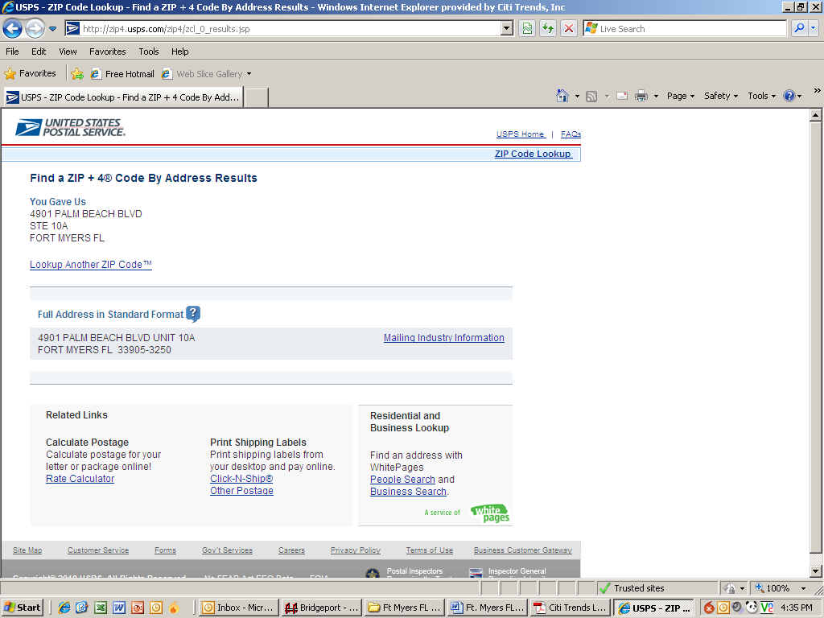

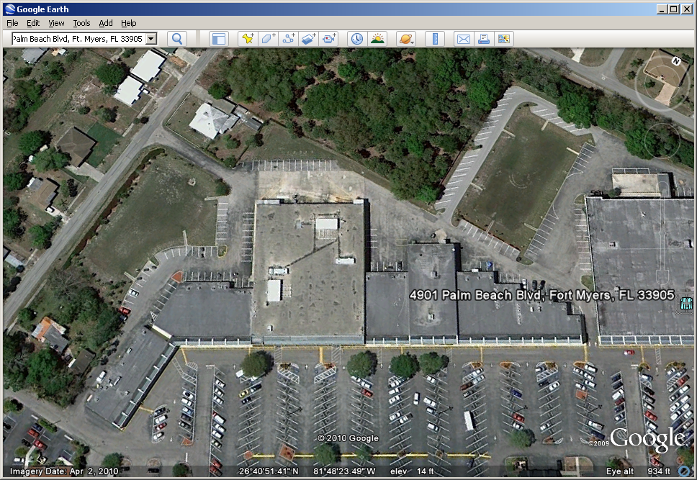
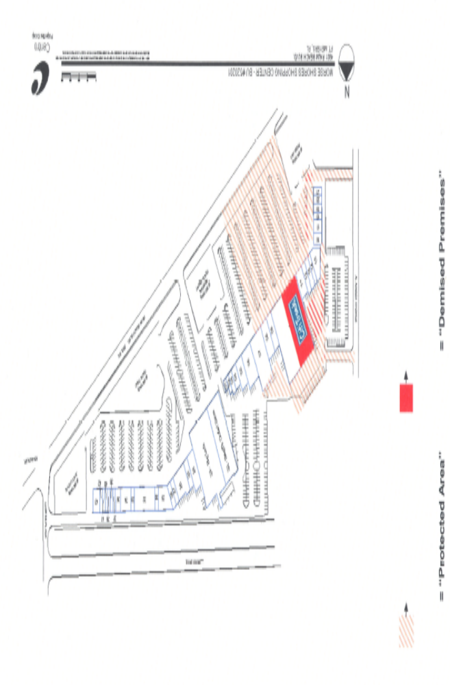

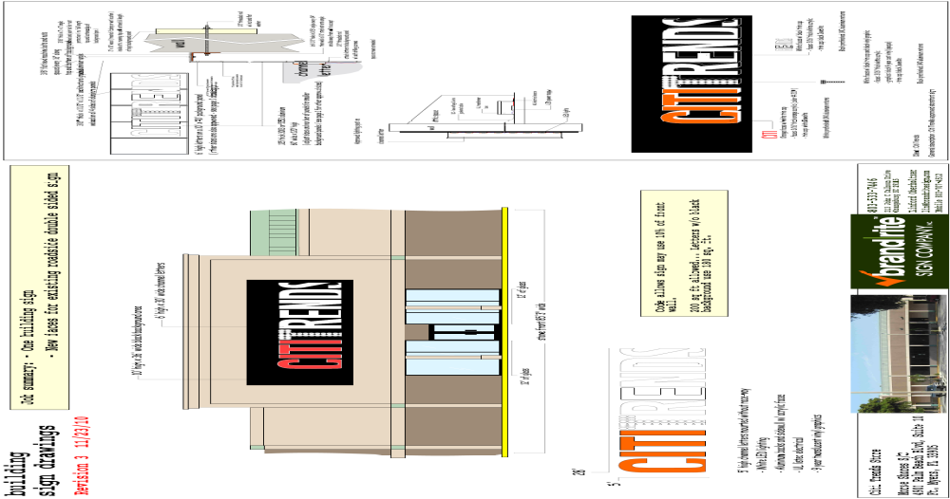
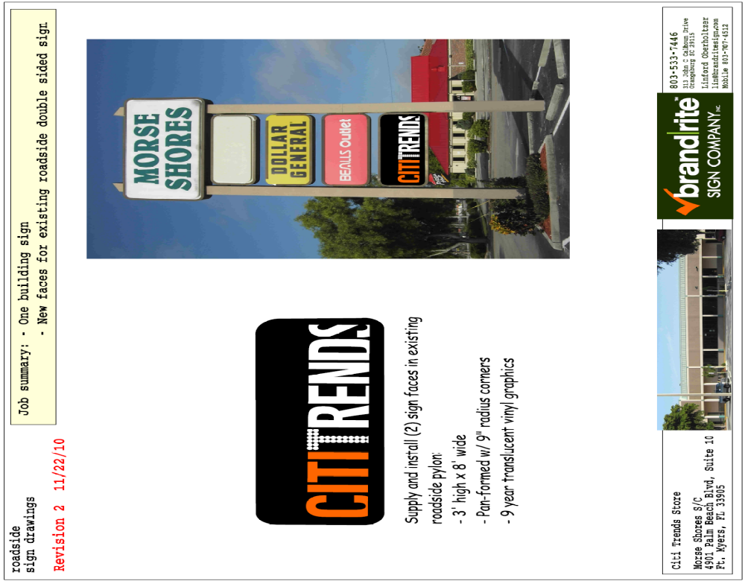

Section 2.01. Demised Premises.

(a) Landlord, in consideration of the rents to be paid and the covenants to be performed by Tenant, hereby leases the Demised Premises to Tenant, and Tenant hereby leases the Demised Premises from Landlord, for the Lease Term. All measurements of the Demised Premises and of leasable area are made from the outside of exterior walls and from the center of interior walls. Landlord reserves the right to change the name of the Shopping Center at any time in its sole discretion.

(b) It is expressly agreed that nothing contained in this Lease shall be construed as a grant or rental of (and the Demised Premises shall not include) (i) any space above the finished ceiling of the Demised Premises (or, if none, above the bottom edge of the framework supporting the roof), (ii) any rights in the roof or exterior of the building within which the Demised Premises is located, (iii) the space below the finished floor of the Demised Premises or (iv) the land upon which the Demised Premises is located.

Section 2.04. Construction Allowance.

As an inducement to the execution and delivery of this Lease and the performance by Tenant of all obligations hereunder, Landlord agrees to pay to Tenant, in consideration therefor, to be applied only toward the cost of the build-out of leasehold improvements and replacement of the existing HVAC systems (specifically excluding the costs of movable fixtures and equipment, design and architectural fees and interior and exterior signage, and all other costs customarily known as "soft costs") in an amount equal to the amount specified in Section 1.01 under Construction Allowance ("Construction Allowance") within sixty (60) days following the date items (a) through (e), below are satisfied,:

(a) Tenant is not in default of any term, covenant or condition of the Lease after notice and the expiration of any applicable cure period, and the Lease must be in full force and effect;

(b) Tenant has completed all of the work required to be performed by Tenant prior to Tenant's opening for business at the Demised Premises in strict accordance with plans and specifications approved in writing by Landlord;

(c) Tenant is open for business;

(d) The Demised Premises, including all installations therein, are free and clear of all liens, security interests, charges and encumbrances and there are no judgments, levies, attachments, liens or tax liens pending (or threatened) or in effect with respect to Tenant;

(e) Tenant submits the following completed documentation to the Landlord. Tenant shall supply either originals or recordable counterparts of the following documents unless otherwise agreed by Landlord:
(i) A Tenant Affidavit certifying that all of the conditions contained herein are satisfied.
(ii) The Tenant's General Contractor's Application for Payment and Lien Waiver.
(iii) The Tenant's Subcontractors'/Materialmen's Application for Payment and Lien Waiver (to be submitted for each and every subcontractor whose aggregate requisitions exceed $5,000).
- Certificate of Occupancy (or equivalent document required to open for business).
- Copies of paid invoices for Tenant’s Work in the Demised Premises (specifically excluding the costs of movable fixtures and equipment, design and architectural fees and interior and exterior signage, and all other costs customarily known as “soft costs”); provided, however, the Construction Allowance shall not decrease in the event such invoices are less than the amount of the Construction Allowance.
- The Tenant’s Form W-9.

(f) If and to the extent that Tenant owes any monies to Landlord under the Lease, excluding any amounts in dispute, at the time when Landlord is obligated to pay the Construction Allowance to Tenant, Landlord shall be permitted to deduct those monies owed to it by Tenant from the Construction Allowance, provided Landlord submits a detailed accounting of such deductions.

(g) If Landlord terminates this Lease prior to the scheduled expiration date on account of a default by Tenant under the terms hereof, in addition to all other remedies available to Landlord on account of such default, Tenant shall, upon receipt of written demand therefor, promptly pay to Landlord the unamortized value of the Construction Allowance actually disbursed by Landlord to Tenant pursuant to this Section (the "Unamortized Allowance"). For purposes of this Section, the Unamortized Allowance shall be calculated by amortizing the actual amount of the Construction Allowance disbursed by Landlord on a straight-line style basis over the initial Lease Term of the Lease using the default Interest as set forth in Section 1.01 and the Unamortized Allowance shall be established as of the date of termination of the Lease. The provisions of this Paragraph shall survive the termination of this Lease.

(h) If Tenant shall be judicially declared bankrupt or insolvent according to law, or if any assignment shall be made of Tenant's property for the benefit of creditors, or if a receiver, guardian, conservator, trustee in involuntary bankruptcy or similar officer shall be appointed to take charge of all or any substantial part of the Tenant's property, or if a petition shall be filed for any reorganization of the Tenant under any provisions of law now or hereafter enacted, or if Tenant shall file a petition for such reorganization, or for arrangements under any provisions of such laws providing a plan for a debtor to settle, satisfy or extend the time for the payment of debts then Landlord shall have the right to defer payment of any Construction Allowance until such time as Tenant both (a) properly assumes this Lease pursuant to the bankruptcy code and (b) pays all pre and post bankruptcy arrears due under the Lease.

(i) In the event Landlord fails to pay the Construction Allowance within sixty (60) days after items (a) through (e), above, have been fully satisfied, then in addition to all other remedies which Tenant may have, Tenant shall thereafter be entitled to offset all Rent, including Minimum Annual Rent, Percentage Rent, and Additional Rent, plus eight percent (8%) interest, until such time as the past due amount of the Construction Allowance is paid in full by Landlord or by such offset.

Section 3.02. Commencement of Lease Term.

(a) The Lease Term, and Tenant's obligation to pay "Rent" (as defined in Section 4.09) shall commence on the Commencement Date, as set forth in Section 1.01 and from and thereafter Minimum Annual Rent shall be paid as set forth in Section 1.01.

(b) The parties hereby acknowledge that certain obligations under various Articles herein may commence prior to the Commencement Date, including, but not limited to, Tenant's obligations to take possession and construct the Demised Premises, to obtain insurance, to indemnify Landlord, to waive certain Landlord liability and to pay for all utilities; and the parties agree to be bound by all such obligations from and after the date of this Lease.

(c) Except as otherwise set forth in this Lease, Landlord shall not under any circumstances be subject to any liability whatsoever to Tenant, and Tenant shall not under any circumstances be entitled to rescind or terminate this Lease, for any delay in Landlord's delivery of the Demised Premises to Tenant.

Section 6.02. Tenant's Construction, Installations and Alterations.

(a) All work or equipment, other than Landlord's Work, if any, shall be performed by Tenant at its own cost and expense and Tenant shall, without limitation, fully equip the Demised Premises with all trade equipment, furniture, operating equipment, furnishings, fixtures and exterior signs and any other equipment necessary for the proper operation of Tenant's business; provided, however, Tenant may re-use any existing mechanical, electrical or plumbing systems or other improvements which are currently located within the Demised Premises. Whenever Tenant is performing work within the Demised Premises, Tenant shall commence such work as soon as is practical and shall diligently prosecute such work to its completion as soon as is practical after its commencement. All fixtures installed by Tenant shall be new or completely reconditioned. Tenant shall not do any construction work or alterations, nor shall Tenant install any equipment other than trade fixtures without first obtaining Landlord's written approval and consent which shall not be unreasonably withheld. Tenant shall present to Landlord plans and specifications for such work at the time approval is sought in accordance with Section 6.01 above. Tenant shall commence its work promptly following Landlord's approval of Tenant's plans and specifications and shall diligently and continuously prosecute its work to completion so as to open for business no later than the Commencement Date.

(b) Tenant agrees that Tenant's Work shall not be done in a manner which would create any work stoppage, picketing, labor disruption or dispute or any interference with the business of Landlord or any tenant or occupant of the Shopping Center (any such violation, stoppage, picketing or disruption hereinafter referred to as a "Conflict"). Tenant shall immediately stop work or other activity if Landlord notifies Tenant that continuing such work or activity would cause a Conflict. Tenant shall indemnify and hold Landlord harmless from any loss, cost or liability suffered or incurred by Landlord as a result of Tenant's violation of the provisions of this paragraph. Tenant's violation of the terms hereof shall constitute a default hereunder and shall entitle Landlord to exercise any remedies that are available to Landlord at law, in equity or hereunder, including, without limitation, obtaining an injunction.

(c) Tenant may not perform any major repairs, renovations, remodeling or alterations to the Demised Premises without having first received the Landlord's written consent thereto. Tenant shall, before performing any major repairs, renovations, remodeling or alterations to the Demised Premises, submit complete architectural and engineering plans and specifications of the Demised Premises, prepared by architects and engineers previously approved in writing by Landlord, describing all of the major repairs, renovations, remodeling or alterations which Tenant proposes. Upon approval by Landlord of Tenant's final plans and specifications therefor, Tenant shall employ a contractor and sub-contractors, to perform the repairs, renovations, remodeling or alterations in accordance with the said approved plans and specifications and in accordance with the other terms and provisions of this Lease. Notwithstanding the foregoing, Tenant may make interior, non-structural, non-mechanical, non-electrical and non-plumbing alterations and repairs to the Demised Premises without Landlord’s consent so long as the total cost does not exceed Fifty Thousand Dollars ($50,000.00) in any twelve (12) month period during the Lease Term.

Section 6.03. Signs, Awnings and Canopies.

(a) Tenant shall not place or suffer to be placed or maintain any sign, awning or canopy in, upon or outside the Demised Premises or in the Shopping Center, nor shall Tenant place in the display windows any sign, decoration, lettering or advertising matter of any kind, without first obtaining Landlord's written approval and consent in each instance. Tenant shall maintain any such sign or other installation as may be approved in good condition and repair. All signs, awnings and canopies shall comply with all laws and regulations, shall be consistent with the general design of the Shopping Center, shall be in appropriate proportion to the size of Tenant's store front and, except as specifically permitted by Landlord, shall not protrude at an angle from the wall to which they are affixed. Notwithstanding anything herein contained, Tenant’s sign rendering is attached hereto as “Exhibit D” and shall be deemed to be approved by Landlord upon the full execution of this Lease.

(b) During the Lease Term of this Lease, Tenant shall be entitled to display its trade name on the existing Shopping Center tenant pylon sign (“Pylon”) in the panel position designated on Exhibit D-1 attached hereto. Landlord shall maintain such Pylon at its cost and expense, and may replace such sign from time to time provided that any new sign shall not be substantially smaller than the original dimensions of the Pylon and Tenant’s position on the new Pylon shall be substantially the same. Tenant shall be responsible for the fabrication and maintenance of Tenant’s sign panel on the Pylon. Tenant’s sign for the Pylon shall be prepared in accordance with all applicable legal requirements and with Landlord’s sign criteria.

(c) At the Expiration Date or earlier termination of the Lease, Tenant shall remove all of its exterior signs from the storefront, fascia and/or canopy and shall repair all damage caused by the initial installation and subsequent removal of such signage.

Section 22.14. Re-measurement.

Within forty-five (45) days after the Delivery Date, Tenant shall have the opportunity to measure the dimensions of the Demised Premises for a determination of its exact square footage and provide Landlord with written notice of its findings. If such measuring discloses that the actual square foot area is either less or greater than two hundred fifty (250) square feet than as stated in this Lease, all monetary calculations in this Lease which rely upon the area shall be recalculated and adjusted retroactive to the Commencement Date. For the purposes of determining the measurement of the actual square foot area of the Demised Premises, the area shall be measured from the outside face of all exterior walls and/or the storefront and the center of all demising walls and there shall be no deduction for columns, interior partitions or the like. If such measurement is not made within the aforementioned forty-five (45) day time limit, Tenant shall be deemed to have waived its right to re-measure.

Section 22.16. Tenant’s Right to Make Repairs.

Notwithstanding the foregoing, if Landlord fails to make any repairs to the Demised Premises which are the responsibility of Landlord under this Lease, which failure materially and adversely affects the operation of business from the Demised Premises or causes a material risk of damage to property in the Demised Premises or injury to persons in the Demised Premises, within fifteen (15) business days after Tenant’s delivery of written notice thereof to Landlord (provided, however, that in the event that the nature of the repair is such that more than fifteen (15) business days are required, Landlord shall have such additional time as may be reasonable to complete such repairs so long as the repair has commenced within thirty (30) days after Tenant’s delivery of written notice thereof to Landlord and Landlord diligently prosecutes the repair to completion), Tenant may perform the applicable repair work and Landlord shall reimburse Tenant for the reasonable costs of such work within thirty (30) days following Tenant’s submission of a request for reimbursement together with reasonable supporting documentation. If such reimbursement is not paid in accordance with the provisions of this Section 22.16, then after no less than one (1) five-(5) day written notice to Landlord of such failure to pay, Tenant may deduct such unpaid amount, plus a 10% administrative fee, from Minimum Annual Rent.

EXHIBIT D

SHOPPING CENTER SIGN SPECIFICATIONS

Any sign approved by Landlord hereunder shall be furnished and installed by Tenant at Tenant's sole cost and expense. The only exterior signs which may be installed by Tenant on or in connection with the use of any building shall be limited to the name of Tenant on such building, and no portion will project in any fashion above the plane of the roof of such building, and not more than 12 inches from the face, the rear or the side of such building. Unless otherwise consented to by Landlord, the area within which the sign can be located is limited by the following: the sign shall consist of individual channel letters mounted on a raceway, internally illuminated by neon or other means. No sign width (meaning all letters, including the space between them) shall extend beyond 80% of the store front of the Demised Premises. The letters can be in any type style, upper or lower case, can be in color, and may include Tenant's logo. No letter may protrude more than 8 inches from the face of the building. All signs will be UL approved. Prior approval by Landlord is required before any installation. Landlord’s execution of this Lease shall be deemed Landlord’s approval of Tenant’s signage and sign specifications. In no event shall Landlord's approval of any sign hereunder be deemed or construed as a warranty or guaranty by Landlord that such sign shall satisfy or be approved by any applicable governmental agency and Tenant acknowledges that Tenant shall be solely responsible at its own cost for obtaining required governmental approvals.

GENERAL SIGN RESTRICTIONS

- No animated, flashing or audible signs shall be permitted.
- No exposed lamps or tubing shall be permitted
- All signs and their installation shall comply with all local building and electrical codes.
- All conduit, cabinets, conductors, transformers and other equipment shall be concealed.
- Painted lettering shall not be permitted.
- Any damage to the sign band or roof deck caused by the installation or removal of Tenant's sign shall be repaired by Tenant at Tenant's sole cost and expense.

EXHIBIT B

LANDLORD'S AND TENANT'S WORK

LANDLORD’S WORK:

- Roof. Landlord shall have the roof inspected by a licensed roofer and provide Tenant with an inspection report indicating that the roof is “water-tight” and has a minimum remaining life of five (5) years.

- Environmental Report. Landlord shall have the Demised Premises inspected by an environmental consultant and provide Tenant with an inspection report indicating that the Demised Premises is free of hazardous materials as of the Delivery Date.

3. Demising Wall. Landlord shall construct a demising wall which shall be a minimum of 20-gauge 6” metal studs at 16” on center with ⁵/₈” gypsum board on both sides (U.L. U465) with R-19 fiberglass sound attenuation batt insulation. In addition, demising walls shall be mudded, taped and sanded smooth Level 4 finish.

4. Electrical Service. Landlord shall provide electrical service to the Premises through a 400-amp/3-phase, 120/208 volt individual meter can and per the itemized requirements set forth in Tenant’s prototype electrical plan. Landlord shall provide electrical distribution to the Premises through a 400-amp/3-phase, 120/208 volt power panel with a minimum of 30 breakers. The electrical panel shall be located in the storage area in the Premises.

5. Storefront. Landlord shall construct the storefront in accordance with Landlord’s elevation plan and Tenant’s Front Elevation both of which are attached hereto as Exhibit B-2. Frontage of the Premises shall be 10’-0” AFF to interior finished floor level and no less than 32 linear feet of glass from side to side and contain a pair of 3’-0”x7’-0” automatic doors, sealed weather-tight and adequate locking systems, all in working order, in the location shown on Exhibit B-1. All glass and framework shall be clean and free of damage and signage at the time of possession. Glass exposed to the exterior of the Premises shall be impact resistant. Landlord shall refurbish the façade with Dri-Vit or similar finish product and shall contain sufficient flat area above the storefront to support signage requirements of Tenant. Fascia shall be free of any previous signage, free of any indication of previous signage and be newly painted. Any canopy attached to, or part of, the exterior of the Premises, shall be in good, clean condition and leak free. Any lighting contained in such canopy shall be in good working condition and maintained by Landlord throughout the Lease Term (subject to inclusion in Shopping Center Operating Costs).

Except as specifically provided above as Landlord's Work, Tenant acknowledges that it is familiar with the Demised Premises and is accepting the same in its "AS IS/WHERE IS" condition with no representation or warranty by Landlord as to the fitness of the Demised Premises, or any equipment servicing the Demised Premises, for any use permitted herein.

In the event, Landlord fails to deliver the Premises to Tenant on the Delivery Date in the condition set forth in this Exhibit B and Exhibit B-2, and as required under Section 1.3 of the Lease, then Tenant may complete such work as is necessary to meet such requirements and Tenant shall have the right to withhold the cost of such work from Rent (including Minimum Annual Rent, Percentage Rent, Shopping Center Operating Costs, Real Estate Taxes, Insurance Charge and all other charges due under the Lease).

TENANT'S WORK:

Tenant's Work shall include all improvements necessary to operate Tenant's business all of which shall be at Tenant's sole cost and expense. The plans and specifications, if any are needed, and the detail and design shall be subject to the written approval of Landlord or Landlord's architect. Landlord’s execution of this Lease shall be deemed Landlord’s approval of such plans (attached hereto as Exhibit B-1).

Tenant shall be allowed, at its sole cost and discretion, to install security equipment, including but not limited to, interior bars, gates, shutters or interior grills across, in front of, or on top of any glass area on the interior walls of the Demised Premises. Tenant may also install an audio warning security monitoring system such as I-Verify. In addition, Tenant shall also be allowed, at its sole cost and expense but subject to Landlord’s review and approval, to install concrete bollards in the Common Facilities directly in front of the Demised Premises. The installation of security equipment and concrete bollards shall be in compliance with the local building code for commercial buildings and in accordance with Article VI of this Lease. At the expiration or earlier termination of this Lease, upon Landlord’s written request, Tenant shall remove any and all security equipment and concrete bollards installed by Tenant at Tenant’s sole cost and expense.

