To: jwithrow@cititrends.com; shildebrand@cititrends.com; mgabriel@cititrends.com; mreames@cititrends.com; jdunn@cititrends.com; icouncil@cititrends.com; sclifford@cititrends.com; bgraves@cititrends.com; acook@cititrends.com; pabraham@cititrends.com; abeisel@cititrends.com; gwilder@cititrends.com; ccheeseman@cititrends.com; jhughley@cititrends.com; dchisholm@cititrends.com; bharris@cititrends.com; vowens@cititrends.com; jcollins@cititrends.com; mboyette@cititrends.com; akoonce@cititrends.com; dmcgraw@cititrends.com; pwright@cititrends.com; bgreen@cititrends.com; spoole@cititrends.com; adrinkman@cititrends.com; shorowitz@cititrends.com; tstephens@cititrends.com; mphillips@cititrends.com; bfeher@cititrends.com; dmiller@cititrends.com; gpinka@cititrends.com; dalexander@cititrends.com; scarter@cititrends.com; jnapoli@cititrends.com; gdurkin@cititrends.com; scabeza@cititrends.com; sholland@cititrends.com;

Fully executed Lease dated: October 25, 2010
Date Received: October 28, 2010
Delivery of Premises: on or before: September 1, 2010
Season: Spring 2011
Name of Shopping Center: Town Place S/C (redevelopment of former Wal-mart)
Store # : 0081 relo
Premises Address: 2530 David H. McLeod Blvd
Florence, SC 29501 (confirmed as a deliverable address at USPS.com)
Subject to change - subdividing space)

County: Florence
Landlord Contact: Claudia Jones Horne Development, LP 412 N. Cedar Bluff Road, #205 Knoxville, TX 37923 865-560-1172 cjones@hpiknox.com

Utilities: Same as existing location

Former Occupant: Wal-Mart (Subdividing space)
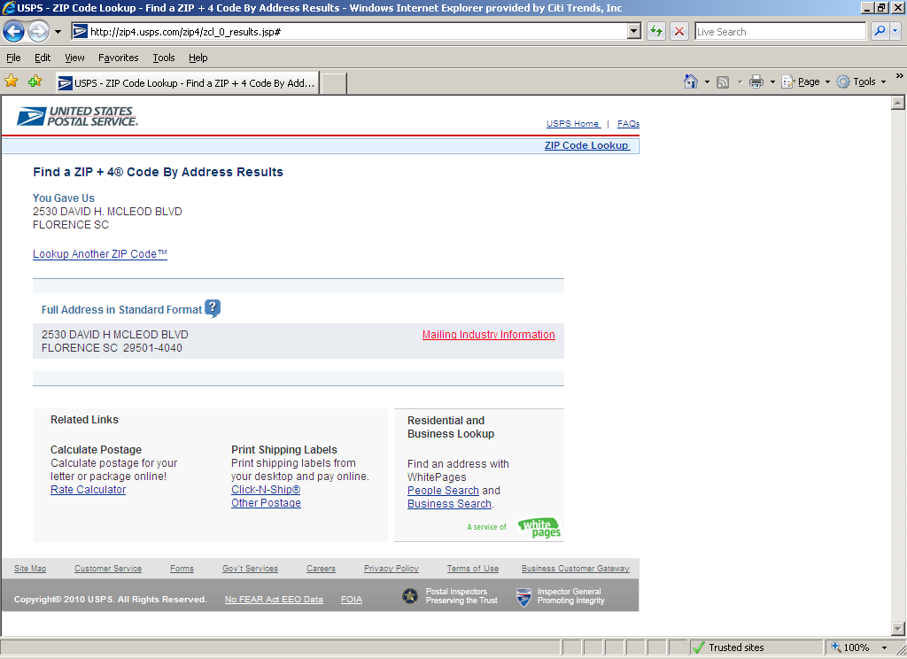

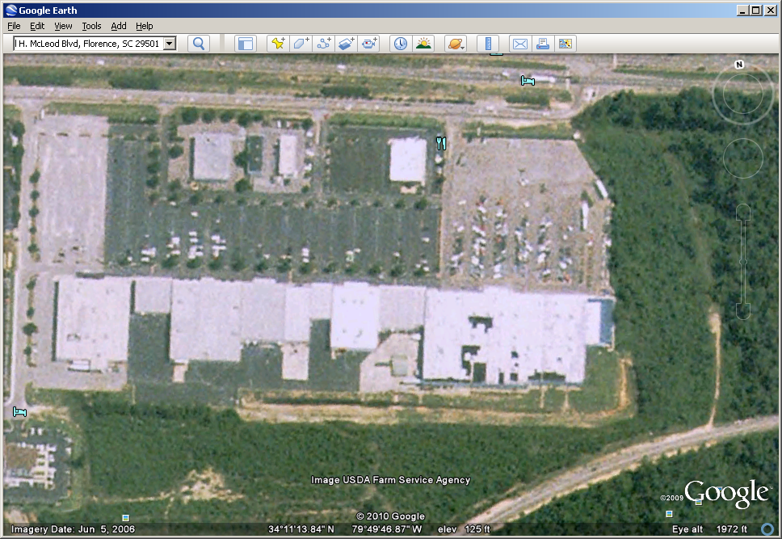
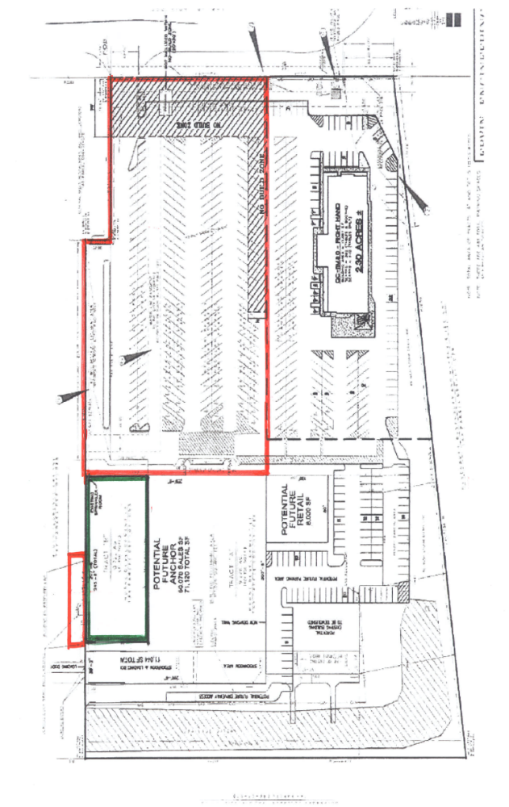
Protected
Area
Golden Corral Parcel
Shopping Center

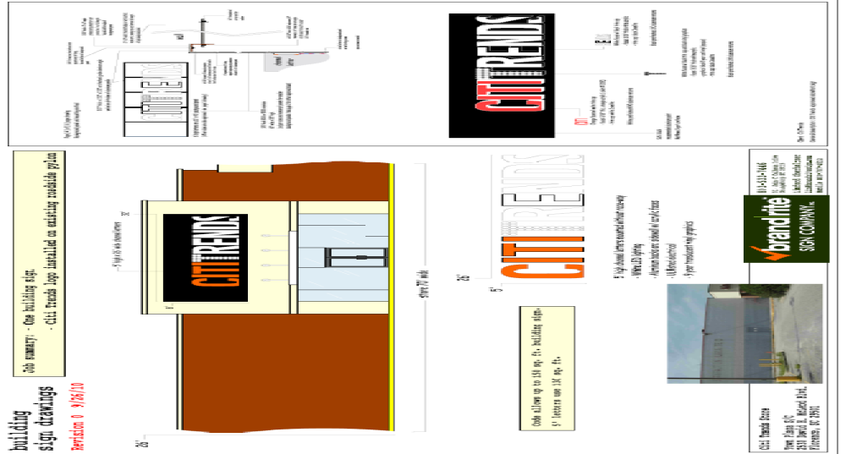
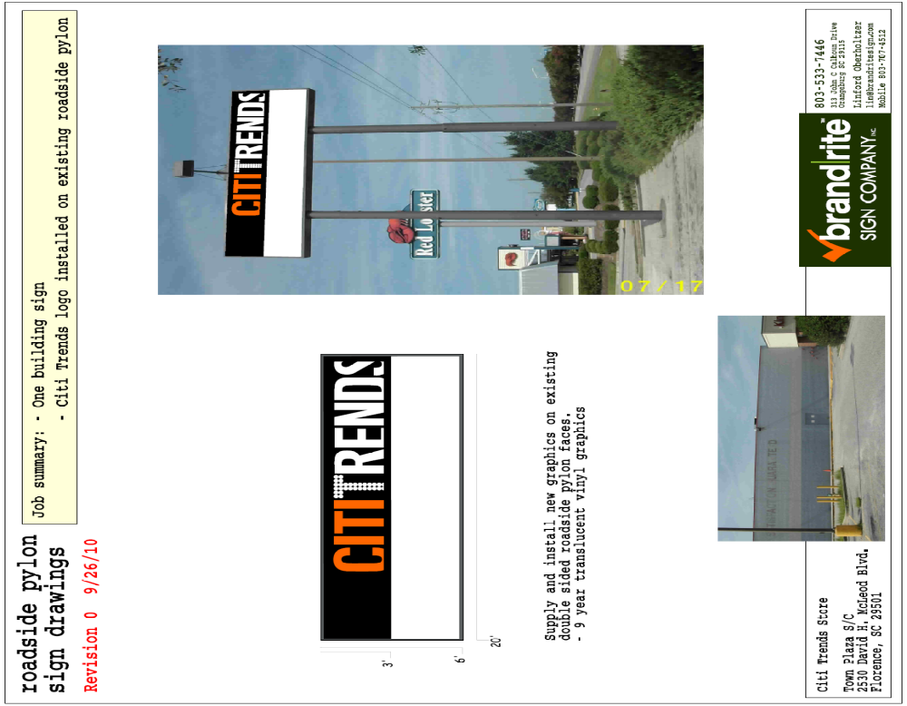

1.2 Premises -- The parties acknowledge that the Premises consist of approximately the square footage set forth in the Reference Provisions of Section 1.1. Within sixty (60) days after the Delivery Date (the “Applicable Period”), either party shall have the opportunity to measure the dimensions of the Premises for a determination of its exact square footage and provide the other party with written notice of its findings. If either party shall contest the square footage of the Premises within the Applicable Period, then the other party shall have fifteen (15) days after receiving written notice of such contest to make its own measurement. The parties shall thereafter use their best efforts to agree on the appropriate square footage. If neither party contests the square footage of the Premises within the Applicable Period, then the parties waive any right to contest such square footage amount in the future. When an agreement between Landlord and Tenant is reached, all monetary calculations in this Lease which rely upon the area shall be recalculated and adjusted retroactive to the Rent Commencement Date (but in no event shall such recalculation result in Tenant paying Rent on any square footage above the square footage set forth in Section 1.1(a) above).

1.3 Commencement Date: -- The Commencement Date shall be one hundred eighty (180) days from the date of the last to occur of all of the following (“Delivery Date”):

- Receipt by Tenant of written notice of delivery of possession of the Premises, and actual delivery of possession of the Premises with Landlord’s Work complete in accordance with Exhibit B;

- Separately metered 400-amp/3 phase, 120/208 volt electrical service stubbed to the Premises by Landlord;

- Tenant’s receipt from Landlord of an inspection report from First Service Networks (or other inspection company approved by Tenant’s Director of Construction) indicating that the roof is “water-tight” and has an expected remaining life of at least 5 years. The report must be dated no earlier than thirty (30) days prior to the Delivery Date. Repairs or replacement to achieve this requirement must be completed prior to the Delivery Date;

- Landlord shall have provided utility services (electricity, gas, water and sewer) have been provided to the Premises at the capacities adequate for Tenant’s needs and the services are separately and individually metered or sub-metered. Tenant will contract directly for all utility services or transfer services to Tenant, but Landlord shall pay all tap fees and connection charges associated with initial construction and Tenant shall be responsible for all fees associated with establishing its account with the utility provided so long as such are not in the nature of new construction;

- Landlord shall have provided a recent report from an environmental consultant that certifies that there are no hazardous materials in the Premises; provided, however, if any asbestos exists in the Premises, such report must state that said asbestos is satisfactorily encapsulated and non-friable;

- Landlord shall have repaired all parking field and delivery area lights;

- Landlord has approved all plans for Tenant’s Work; and

3.2 Acceptance by Tenant – Acceptance of possession by Tenant of the Premises shall constitute acceptance of the Premises by Tenant, except for punch list items to Landlord’s Work, if any, and patent defects discovered within ninety (90) days after the Commencement Date, and any latent defects. This Section 3.2 shall not negate or limit any representations or warranties made by Landlord under this Lease nor constitute any agreement by Tenant that such representations and warranties have been satisfied.

6.5 Roof Penetrations -- In the event Tenant installs or replaces any equipment that requires penetration of the roof, such penetration shall require Landlord’s prior written approval, which approval shall not be unreasonably withheld, conditioned or delayed, and the use of Landlord’s roof contractor or another contractor reasonably approved by Landlord.

7.2 Security Equipment - Tenant shall be allowed, at its sole cost and discretion, to install security equipment, including but not limited to, bars, gates, shutters or interior grills across, in front of, or on top of any glass area on the exterior walls of the Premises. In addition, Tenant shall also be allowed, at its sole cost and expense, to install concrete bollards in the Common Area in front of the Premises. The installation of security equipment shall be in compliance with the local building code for commercial buildings and in accordance with Section 6.5, above. At the expiration or earlier termination of the Lease, upon Landlord’s written request, Tenant shall remove any and all movable security equipment installed by Tenant at Tenant’s sole cost and expense and shall repair any damage to the Premises caused by such removal. The obligation contained in the immediately preceding sentence shall survive the expiration or earlier termination of this Lease. Any such items remaining in the Premises on the expiration or other termination of this Lease shall be deemed abandoned for all purposes and shall become the property of Landlord, and Landlord may dispose of the same without liability of any kind.

14.17 Signs, Awnings, and Canopies - Landlord may erect and maintain such suitable signs as it, in its sole discretion, may deem appropriate to advertise the Shopping Center but not on the exterior of the Premises. Tenant shall erect and maintain on the facade of the Premises, without cost to or charge by Landlord, one of Tenant’s standard signs at least 60” in height (but not to exceed the maximum amount permitted under applicable law). No tenant shall have a sign or sign letters larger than Tenant’s unless such tenant’s premises contains more floor area than the Premises contains. Tenant shall also be permitted to install (i) an undercanopy or blade sign, at Tenant’s expense and/or (ii) sign panels on both sides of all existing and future pylon and monument structures, as provided below. Tenant shall submit to Landlord detailed drawings of such sign for review and approval by Landlord which shall not be unreasonably withheld prior to erecting said sign on the Premises. Landlord hereby approves Tenant’s Sign Specifications attached hereto as Exhibit C. Tenant also shall have the right to display from time to time on the exterior of the Premises professionally-made advertising banners.

During the term of this Lease, Tenant shall be entitled to display its trade name on both sides of all existing and future Shopping Center pylon and monument signs (each a “Pylon”) in the position designated on Exhibit C-1 attached hereto. Landlord shall maintain and repair such Pylon and Pylon sign cabinets at its cost and expense, and may replace such sign from time to time provided that any new sign shall not be substantially smaller than the original dimensions of the Pylon and Tenant’s position on the new Pylon shall be substantially the same. Tenant shall be responsible for the fabrication and maintenance of Tenant’s sign panel on the Pylon. Tenant’s sign for the Pylon shall be prepared in accordance with all applicable legal requirements and with Landlord’s sign criteria.

Exhibit B

“AS IS” PREMISES

General

A. Landlord agrees to notify Tenant, in writing, at least 70 days prior to the Delivery Date.

- Tenant shall be permitted to use all existing improvements/fixtures in the Premises.

- Landlord agrees to provide any asbestos reports required for governmental permits.

- Landlord agrees to provide to Tenant Appendix B-Building Code Summary-2002 Edition-IBC (if required by local jurisdiction).

Except as provided in Section 1.3 of the Lease (Delivery Date requirements) and as provided below, Landlord will tender the Premises in its “AS IS” condition, without any further work by Landlord, it being acknowledged here that all structural and mechanical components of the Premises will meet local, state or federal code requirements on the Delivery Date and the Premises will be free of all Hazardous Materials;

In the event, Landlord fails to tender the Premises to Tenant on the Delivery Date in the condition set forth in Section 1.3 and this Exhibit B, then Tenant may complete such work as is necessary to meet the “As-Is” condition herein and Tenant shall have the right to withhold the cost of such work from Rent (including Minimum Annual Rent, CAM Costs, Real Estate Taxes, Insurance Costs and all other charges due under the Lease).

