To: jwithrow@cititrends.com; shildebrand@cititrends.com; mgabriel@cititrends.com; mreames@cititrends.com; jdunn@cititrends.com; icouncil@cititrends.com; sclifford@cititrends.com; bgraves@cititrends.com; acook@cititrends.com; pabraham@cititrends.com; abeisel@cititrends.com; gwilder@cititrends.com; ccheeseman@cititrends.com; jhughley@cititrends.com; dchisholm@cititrends.com; bharris@cititrends.com; vowens@cititrends.com; jcollins@cititrends.com; mboyette@cititrends.com; akoonce@cititrends.com; dcook@cititrends.com; pwright@cititrends.com; bgreen@cititrends.com; spoole@cititrends.com; adrinkman@cititrends.com; shorowitz@cititrends.com; mphillips@cititrends.com; bfeher@cititrends.com; dmiller@cititrends.com; dalexander@cititrends.com; scarter@cititrends.com; jnapoli@cititrends.com; gdurkin@cititrends.com; scabeza@cititrends.com; sholland@cititrends.com; mbuchsbaum@cititrends.com; kgroneck@cititrends.com; apulsney@cititrends.com; vdavis@cititrends.com;
Fully executed Lease dated: February 21, 2011
Date Received: February 22, 2011

Delivery of Premises: on or before: February 21, 2011

Season: Spring 2011

Name of Shopping Center: Columbia Plaza

STORE #: 0507

Premises Address: 74 South 20th Street, Battle Creek, MI 49015-2997
(confirmed as a deliverable address at USPS.com)

County: Calhoun

Landlord Contact: Ted G. Arvanitis
Columbia Plaza, LLC
664 N. Milwaukee Ave., Suite 200, Prospect Heights, IL 60070
(Ph) 847.520.4200 x.104 (Fax) 847.520.0238
(Email) tarvanitis@pabcormanagement.com

Utilities:
Electric: Consumers Energy
Water: City of Battle Creek
Gas: Semco Energy

Former Occupant: Parlin’s furniture

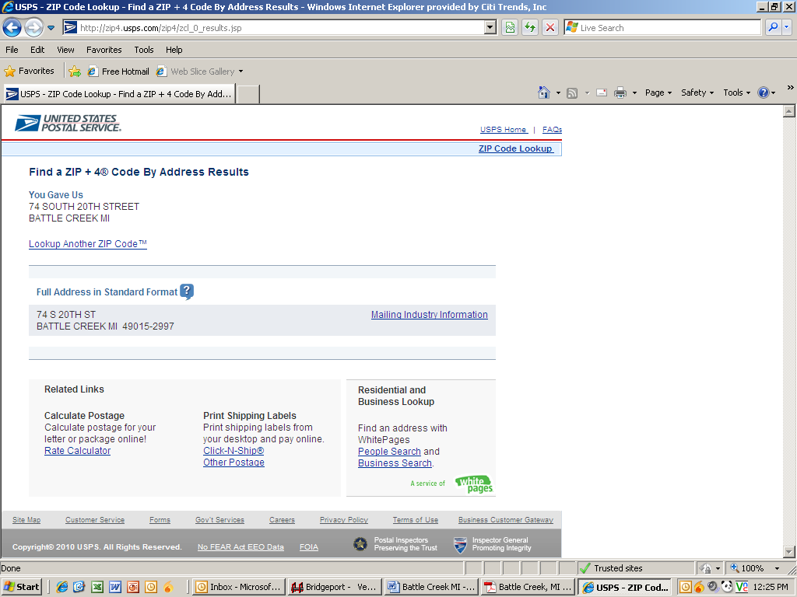
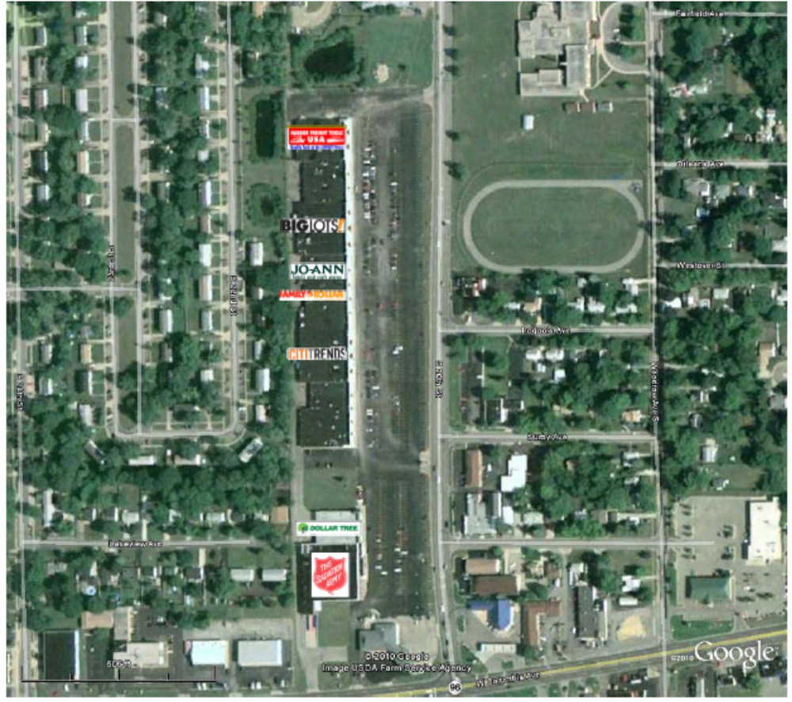

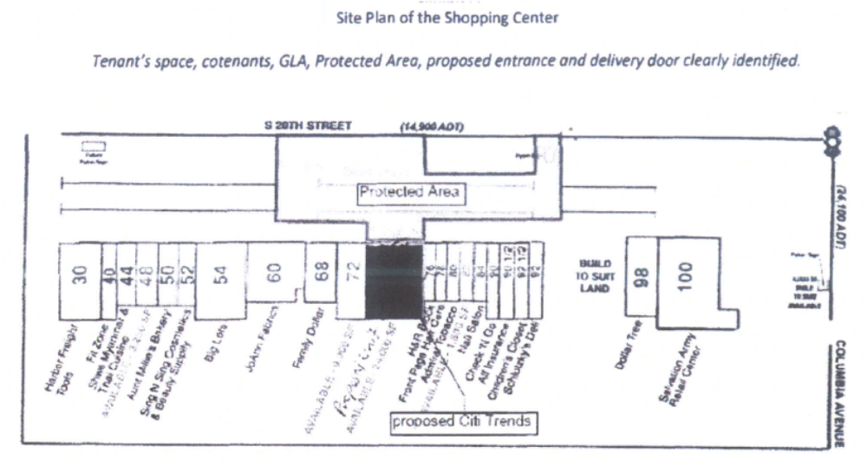

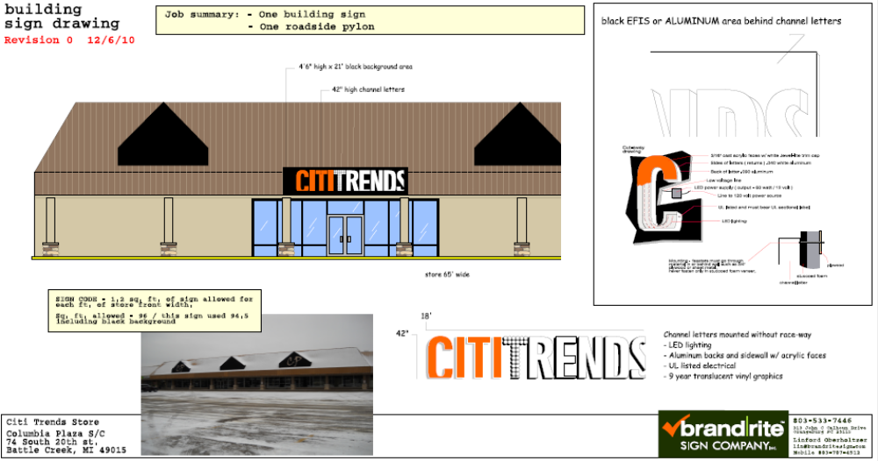
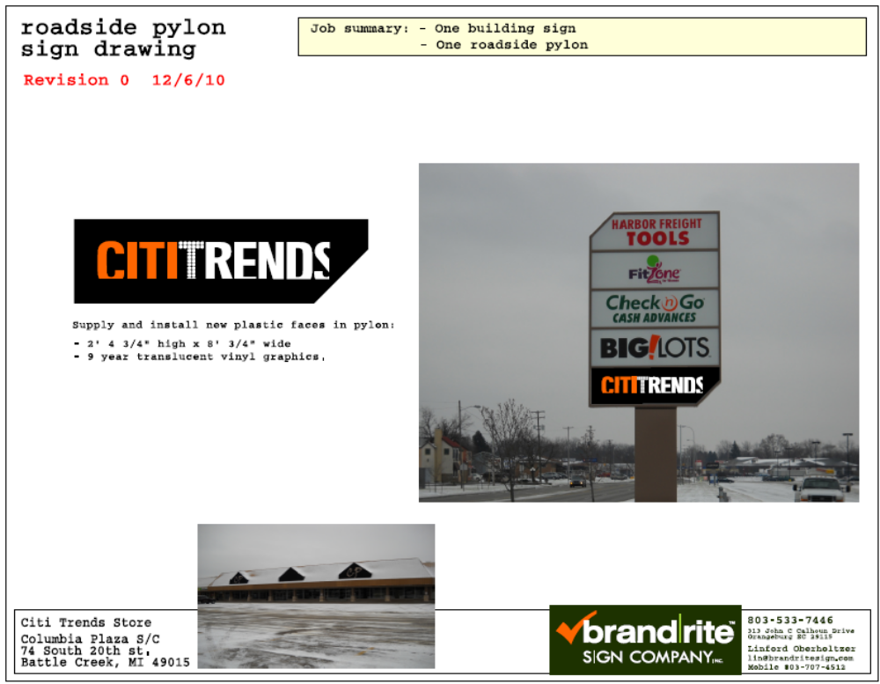

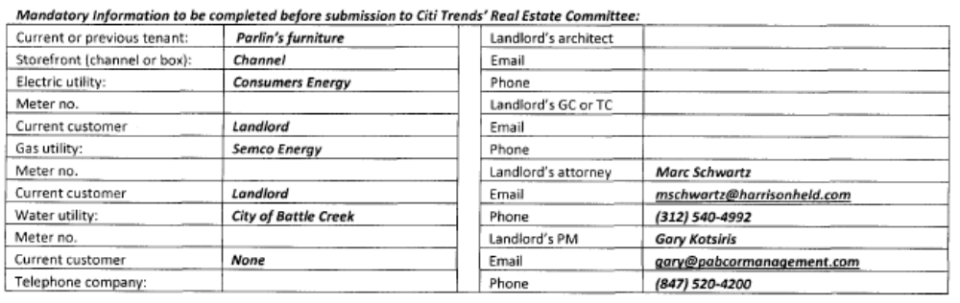

1.2 Premises – The parties acknowledge that the Premises consist of approximately the square footage set forth in the Reference Provisions of Section 1.1. Within sixty (60) days after the Delivery Date (the “Applicable Period”), either party shall have the opportunity to measure the dimensions of the Premises for a determination of its exact square footage and provide the other party with written notice of its findings. If either party shall contest the square footage of the Premises within the Applicable Period, then the other party shall have fifteen (15) days after receiving written notice of such contest to make its own measurement. The parties shall thereafter use their best efforts to agree on the appropriate square footage. If neither party contests the square footage of the Premises within the Applicable Period, then the parties waive any right to contest such square footage amount in the future. When an agreement between Landlord and Tenant is reached, all monetary calculations in this Lease which rely upon the area shall be recalculated and adjusted retroactive to the Rent Commencement Date (but in no event shall such recalculation result in Tenant paying Rent on any square footage above the square footage set forth in Section 1.1(a) above).
1.3 Commencement Date – The Commencement Date shall be the earlier of (a) Tenant opening for business, (provided that all of the delivery requirements (1)-(8), below (the “Delivery Requirements”), are satisfied), or (b) one hundred eighty (180) days from the date the last of the Delivery Requirements is satisfied (“Delivery Date”):
- Possession of the Premises after due notice in accordance with Exhibit B ;
- Tenant’s receipt from Landlord of an inspection report from an inspection company approved by Tenant’s Director of Construction and Landlord, which such approvals shall not be unreasonably withheld, conditioned or delayed, indicating that the roof is “water-tight” and has an expected remaining life of at least 5 years. The report must be dated no earlier than sixty (60) days prior to the Delivery Date. Repairs or replacement to achieve this requirement must be completed prior to the Delivery Date;
- Landlord shall have provided utility services (electricity, gas, water and sewer) have been provided to the Premises at the capacities adequate for Tenant’s needs and the services. Notwithstanding the foregoing, the Premises are part of an original 24,000 square foot area (the “Original Area”), of which the Premises are a 12,000 square foot portion of the Original Area. Tenant has the full use of the existing utility services to the building. Upon the leasing of any portion of the Original Area not being the Premises, the Landlord may split off the capacity Tenant is not using and shall cause all utility services to be separately and individually metered or sub-metered. In performing this work, Landlord shall not interrupt Tenant’s business and shall comply with the construction requirements set forth in Section 4.3 of this Lease. Tenant will contract directly for all utility services or transfer services to Tenant, but Landlord shall pay all tap fees and connection charges;
- Landlord shall have provided a report from an environmental consultant satisfactory to Tenant. Tenant acknowledges that it has received this report.;
- Landlord shall has repaired, and Tenant acknowledges, as of the date of this Lease, all parking field lights and delivery area lights are in good working order;
- Receipt by Tenant of Landlord’s approval of Tenant’s Plans (to be attached as Exhibit B-1), and Tenant obtaining construction permits (if necessary, and provided Tenant diligently and timely pursues such permits) for Tenant’s Work;
3.2 Acceptance by Tenant – Acceptance of possession by Tenant of the Premises shall constitute acceptance of the Premises by Tenant, except for punch list items to Landlord’s Work, if any, any patent defects discovered within six (6) months after the Commencement Date, and any latent defects. This Section 3.2 shall not negate or limit any representations or warranties made by Landlord under this Lease nor constitute any agreement by Tenant that such representations and warranties have been satisfied.
7.2 Security Equipment – Tenant shall be allowed, at its sole cost and discretion, to install security equipment, including but not limited to, bars, gates, shutters or interior grills across, in front of, or on top of any glass area on the exterior walls of the Premises. In addition, Tenant shall also be allowed, at its sole cost and expense, to install concrete bollards in the Common Area in front of the Premises. The installation of security equipment shall be in compliance with the local building code for commercial buildings. At the expiration or earlier termination of the Lease, upon Landlord’s written request, Tenant shall remove any and all security equipment installed by Tenant at Tenant’s sole cost and expense.
14.17 Signs, Awnings, and Canopies – Landlord may erect and maintain such suitable signs as it, in its sole discretion, may deem appropriate to advertise the Shopping Center but not on the exterior of the Premises. Subject to applicable local ordinances Tenant shall erect and maintain on the facade of the Premises one of Tenant’s standard signs at least 72” in height (but not to exceed the maximum amount permitted under applicable law). Landlord at its own expense will construct a raised marquee (mansard or parapet or tower) on the storefront to accommodate Tenant’s signage. No tenant shall have a sign or sign letters larger than Tenant’s unless such tenant’s premises contains more floor area than the Premises contains. Tenant shall also be permitted to install (i) an under-canopy or blade sign, at Tenant’s expense and/or (ii) sign panels on both sides of all existing and future pylon and monument structures, as provided below. Tenant shall submit to Landlord detailed drawings of such sign for review and approval by Landlord which shall not be unreasonably withheld prior to erecting said sign on the Premises. Landlord hereby approves Tenant’s Sign Specifications attached hereto as Exhibit C. Tenant also shall have the right to display from time to time on the exterior of the Premises professionally-made advertising banners.
During the Term of this Lease, Tenant shall be entitled to display its trade name on both sides of all existing Shopping Center pylon and monument signs in the position designated on Exhibit C-1 attached hereto and in prominent positions on both sides of all future Shopping Center pylon and monument signs (each a “Pylon”). Landlord shall maintain and repair such Pylon and Pylon sign cabinets at its cost and expense, and may replace such sign from time to time provided that any new sign shall not be substantially smaller than the original dimensions of the Pylon and Tenant’s position on the new Pylon shall be substantially the same. Tenant shall be responsible for the fabrication and maintenance of Tenant’s sign panel on the Pylon. Tenant’s sign for the Pylon shall be prepared in accordance with all applicable legal requirements and with Landlord’s sign criteria.
15.5 Construction Allowance – Landlord shall provide Tenant the sum of Three Hundred Thousand and 00/100 Dollars ($300,000.00) as and for a construction allowance and contribution toward the cost to Tenant for performing Tenant’s Work in the Premises. This allowance and contribution is reflected as a reduction in the amount of rent per square foot from $6.00 per square foot to $1.00 per square foot over the Initial Term, as shown in the rent schedule for Minimum Annual Rent at Section 1.1(e). Tenant shall provide Landlord with, (i) lien waivers by each of Tenant’s contractors or subcontractors providing work or services in excess of $10,000.00, (ii) a final certificate of occupancy, or the equivalent, for the Premises, unless obtainable in connection with Landlord’s work; (iii) an estoppel certificate that the Lease is in full force and effect; and (iv) a completed W-9 form.
Exhibit B

- Tenant shall be permitted to use all existing improvements/fixtures in the Premises.

