To: jwithrow@cititrends.com; shildebrand@cititrends.com; mgabriel@cititrends.com; mreames@cititrends.com; jdunn@cititrends.com; icouncil@cititrends.com; sclifford@cititrends.com; bgraves@cititrends.com; acook@cititrends.com; pabraham@cititrends.com; abeisel@cititrends.com; gwilder@cititrends.com; ccheeseman@cititrends.com; jhughley@cititrends.com; dchisholm@cititrends.com; bharris@cititrends.com; vowens@cititrends.com; jcollins@cititrends.com; mboyette@cititrends.com; akoonce@cititrends.com; dcook@cititrends.com; pwright@cititrends.com; bgreen@cititrends.com; spoole@cititrends.com; adrinkman@cititrends.com; shorowitz@cititrends.com; mphillips@cititrends.com; bfeher@cititrends.com; dmiller@cititrends.com; dalexander@cititrends.com; scarter@cititrends.com; jnapoli@cititrends.com; gdurkin@cititrends.com; scabeza@cititrends.com; sholland@cititrends.com; mbuchsbaum@cititrends.com; kgroneck@cititrends.com; apulsney@cititrends.com; vdavis@cititrends.com;

Fully executed Lease dated: February 17, 2011
Date Received: February 28, 2011
Season: Spring 2011

Name of Shopping Center: Town & Country Shopping Center

STORE #: 0502

Premises Address: 2385 MacArthur Blvd., Springfield, IL 62704-4503
(confirmed as a deliverable address at USPS.com)

County: Sangamon

Landlord Contact: James Zerkle
Town & Country Group
500 West Monroe
Springfield, IL 62704
217-698-7511
lawofficesjkz@hotmail.com

Utilities:
Electric: Unknown
Water: Unknown
Gas: Unknown

Former Occupant: Unknown

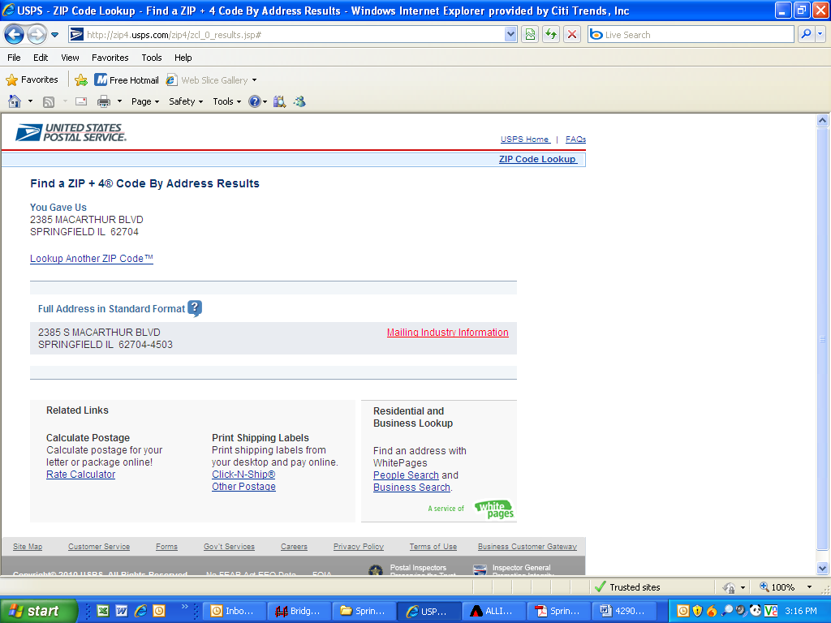
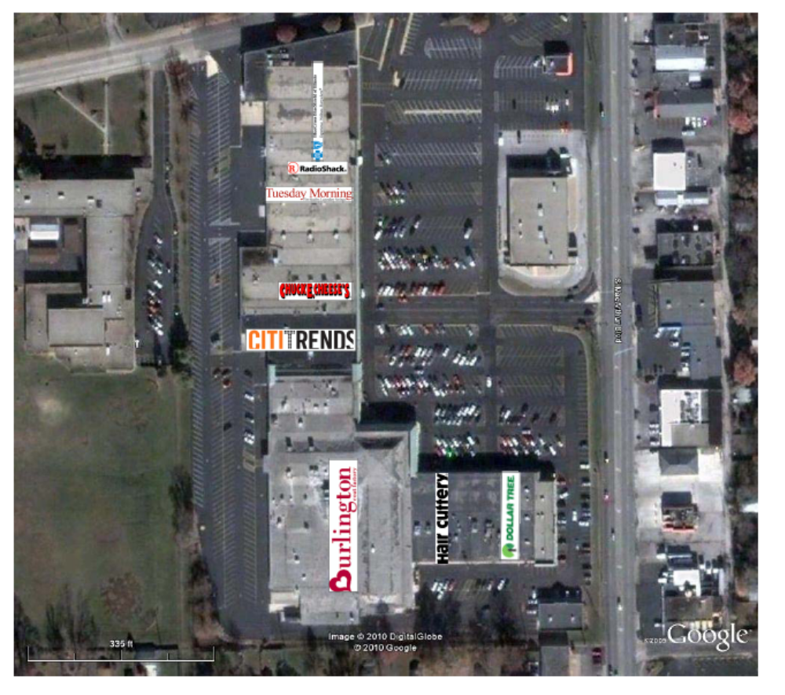

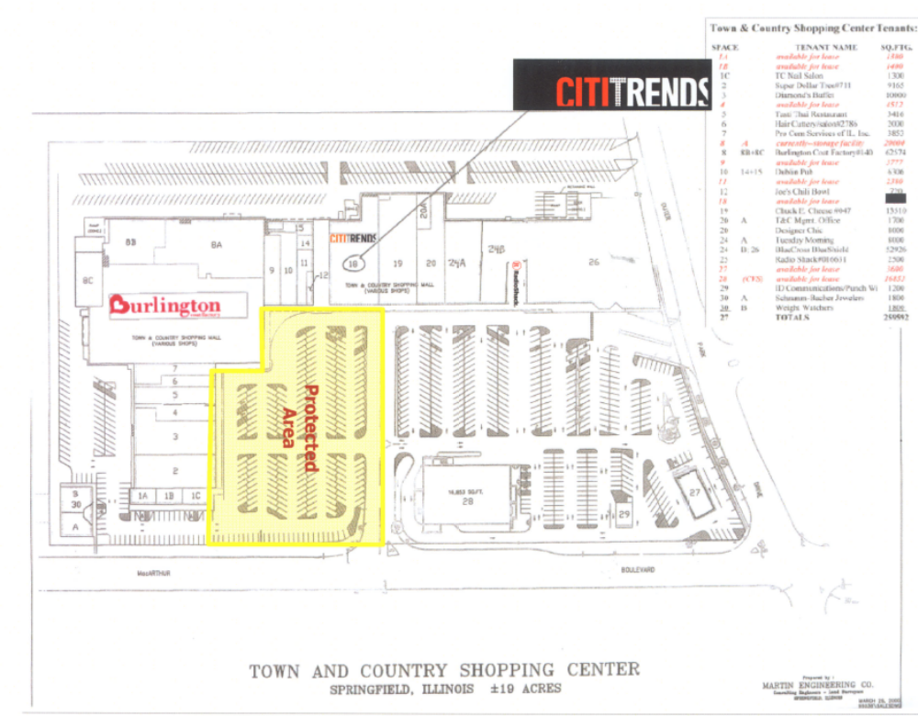

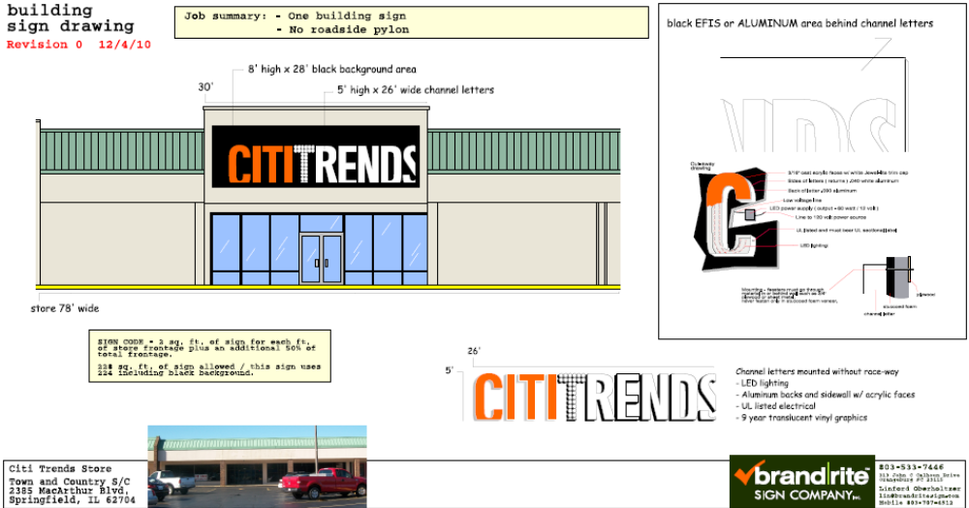

1.2 Premises -- The parties acknowledge that the Premises consist of approximately the square footage set forth in the Reference Provisions of Section 1.1. Within sixty (60) days after the Delivery Date (the “Applicable Period”), either party shall have the opportunity to measure the dimensions of the Premises for a determination of its exact square footage and provide the other party with written notice of its findings. If either party shall contest the square footage of the Premises within the Applicable Period, then the other party shall have fifteen (15) days after receiving written notice of such contest to make its own measurement. The parties shall thereafter use their best efforts to agree on the appropriate square footage. If neither party contests the square footage of the Premises within the Applicable Period, then the parties waive any right to contest such square footage amount in the future. When an agreement between Landlord and Tenant is reached, all monetary calculations in this Lease which rely upon the area shall be recalculated and adjusted retroactive to the Rent Commencement Date (but in no event shall such recalculation result in Tenant paying Rent on any square footage above the square footage set forth in Section 1.1(a) above).

1.3 Commencement Date: -- The Commencement Date shall be the earlier of (a) Tenant opening for business, (provided that all of the delivery requirements (1)-(9), below (the “Delivery Requirements”), are satisfied), or (b) one hundred eighty (180) days from the date of the last to occur of all of the following (“Delivery Date”):

- Possession of the Premises with Landlord’s Work complete in accordance with Exhibit B. Landlord’s Work shall be consistent with Exhibit B-1 (Landlord-approved Tenant’s Plans);

- Tenant’s receipt from Landlord of an inspection report indicating that the roof is “water-tight” and has an expected remaining life of at least 5 years. The report must be dated no earlier than thirty (30) days prior to the Delivery Date. Repairs or replacement to achieve this requirement must be completed prior to the Delivery Date;

- Landlord shall have provided utility services (electricity, gas, water and sewer) to the Premises at the capacities adequate for Tenant’s needs and the services are separately and individually metered or sub-metered. Tenant will contract directly for all utility services or transfer services to Tenant, but Landlord shall pay all tap fees and connection charges;

- Landlord shall have provided a report dated no earlier than six (6) months prior to the Delivery Date provides detailed information as to the location and condition of Hazardous Materials in the Premises including, without limitation, the walls, roof, roof covering, ceilings, structural steel, flooring, pipes and boilers of the Premises or certifies that there are no Hazardous Materials in the Premises;

- If necessary, Landlord shall have repaired/re-lamped the lighting in the parking and delivery areas so as to be in good working condition;

- Receipt by Tenant of Landlord’s approval of Tenant’s Plans, and Tenant obtaining construction permits (if necessary) for Tenant’s Work; and

- Complete heating and air conditioning system in working order for the entire Premises (sales area, storage area and bathroom area). The system shall be comprised of one (1) ton per 350 square feet of floor area and shall include one (1) working thermostat (locations to be determined by Tenant) per unit. Tenant acknowledges that the existing HVAC system meets these requirements.

3.2 Acceptance by Tenant – Acceptance of possession by Tenant of the Premises shall constitute acceptance of the Premises by Tenant, except for punch list items to Landlord’s Work, if any, any patent defects discovered within one (1) year after the Commencement Date, and any latent defects. This Section 3.2 shall not negate or limit any representations or warranties made by Landlord under this Lease nor constitute any agreement by Tenant that such representations and warranties have been satisfied.

7.2 Security Equipment -- Tenant, at its sole cost and discretion, may install security equipment, including but not limited to, bars, gates, shutters or interior grills across, in front of, or on top of any glass area on the exterior walls of the Premises. In addition, Tenant shall also be permitted, at its sole cost and expense, to install concrete bollards in the Common Area in front of the Premises. The installation of security equipment shall be in compliance with the local building code for commercial buildings. At the expiration or earlier termination of the Lease, upon Landlord’s written request, Tenant shall remove any and all security equipment installed by Tenant at Tenant’s sole cost and expense.

14.17 Signs, Awnings, and Canopies -- Landlord may erect and maintain such suitable signs as it, in its sole discretion, may deem appropriate to advertise the Shopping Center but not on the exterior of the Premises. Tenant shall erect and maintain on the facade of the Premises one of Tenant’s standard signs subject to the approval of the Landlord (but not to exceed the maximum amount permitted under applicable law), such approval not to be unreasonably withheld, conditioned or delayed. In addition, subject to Landlord’s approval, Tenant at its own expense may construct a raised marquee (mansard or parapet or tower) on the storefront to accommodate Tenant’s signage. No tenant shall have a sign or sign letters larger than Tenant’s unless such tenant’s premises contains more floor area than the Premises contains. Tenant shall also be permitted to install (i) an under-canopy or blade sign, at Tenant’s expense and/or (ii) sign panels on both sides of all existing and future pylon and monument structures, as provided below. Tenant shall submit to Landlord detailed drawings of such sign for review and approval by Landlord which shall not be unreasonably withheld prior to erecting said sign on the Premises. Landlord hereby approves Tenant’s Sign Specifications attached hereto as Exhibit C. Tenant also shall have the right, with Landlord’s consent to display from time to time on the exterior of the Premises professionally-made advertising banners in accordance with any ordinance, regulation, code, or the like, having jurisdiction of such matters.

During the term of this Lease, Tenant shall be entitled to display its trade name on both sides of all future Shopping Center pylon and monument signs (each a “Pylon”) attached hereto, provided the Pylon is designed to accommodate multiple sign panels, provided, Tenant’s sign shall be subject to the approval of the Landlord. Landlord shall maintain and repair such Pylon and Pylon sign cabinets at its cost and expense, and may replace such sign from time to time provided that any new sign shall not be substantially smaller than the original dimensions of the Pylon and Tenant’s position on the new Pylon shall be substantially the same. Tenant shall be responsible for the fabrication and maintenance of Tenant’s sign panel on the Pylon. Tenant’s sign for the Pylon shall be prepared in accordance with all applicable legal requirements and with Landlord’s sign criteria.

15.5 Construction Allowance -- Landlord shall pay to Tenant as and for a construction allowance and contribution toward the cost to Tenant for performing Tenant’s Work in the Premises, the sum of sixty-seven thousand five hundred and 00/100 Dollars ($67,500.00) in the form of a Minimum Annual Rent reduction. Such reduction shall be equal to:(a) $30,000.00 during the 1st Lease Year; (b) $22,500.00 during the 2nd Lease Year; and (c) $15,000.00 during the 3rd Lease Year (recognizing that in certain cases [e.g. Substitute Rent or Rent abatement due to a Casualty] the anticipated Minimum Annual Rent reduction may not be fully available in the Lease Year stated and will be applied thereafter). Within sixty (60) days after the Commencement Date, Tenant shall provide Landlord with lien waivers by each of Tenant’s contractors or subcontractors providing work or services in excess of $10,000.00.
Exhibit B
“As Is” Premises
General

A. Landlord agrees to notify Tenant, in writing, at least 5 days prior to the Delivery Date.

- Tenant shall be permitted to use all existing improvements/fixtures in the Premises.

- Landlord agrees to provide any asbestos reports required for governmental permits.

- Landlord agrees to provide to Tenant Appendix B-Building Code Summary-2002 Edition-IBC (if required by local jurisdiction).

Except as set forth in Section 1.3 of the Lease and as provided below, Landlord will provide the Premises in its “AS IS” condition, without any further work by Landlord, it being acknowledged here that all structural and mechanical components of the Premises will meet local, state or federal code requirements on the Delivery Date and the Premises will be free of all Hazardous Materials.

1. A smooth, level, broom clean, concrete floor.

2. All interior walls shall have clean, exposed drywall.

3. The Storefront façade and fascia of the Premises will be the same color as throughout the Shopping Center. All penetrations from previous signage or other attachments or appurtenances will be filled and painted and ready for the installation of Tenant’s exterior sign on the Delivery Date.

In the event, Landlord fails to deliver the Premises to Tenant on the Delivery Date in the condition set forth in Section 1.3 of the Lease and in this Exhibit B, then Tenant may complete such work as is necessary to meet the “As-Is” condition herein and Tenant shall have the right to withhold the cost of such work from Rent (including Minimum Annual Rent, Percentage Rent, CAM Costs, Real Estate Taxes, Insurance and all other charges due under the Lease).

